

Requirement & Design Specification
TREKMATE
AI-Supported Trekking Coordination Platform For Tour Guides And Tour Operators
Subject: SWD392
Version: 1.0

– Danang, May 2026 –

Record of Changes
Version | Date | A, M, D | In charge | Change Description
V1.0 | 15/05/2026 | A | All | Add initial version
*A - Added M - Modified D - Deleted

Table of Contents
Record of Changes 2
Table of Contents 2
I. Overview 9
1. User Requirements 9
1.1 Actors 9
1.2 Use Cases 10
a. Diagram(s) 10
b. Descriptions 14
2. Overall Functionalities 20
2.1 Screens Flow 20
2.2 Screen Descriptions 22
2.3 Screen Authorization 28
2.4 Non-UI Functions 30
3. System High Level Design 32
3.1 Database Design 32
a. Database Schema 32
b. Table Descriptions 33
3.2 Code Packages 38
II. Requirement Specifications 43
1. Authentication 43
1.1 UC-01_Register 43
a. Functionalities 43
b.Business Rule 44
1.2 UC-02_Login 45
a. Functionalities 45
b.Business Rule 47
1.3 UC-03_Logout 47
a. Functionalities 47
b.Business Rule 49
1.4 UC-04_View profile 49
a. Functionalities 49
b.Business Rule 50
1.5 UC-05_Edit profile 50
a. Functionalities 50
b.Business Rule 51
1.6 UC-06_Change password 51
a. Functionalities 51
b.Business Rule 53
1.7 UC-07_Forgot password 53
a. Functionalities 53
b.Business Rule 55
1.8 UC-08_Login with Google 55
a. Functionalities 55
b.Business Rule 56
2. Process Order 57
2.1 UC-11_Add product to shopping cart 57
a. Functionalities 57
b.Business Rule 58
2.2 UC-15_Bartending/Serving 59
a. Functionalities 59
b.Business Rule 60
2.3 UC-20_Add to favorites 61
a. Functionalities 61
b.Business Rule 62
2.4 UC-21_Search for products 62
a. Functionalities 62
b.Business Rule 64
2.5 UC-22_View invoice 64
a. Functionalities 64
b.Business Rule 65
3. Manage Account 66
3.1 UC-27_Manage User 66
a. Functionalities 66
b.Business Rule 68
3.2 UC-28_Role Management 68
a. Functionalities 68
b.Business Rule 70
3.3 UC-38_Ban/Unban User 71
a. Functionalities 71
b.Business Rule 73
4. Manage Order 73
4.1 UC-12_Order dish 73
a. Functionalities 73
b.Business Rule 75
4.2 UC-13_Track the order 76
a. Functionalities 76
b.Business Rule 77
5. Manage Product 78
5.1 UC-08_View Menu 78
a. Functionalities 78
b.Business Rule 80
5.2 UC-17_Update inventory 80
a. Functionalities 80
b.Business Rule 81
5.2 UC-19_Add product 82
a. Functionalities 82
b.Business Rule 84
5.3 UC-23_Edit product 85
a. Functionalities 85
b.Business Rule 86
5.4 UC-24_Delete product 87
a. Functionalities 87
b.Business Rule 88
6. Manage Sales 88
6.1 UC-32_Export Excel, PDF of daily revenue 88
a. Functionalities 89
b.Business Rule 90
6.2 UC-33_Revenue chart: day, month, year, quarter 90
a. Functionalities 90
b.Business Rule 92
6.3 UC-37_Product evaluation 92
a. Functionalities 92
b.Business Rule 94
7. Manage System 94
7.1 UC-34_Add notification 94
a. Functionalities 94
b.Business Rule 96
7.2 UC-35_Edit notification 96
a. Functionalities 96
b.Business Rule 97
7.3 UC-36_Show and hide notification 98
a. Functionalities 98
b.Business Rule 99
8. Manage Employee 99
8.1 UC-18_Check the work schedule 99
a. Functionalities 99
b.Business Rule 100
8.2 UC-26_Work shift assignment 101
a. Functionalities 101
b.Business Rule 102
9. Payment 103
9.1 UC-14_Payment 103
a. Functionalities 103
b.Business Rule 104
9.2 UC-16_Confirm payment 104
a. Functionalities 104
b.Business Rule 106
10. Report 106
10.1 UC-25_View the revenue report 106
a. Functionalities 106
b.Business Rule 107
III. Design Specifications 108
1.Authentication 108
1.1. Register 108
UI Design 108
Database Access 110
1.2. Forgot Password 111
UI Design 111
Database Access 112
1.3. Login 114
UI Design 114
Database Access 116
1.4. Login via Google 116
UI Design 116
Database Access 117
1.5. Logout 120
UI Design 120
Database Access 120
1.6. User Profile 121
UI Design 121
Database Access 122
2. Menu & Product Browsing 123
2.1 View Menu 123
UI Design 123
Database Access 124
2.2 Search Products 125
UI Design 126
Database Access 126
2.3 Add Product to Shopping Cart 127
UI Design 127
Database Access 129
3. Order & Payment 131
3.1 Order Dish (Create Order) 131
UI Design 131
Database Access 132
3.2 Payment (Cash, E-wallet, PayOS QR) 135
UI Design 135
Database Access 137
3.3 Order Tracking & Delivery 139
UI Design 139
Database Access 140
3.4. Locate User’s Current Location & Map Input 141
UI Design 142
Database Access 142
3.5 Order History 143
UI Design 143
Database Access 144
3.6. View Incoming Orders List (Staff) 145
UI Design 145
Database Access 146
3.7. Notification 147
UI Design 147
Database Access 150
4. Manage Product & Inventory 151
4.1 Add Product 151
UI Design 151
Database Access 153
4.2 Edit Product 154
UI Design 154
Database Access 156
5. Manage Employee & Work Shifts 157
5.1 View Work Schedule (Employee) 157
UI Design (My Schedule – Employee) 157
Database Access 158
5.2 Work Shift Assignment (Admin/Manager) 159
UI Design (Shift Assignment Screen) 160
Database Access 161
5.3 Auto-generate Work Schedules 162
UI Design (Auto Schedule Screen) 162
Database Access 164
5.4 View All Shifts (Admin) 167
UI Design (Admin – All Shifts View) 167
Database Access 168
6. Dashboard & Revenue Reports. 169
UI Design 170
Database Access 172
7. AI Functions (Kopi) 173
7.1 AI Product Suggestion 173
UI Design 174
Database Access 175
7.2 Chatbox AI Assistant 176
UI Design 177
Database Access 178
IV. Appendix 181
1. Assumptions & Dependencies 181
Assumptions: 181
Dependencies: 181
2. Limitations & Exclusions 182
3. Business Rules 183
4. Application Messages List 187

I. Requirement Specification

I.1 Problem Description

Purpose: Build a website for TrekMate Danang, a platform that introduces, manages, and supports online booking for hiking tours in Da Nang. The website allows customers to browse hiking tours, search for suitable trips, book tours online, rent hiking equipment, make payments, and receive AI-based tour consultation. The system also supports tour guides, equipment staff, and administrators in managing tours, bookings, equipment rental, customer information, articles, and system operations.

The system requirements are described as follows:

1. TrekMate Danang provides various hiking tour categories such as beginner tours, advanced hiking tours, mountain trekking, waterfall exploration, camping tours, and group hiking tours. When the system needs to add a new tour category, the administrator is responsible for entering the tour category information into the system. The administrator can update or delete the tour category information if there are errors or changes.

2. Each tour category may contain many different hiking tours. When a new hiking tour is created, the administrator enters the tour information into the system, including tour name, location, description, difficulty level, duration, price, available schedule, required equipment, images, and tour guide information. If the tour information is incorrect or changes, the administrator can update, hide, or delete the tour information according to business rules.

3. TrekMate works with different tour guides who lead hiking tours for customers. When there is a new tour guide, the administrator enters the tour guide information into the system, including full name, phone number, email, experience, assigned tours, and working status. If the guide information is incorrect or changes, the administrator can update or deactivate the guide account. A tour guide can be assigned to many different tours.

4. Customers can visit the website to browse hiking tour information. Tours can be organized by groups such as newest tours, popular tours, promotional tours, recommended tours, and tour categories. Customers can also use the search function to find tours by name, location, difficulty level, or price range. If customers are interested in a tour, they can view detailed tour information before booking.

5. Customers can use the AI Assistant to receive tour recommendations based on their preferences, health condition, available time, budget, difficulty level, and travel purpose. The AI Assistant can also answer questions about tour details, hiking preparation, required equipment, and safety notes. The system applies Retrieval-Augmented Generation (RAG) with Google Gemini so that the AI Assistant can provide answers based on TrekMate’s real tour data instead of giving only general responses.

6. The system supports route optimization and personalized tour recommendation. Based on customer preferences, location, time, and tour difficulty, the system can suggest suitable hiking routes or schedules. The project may apply optimization algorithms such as Genetic Algorithm to support route planning and improve the quality of tour suggestions.

7. TrekMate provides hiking equipment rental services such as backpacks, trekking poles, raincoats, tents, flashlights, shoes, and first-aid kits. Equipment staff are responsible for managing equipment information, including equipment name, type, quantity, rental price, condition, and availability status. If equipment information is incorrect or changes, equipment staff can update or delete the information according to business rules.

8. When customers book a tour, they can also rent necessary equipment. The system must check equipment availability before confirming the rental request. Equipment staff can confirm equipment pickup, return, damage, loss, or rental completion. The system needs to monitor the available quantity and status of each equipment item to support rental operations.

9. Customers who want to book a tour need to log in first. Customers can log in using their account or Google OAuth. When customers log in for the first time, the system requires them to enter information such as full name, phone number, email, and address. Customers can view and update their personal information if there are any errors.

10. Customers can view the list of bookings they have made along with detailed information for each booking. For bookings that have not yet started, customers may cancel the booking according to the cancellation policy. For completed tours, customers can provide feedback, rate the tour, and book the same or similar tour again.

11. Tour guides can view detailed information about the tours assigned to them, including customer list, tour schedule, meeting location, rented equipment, and customer notes. After completing a tour, tour guides can update the tour status, report problems, and confirm whether the tour was completed successfully.

12. To promote tour information and improve customer engagement, staff can create and update news or articles about hiking experiences, new tours, travel tips, safety guidelines, equipment preparation, and Da Nang destinations. If there are errors in the content, staff can correct or delete the article. Staff can also hide outdated articles or re-display previously hidden articles.

13. To support business management, the system provides statistics and reports for administrators, such as total bookings, revenue, popular tours, customer feedback, equipment rental frequency, cancellation rate, and AI recommendation effectiveness. These reports help the administrator evaluate business performance and improve tour planning.

14. All staff must log in before performing system functions. The administrator or store owner has the highest permission and can perform staff functions when necessary. When TrekMate hires new staff, the administrator creates an account and assigns appropriate roles such as tour guide, equipment staff, or content staff. If a staff member quits or no longer works for TrekMate, the administrator can deactivate or revoke their access rights.

I.2 Scope

I.2.1 In-Scope (System Scope)

Customer Side:

Register and log in using a regular account or Google OAuth

View tour lists by category (latest, popular, promotional, by category)

Search tours by name, location, difficulty level, price range

View tour details and book tours online

Manage your tour shopping cart (add, edit, delete)

Rent climbing equipment when booking tours

Pay online via PayOS

View tour booking history, cancellations, reviews & feedback

Use AI Assistant to receive tour advice and get answers to your questions

Read articles/news about climbing, preparation guides, and safety tips

Staff & Admin:

Manage tour catalog and information (add, edit, delete, hide/show)

Manage tour guides (add, edit, assign tours)

Manage rental equipment (add, edit, track status, confirm equipment receipt/return)

Process tour bookings (confirm, assign tour guides, update status)

Manage promotions/discounts

Manage posts/news

Manage user accounts & permissions

View revenue statistics, tour booking reports, equipment performance

Manage employee shifts

System Features:

AI Assistant integrated with RAG + Google Gemini based on TrekMate's real-world tour data

Optimal itinerary suggestion system (Genetic Algorithm can be applied)

Responsive interface supporting desktop, tablet, and mobile (320px – 1920px)

JWT authentication & Refresh Token

Image storage via Cloudinary

I.2.2 Out-of-Scope
The following items are not included in the initial release of the system:
# | Item | Reason
OS-1 | Native mobile application | Mobile access is provided through responsive web only
OS-2 | Multi-branch management | Version 1.0 supports TrekMate Da Nang as a single location only
OS-3 | Advanced analytics (revenue forecasting, customer trend analysis) | Not required in v1.0
OS-4 | Integration with third-party accounting systems | Outside current project requirements
OS-5 | Automated inventory updates via IoT devices | Inventory is updated manually through the system
OS-6 | Mobile loyalty app or membership card integration | Loyalty programs are managed internally by staff
OS-7 | Automated social media posting or email marketing | Not integrated in v1.0
OS-8 | Industry benchmarking and performance comparison tools | No built-in benchmarking in initial release

I.2.3 Assumptions

All users (customers, staff, and administrators) have stable internet access when using the system

Users possess basic digital literacy to interact with the platform (browsing tours, making bookings, processing payments, managing schedules)

Staff and administrators follow the defined workflows for booking processing, equipment management, and shift scheduling

All data entered into the system (tours, equipment, pricing, user information) is accurate and valid

Google OAuth and PayOS are properly configured and remain available throughout system operation

TrekMate's actual tour data is maintained and kept up to date within the RAG knowledge base so that the AI Assistant can provide accurate responses. It is assumed that the response time of the AI ​​Assistant and the optimization algorithm are within acceptable limits (e.g., under 10 seconds) to avoid degrading the user experience.

I.2.4. Dependencies

Google OAuth: Authenticates login via Google

PayOS/VNPay: Processes online payments

Google Gemini API/ Groq: Provides an AI platform for tour advisory features

Cloudinary: Stores tour images, equipment, and articles

Mapbox: Interactive map display for tour locations, meeting points, and hiking route visualization

SMTP Email Service: Sending OTP codes, password reset notifications, and booking confirmation emails to users

DBMS (MySQL/PostgreSQL): Stores all system data

I.3 Major Features

I.3.1 Features for customers are as follows
F01: Viewing hiking tours:
View tour list by category, view new tours, view popular tours, view promotional tours, search tours by name/location/difficulty level, and view tour details.

F02: Tour recommendation and AI consultation:
Use AI Assistant to get tour suggestions based on customer preferences, health condition, budget, available time, difficulty level, and travel purpose. Customers can also ask questions about tour details, required equipment, preparation tips, and safety notes.

F03: Booking cart management:
Add tour to booking cart, view booking cart, edit booking cart, change number of participants, remove selected tour or rental equipment.

F04: Tour booking placement:
Select tour schedule, choose number of participants, rent hiking equipment if needed, confirm booking information, and proceed to checkout.

F05: Customer authentication:
Register/Login using normal account or Google OAuth, manage profile, view personal information, and update profile information.

F06: My booking history:
View booking history, view booking details, cancel booking according to cancellation policy, send feedback, rate completed tours, and rebook the same or similar tour.

F07: Viewing news/articles:
View hiking news, travel guides, safety tips, equipment preparation guides, and search news/articles by title or keyword.

I.3.2 Features for Staff
F08: Tour category management:
Add, edit, delete, sort, and search tour categories such as beginner hiking, advanced hiking, camping tour, mountain trekking, waterfall exploration, and group hiking tour.

F09: Tour management:
Add, edit, delete, search, sort, hide, and display hiking tours. Manage tour information such as name, location, description, difficulty level, duration, price, images, schedule, required equipment, and assigned tour guide.

F10: Tour guide management:
Add, edit, delete/deactivate, search, and sort tour guide information. Manage guide profile, experience, contact information, assigned tours, and working status.

F11: Equipment management:
Add, edit, delete, search, and sort hiking equipment such as backpacks, trekking poles, tents, flashlights, raincoats, shoes, and first-aid kits. Manage equipment quantity, rental price, condition, and availability status.

F12: Equipment rental management:
View rental requests, confirm equipment pickup, confirm equipment return, update equipment condition, handle damaged/lost equipment, and update equipment availability.

F13: Booking processing:
View booking list, view booking details, confirm booking, assign tour guide, check rented equipment, confirm payment status, update tour status, confirm completed tour, confirm cancelled booking, and handle customer feedback.

F14: Promotion/discount management:
Create discounts, edit discounts, delete discounts, apply discounts to selected tours or equipment rental services, and manage promotional campaigns.

F15: News/article management:
View article details, add news/articles, edit articles, delete articles, disable outdated articles, and enable hidden articles.

F16: User management:
Staff login, create staff account, assign staff roles and permissions, update staff information, deactivate staff account, and revoke staff permission.

F17: Statistics and reports:
View statistics on total bookings, revenue, popular tours, cancelled bookings, customer feedback, equipment rental frequency, available equipment, damaged/lost equipment, and AI recommendation effectiveness.

I.4 Nonfunctional Requirements
NF-01 Maintainability:
The system should be designed to support efficient maintenance, updates, and future extension. The source code should be modular, well-organized, and clearly separated by business domains such as tour management, booking management, equipment rental, user management, payment, news management, and AI Assistant.
The system should provide clear documentation for components, modules, database design, API endpoints, and interactions between frontend, backend, database, payment service, Cloudinary storage, and AI service. This helps developers understand the system easily and modify features smoothly when business requirements change.

NF-02 Usability:
The website must provide a user-friendly interface so that customers can easily search for tours, view tour details, receive AI consultation, rent equipment, and complete tour booking.

The interface should be clear, responsive, and easy to use for both customers and staff.
- Task completion time: Customers should be able to find a suitable tour and complete booking within 5 minutes.
- Error rate: The error rate for key tasks such as searching tours, booking tours, renting equipment, and making payment should be less than 5%.
- User satisfaction: At least 85% of users should be satisfied with the website experience.
- Staff usability: Staff should be able to manage tours, bookings, equipment, and articles without needing advanced technical knowledge.

NF-03 Portability:
The website should be compatible across different browsers, devices, and operating systems.
- Browser compatibility: The system should work properly on the latest versions of Chrome, Firefox, Safari, and Edge.
- Device compatibility: The system should support desktop, tablet, and mobile screen sizes.
- Operating system compatibility: The system should work on at least Windows, macOS, Android, and iOS.
- Responsive design: The interface should support screen widths from 320px to 1920px.

NF-04 Performance:
The website should ensure fast performance, quick response time, and smooth interaction for both customers and staff.
- Page load time: Main pages such as homepage, tour list, tour detail, booking page, and login page should load in less than 4 seconds for 95% of users.
- Response time: The system should handle at least 500 users with an average response time of less than 6 seconds.
- Stress testing: The system should support at least 200 concurrent users with performance degradation of less than 20%.
- Search performance: Tour search and filtering should return results within 3 seconds under normal traffic.
- AI response time: The AI Assistant should return tour consultation responses within an acceptable time, preferably less than 10 seconds for normal questions.

NF-05 Security:
The system must protect user information, staff accounts, booking data, payment information, and system management functions.
- Authentication: Customers and staff must log in before using protected features.
- Authorization: Staff features must be restricted based on roles such as Admin, Tour Guide, Equipment Staff, and Content Staff.
- Token security: The system should use JWT and Refresh Token to manage secure authentication sessions.
- OAuth security: Google OAuth should be used securely for customer login.
- Payment security: Payment processing through PayOS must ensure that transaction information is verified before confirming a booking.
- Data protection: Sensitive user data such as phone number, email, address, and booking history must be protected from unauthorized access.

NF-06 Reliability:
The system should operate reliably and reduce the risk of booking or payment errors.
- Booking reliability: A booking should only be confirmed when customer information, tour schedule, equipment availability, and payment status are valid.
- Equipment availability: The system should prevent customers from renting unavailable equipment.
- Payment confirmation: The system should correctly update booking status after successful payment.
- Failure handling: If payment or AI service fails, the system should show clear messages and allow users to retry.

NF-07 Scalability:
The system should be designed to support future growth in users, tours, bookings, equipment, and AI-related data.
- The backend architecture should support future extension using Clean Architecture, Hexagonal Architecture, or Microservice-oriented design.
- The system should be able to add more tour types, more locations, more guides, and more equipment without major redesign.
- Redis caching can be used to reduce database load for popular tour queries.
- The AI Assistant should be extendable to support more knowledge sources and more advanced recommendation logic.

NF-08 Availability:
The system should be available for customers and staff during normal business operation.
- Customers should be able to browse tours, view articles, and make bookings at any time.
- Staff should be able to manage tours, bookings, equipment, and articles during working hours.
- The system should minimize downtime during updates and maintenance.

NF-09 Data Integrity:
The system must ensure that important data is accurate and consistent.
- Booking data, payment data, equipment rental data, and customer information must be stored correctly.
- Equipment quantity must be updated accurately after rental, return, damage, or loss.
- Tour availability and booking capacity must be consistent to avoid overbooking.
- Reports and statistics must be calculated from valid system data.

NF-10 AI Answer Quality:
The AI Assistant should provide useful, relevant, and safe tour consultation.
- AI answers should be based on TrekMate’s real tour data using RAG.
- The AI should avoid giving unsupported or misleading information.
- The AI should recommend tours based on user preferences, difficulty level, budget, time, and preparation needs.
- If the system does not have enough information, the AI should clearly state that the information is unavailable instead of guessing.

In this project, UML will be used to construct models in the requirements, analysis, and design phases of software development. These models are platform-independent and follow the PIM (Platform-Independent Model) approach. Therefore, the models focus on business logic and functional requirements of the TrekMate Danang system without being tied to a specific technology platform. In the following sections, the models for each phase, including requirements, analysis, and design, will be presented, followed by the mapping of these models to source code.

I. Overview

1. User Requirements

1.1 Actors
# | Actor | Description
1 | Admin | An admin is responsible for platform governance. They can manage users, employees, roles, products, inventory, and store settings. Has access to advanced features such as revenue reports, analytics, notifications, and system logs. Can ban/unban users and perform backup/restore operations.
2 | Employee | An employee who handles daily operations. Responsible for receiving and serving orders, confirming payments, updating inventory, and checking work schedules. Can view assigned shifts and perform basic tasks.
3 | Customer | An user is a registered individual who can view the menu, place in-store or online orders, make payments (cash, e-wallet, card), and track order status. Can manage their profile (view/edit personal information, change password), add favorite products, view invoices, and rate products.
4 | Guest | A guest is someone who has not created an account on the system. Can only view the home page and menu. To place orders or access advanced features, they must register and become a Customer.

1.2 Use Cases

a. Diagram(s)

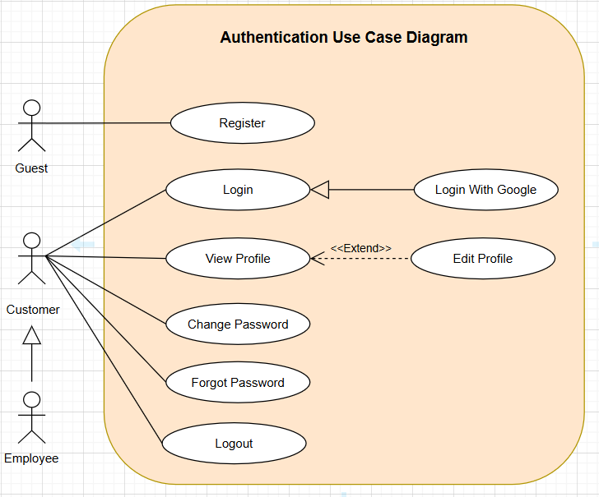
Figure 1. Authentication Use Case Diagram

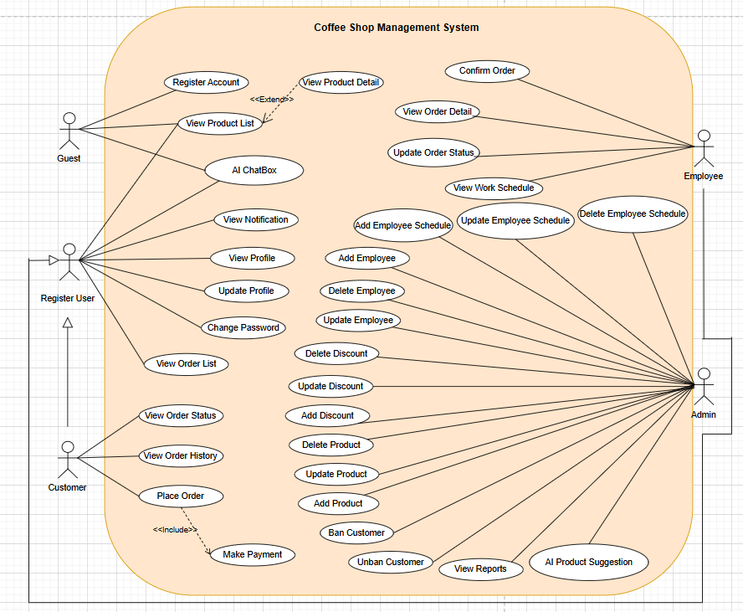
Figure 2. Overview Use Case Diagram

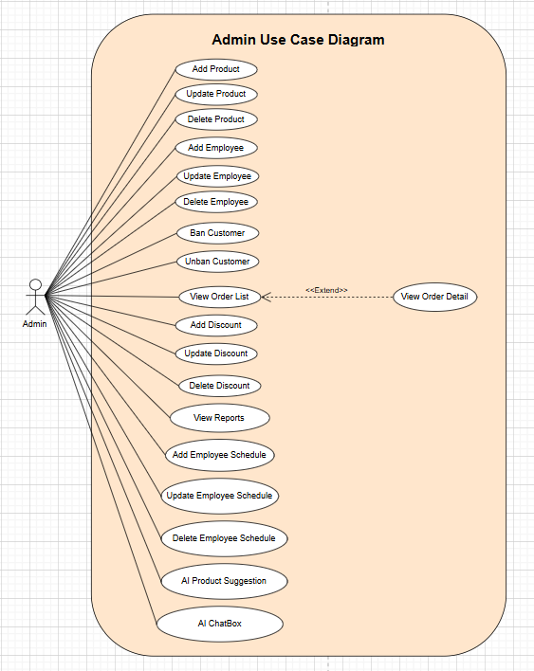
Figure 3. Admin Use Case Diagram

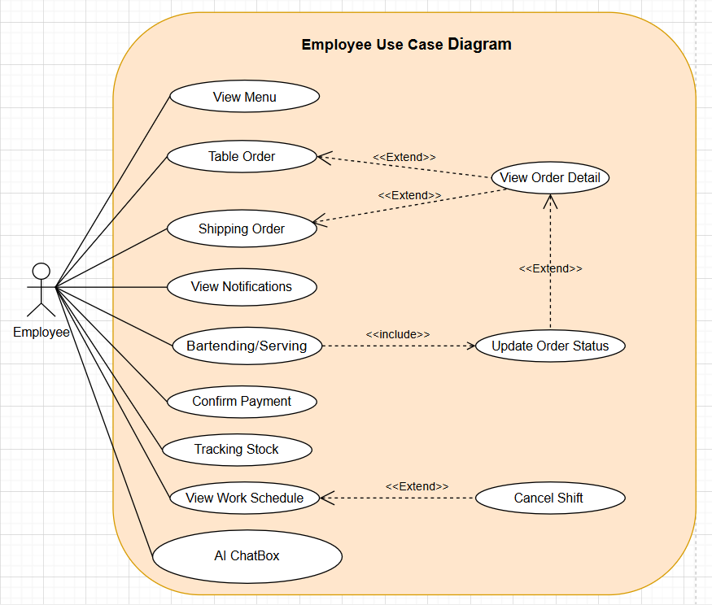
Figure 4. Employee Use Case Diagram

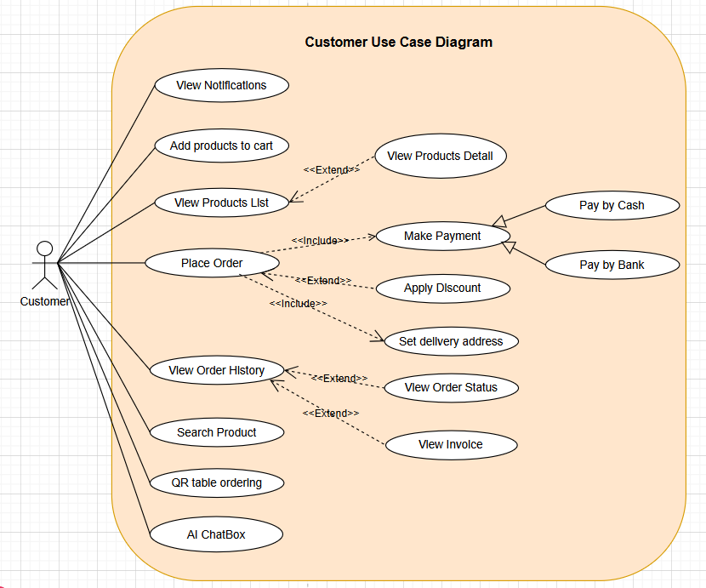
Figure 5. Customer Use Case Diagram

b. Descriptions
ID | Feature | Use case | Description
UC-01 | Authentication | Register | Guest registers a new account to access the system’s features using a unique email address (registration popup and verification email are sent).
UC-02 | Authentication | Login | Customer, Employee, Admin/Manager log in with username/password to access the system.
UC-03 | Authentication | Logout | Customer, Employee, Admin/Manager log out of the system.
UC-04 | Authentication | View Profile | Customer, Employee, Admin/Manager can view their profile after logging in successfully.
UC-05 | Authentication | Edit Profile | Customer, Employee, Admin/Manager can edit their information such as name, date of birth, etc.
UC-06 | Authentication | Change Password | Customer, Employee, Admin/Manager can change their password as long as they enter a valid old password.
UC-07 | Authentication | Forgot Password | Customer, Employee, Admin/Manager who forget their password can request a verification email to get an OTP and then set a new password.
UC-08 | Manage Product | View Menu | All users can view all drinks/food items with prices and descriptions.
UC-09 | Authentication | Login with Google | Customer, Employee, Admin/Manager can log in via an available Google account using a button on the login screen that redirects to Google authentication.
UC-10 | Authentication | Verify Email | Guest, Customer receive an OTP via email after registration and must verify their email before the account is activated.
UC-11 | Process Order | Add product to shopping cart | Customer adds the products they want to buy to the shopping cart.
UC-12 | Manage Order | Order dish | Customer chooses dishes from the menu, adds them to the cart, and confirms the order.
UC-13 | Manage Order | Track the order | Customer checks the current status of the order (pending, in process, completed).
UC-14 | Payment | Payment | Customer makes the payment using cash, e-wallet, card, or QR transfer via PayOS.
UC-15 | Process Order | Bartending / Serving | Employee receives order notifications, prepares beverages, and serves them.
UC-16 | Payment | Confirmation of payment QR transfer | Employee confirms QR transfer payments by checking the transaction list link on PayOS.
UC-17 | Manage Employee | View the work schedule | Employee can view their upcoming work shifts and working hours on the schedule.
UC-18 | Manage Product | Add product | Admin/Manager adds a new item to the menu with price and stock quantity.
UC-19 | Process Order | Search for products | Customer searches for products by entering keywords into the search bar.
UC-20 | Process Order | View invoice | Customer views payment invoice information.
UC-21 | Manage Product | Edit product | Admin/Manager updates product information (name, price, description, stock).
UC-22 | Manage Product | Delete product | Admin/Manager removes (hides) an item from the menu (soft delete).
UC-23 | Report | View the revenue report | Admin/Manager views revenue by day/week/month.
UC-24 | Manage Employee | Work shift assignment | Admin/Manager creates and assigns work shifts for employees.
UC-25 | Manage Account | Manage User | Admin/Manager adds, edits, locks/unlocks user accounts.
UC-26 | Manage Account | Role management | Admin/Manager assigns or changes roles for each account (Customer, Employee, Manager).
UC-27 | Manage Sales | Create promotion | Admin/Manager creates new discount codes or discount events with type (PERCENT/AMOUNT), value, start/end date, usage limit, and applicable products.
UC-28 | Manage Sales | Edit promotion | Admin/Manager updates existing discount codes or discount events (name, value, validity period, status, applicable products).
UC-29 | Manage Sales | Export Excel, PDF of daily revenue | Admin/Manager exports daily sales revenue to Excel or PDF files.
UC-30 | Manage Sales | Revenue chart: day, month, year, quarter | Admin/Manager views revenue charts of the store by day, month, year, and quarter.
UC-31 | Manage Account | Ban / unban user | Admin/Manager bans or unbans users on the platform.
UC-32 | Process Order | QR table ordering | Guest, Customer scan the table’s QR code to open the menu, select items, and create a table order without going to the counter.
UC-33 | Manage System | Manage café tables & QR codes | Admin/Manager views the list of tables, adds/edits tables, changes table status (AVAILABLE/OCCUPIED), and rotates/regenerates QR code for each table.
UC-34 | Manage System | View notification center | Customer, Employee, Admin/Manager view the notification list (with pagination), filter unread notifications, and mark notifications as read.
UC-35 | Manage Order | Track delivery location | Customer, Employee track the real-time location of the shipper and can update the delivery location during shipping.
UC-36 | Manage Employee | Auto-generate work schedules | Admin/Manager automatically generates weekly/monthly work schedules based on recurrence patterns and shift rules, then assigns shifts to employees.
UC-37 | Manage Order | Shipping order | Employee, Shipper handle the shipping process for delivery orders, including updating shipping status and confirming successful delivery.
UC-38 | Manage Employee | View all shifts (admin) | Admin/Manager views all employee shifts for a selected day/week to manage staffing.
UC-39 | Manage Order | View order history | Customer views a list of past orders with status, total amount, and order  details.
UC-40 | Manage Order | Cancel order | Employee cancels an order while it is still in pending or preparing status.
UC-41 | Manage Order | View incoming orders list | Employee views the list of new and in-progress orders that need to be prepared or served.
UC-42 | Agent AI | AI Product Suggestion | System AI searches for hot trending drinks, finds related YouTube videos, extracts basic recipes and video sources, and rates those drinks for admins to review and consider adding to the main menu.
UC-43 | Agent AI | Chatbox AI Assistant | AI chatbox supports all users: admins to manage the coffee shop system (revenue, inventory, etc.) and customers to view suggested menus, get detailed product information, and receive support for ordering.
UC-44 | Process Order | Locate the user's current location | Customer’s current location is detected to choose the delivery destination.
UC-45 | Process Order | Map positioning based on user input | Customer enters or adjusts address on the map to select the delivery destination.
UC-46 | Process Order | View order progress | Customer views order progress, order status, shipper location on the map, and estimated delivery time.

2. Overall Functionalities

2.1 Screens Flow
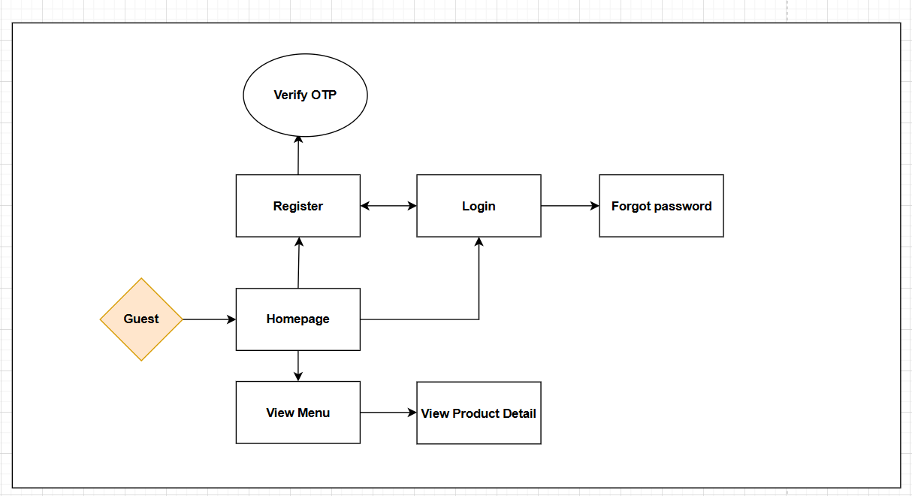
Figure 8. Screen flow Diagram – Guest

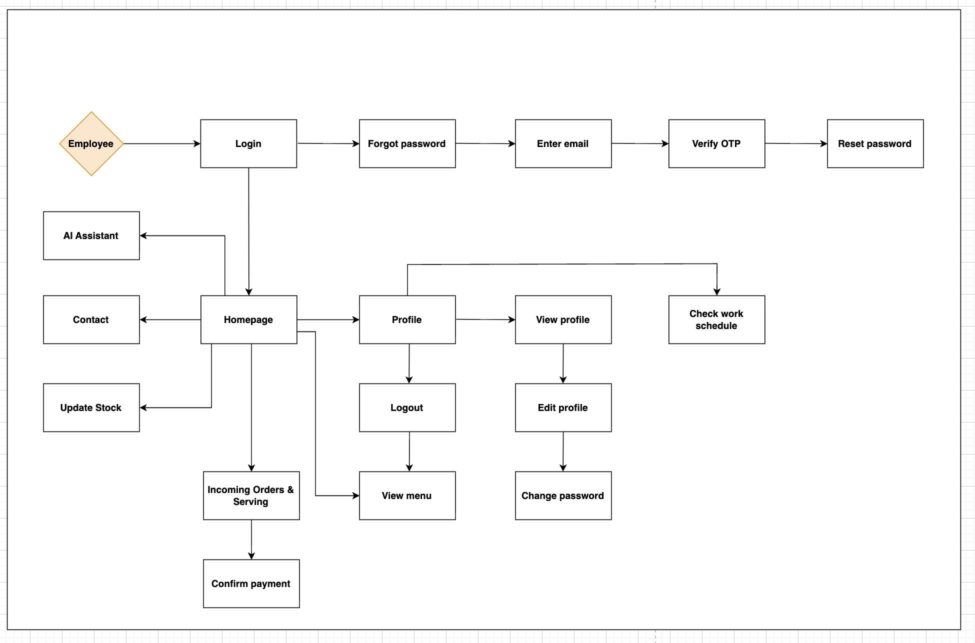
Figure 9. Screen flow Diagram – Employee

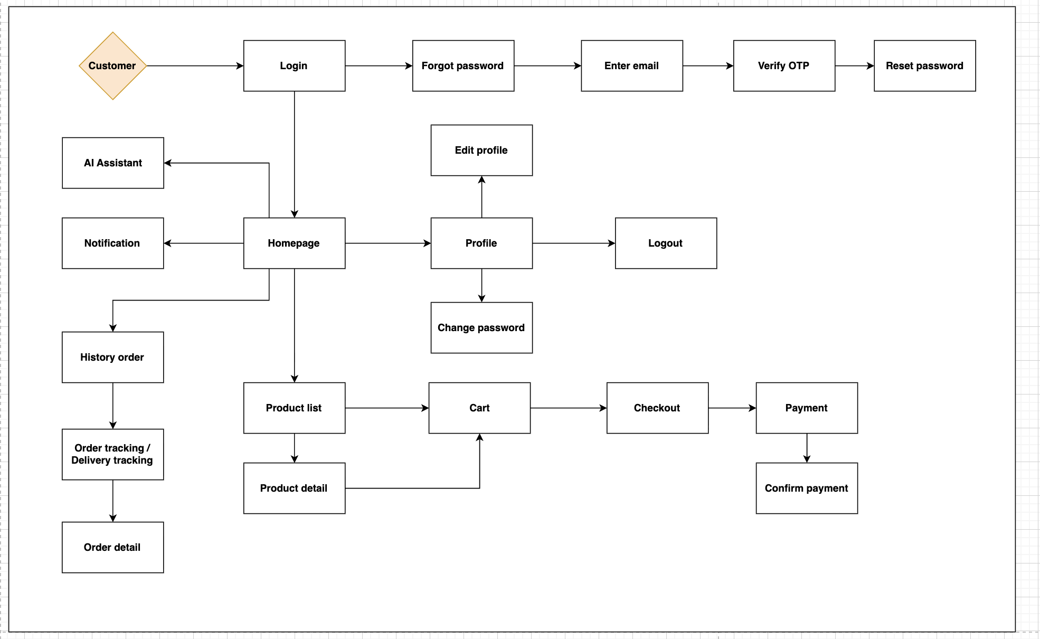
Figure 10. Screen flow Diagram – Customer

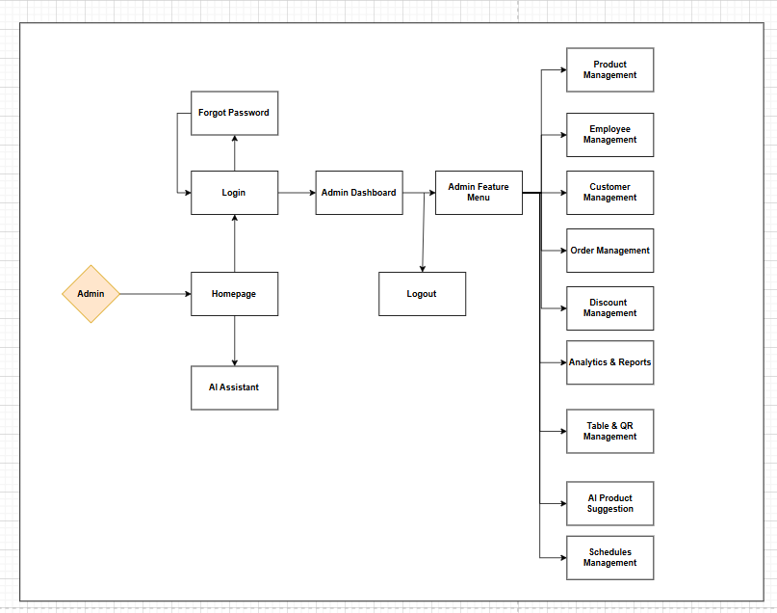
Figure 11. Screen flow Diagram – Admin

2.2 Screen Descriptions
ID | Feature | Screen | Description
1 | Register | Register | Allows users to register new accounts to use the system.
2 | Verify email / Verify OTP | Verify OTP | Allows users to enter the OTP sent to their email to verify and activate the account (after registration or during password reset).
3 | Login | Login | Allows users to log into the system using their registered accounts.
4 | Logout | Logout | Allows users to log out of the system.
5 | Login with Google | Login | Allows users to log in to the system using their Google account.
6 | View Profile | Profile | Allows users to view their personal profile information.
7 | Edit Profile | Edit Profile | Allows users to edit their personal information.
8 | Change Password | Change Password | Allows the user to change their current password.
9 | Forgot Password | Forgot Password | Allows users to recover their password if they forget it.
10 | Add product to shopping cart | Shopping Cart | Allows customers to add selected products to the shopping cart.
11 | View Menu | Menu | Allows customers to view the list of available food and drinks.  When scanning the table QR code, this screen is also used to show the menu for QR table ordering.
12 | Order dish | Ordering Page | Allows customers to place an order for dishes from the menu.
13 | Track the order | Order Tracking | Allows customers to track their orders: view order status, delivery progress, estimated delivery time and, for delivery orders, view the shipper’s current location on the map.
14 | Payment | Payment Page | Allows customers to pay for their orders (cash, card, e-wallet).
15 | Bartending/Serving | Staff Dashboard | Allows staff to view, confirm, and process drink/food orders.  Allows staff to view the incoming orders list, confirm and process orders (prepare, serve or ship), update order status and cancel orders when needed.
16 | Confirm payment | Staff Dashboard | Allows staff to confirm customer payment (cash/card/e-wallet/PayOS QR transfer) and update the payment status.
17 | Update Stock | Stock Management | Allows staff/admin to update product stock after orders.
18 | Check the work schedule | Work Schedule | Allows staff to view their assigned work shifts.
19 | Add product | Product Management | Allows admin to add new products to the menu.
20 | Add to favorites | Favorites | Allows customers to add products to their favorites list.
21 | Search for products using the toolbar | Toolbar Search | Allows customers to search for products by name or category.
22 | View invoice | Invoice Page | Allows customers to view detailed invoices for their orders.
23 | Edit product | Product Management | Allows admin to edit product details such as price or stock.
24 | Delete product | Product Management | Allows admin to delete a product from the system.
25 | View the revenue report | Revenue Report | Allows admin/manager to view sales and revenue reports by day/week/month with filter options; this screen is the base for export and charts.
26 | Work shift assignment | Staff Management | Allows manager to assign shifts and review all employees’ shifts; auto-generated schedules are based on this configuration.
27 | Manage User | User Management | Allows admin to manage user accounts.
28 | Role management | Role Management | Allows admin to assign or edit roles (Admin, Staff, Customer).
29 | Notification Center / View notification | Notification Center | Allows customers, employees and admins to view the notification list, filter unread notifications and mark them as read.
30 | View order history | Order History | Allows customers to view their past orders with status, total amount and link to order detail/invoice.
31 | Table & QR Management | Table & QR Management | Allows admin/manager to view tables, add/edit tables, change status (AVAILABLE/OCCUPIED) and rotate/regenerate QR code for each table.
32 | Export Excel, PDF of daily revenue | Export | Allows admin to export daily revenue reports in Excel/PDF format.
33 | Revenue chart: day, month, year, quarter | Revenue Chart | Allows admin to view visualized revenue statistics.
34 | Add notification | Notification Management | Allows admin to add new notifications for users.
35 | Edit notification | Notification Management | Allows admin to edit existing notifications.
36 | Show and hide notification | Notification Management | Allows admin to show/hide notifications from the system.
37 | Product evaluation | Product Details | Allows customers to evaluate and rate products.
38 | Ban/Unban user | User Management | Allows admin to ban or unban user accounts.
39 | AI Assistant & Analytics Dashboard | Analytics Dashboard | Provides an AI assistant for users (chat support) and AI-based analytics for admins: analyze revenue trends, predict sales and suggest hot, trending drinks (AI Product Suggestion).”

2.3 Screen Authorization
Screen | Guest | Customer | Employee | Admin
Home page | X | X | X | X
Register | X
Login |  | X | X | X
Logout |  | X | X | X
Forgot Password / Verify OTP |  | X | X | X
Profile |  | X | X | X
View Profile |  | X | X | X
Edit Profile |  | X | X | X
Change Password |  | X | X | X
View Menu | X | X | X | X
Add product to cart | X | X
Order dish |  | X
Order history |  | X
Track order |  | X
Payment |  | X
Add to favorites |  | X
Search products (toolbar) | X | X | X | X
View invoice |  | X | X | X
Product evaluation |  | X
Bartending / Serving |  |  | X
Confirm payment |  |  | X
Update stock |  |  | X | X
Check work schedule |  |  | X
Add product |  |  |  | X
Edit product |  |  |  | X
Delete product |  |  |  | X
View revenue report |  |  |  | X
Export Excel/PDF daily revenue |  |  |  | X
Revenue chart (day/month/.. ) |  |  |  | X
Work shift assignment |  |  |  | X
Add/Edit/Show notification |  |  |  | X
Notification Center |  | X | X | X
Manage User |  |  |  | X
Role management |  |  |  | X
Table & QR Management |  |  |  | X
Ban / Unban user |  |  |  | X
AI Assistant (chatbox) | X | X | X | X
AI Suggestion |  |  |  | X

2.4 Non-UI Functions
ID | Feature | System Function | Description
1 | Authentication & OTP Verification | GenerateAndSendOTP | Automatically generates a one-time password (OTP) and sends it to the user’s email for account verification and password reset flows. Supports “Register”, “Verify email” and “Forgot password / Reset password” use cases.
2 | Security Hardening | BlockDevToolsAndScreenshot | Applies client-side and configuration-level restrictions to block or limit the use of browser developer tools (F12) and taking screenshots on sensitive pages, helping to protect business data and system configuration.
3 | Data Backup | AutomaticDatabaseBackup | Periodically backs up the database and important configuration data to a secure storage location, ensuring data can be recovered in case of system failure or data corruption.
4 | System Logging & Auditing | WriteSystemLog | Automatically records important events (login, logout, role changes, user management operations, configuration updates, critical errors) into the system log for monitoring and auditing purposes.
5 | Auto Work Schedule Generation | AutoScheduleGenerator | Uses predefined business rules (shift templates, employee availability, working hours constraints) to automatically generate weekly/monthly work schedules for employees, which are then displayed in the Work Schedule and Staff Management screens.
6 | Delivery Routing & Map Integration | CalculateDeliveryRoute | Integrates with mapping services to calculate delivery routes, estimate delivery time and update shipper location for order tracking, delivery tracking and map positioning functions.
7 | AI Product Suggestion Engine | SuggestTrendingDrinks | Uses AI models and external data sources (such as trending drinks, online content, recipe videos) to suggest new or hot products, including basic recipes and rating references, for admins to consider adding to the main product menu.
8 | AI Revenue Analytics Engine | AnalyzeRevenueTrends | Uses AI/ML techniques to analyze historical revenue data, detect trends, forecast future revenue and provide insights that are displayed on the analytics dashboard for admins (supports AI revenue analytics and AI assistant features).

3. System High Level Design

3.1 Database Design

a. Database Schema
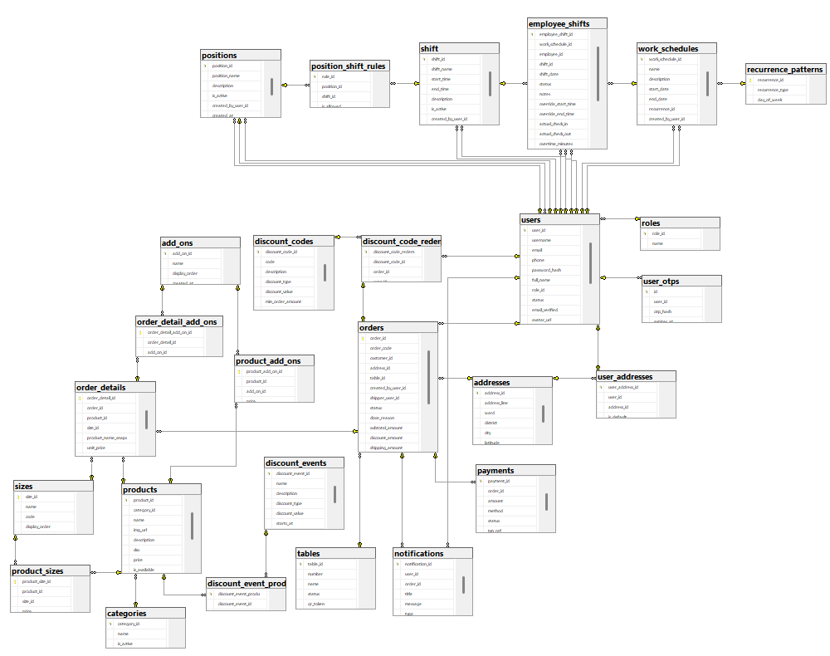

b. Table Descriptions
No | Table | Description
1 | roles | Stores information about user roles, including role name and description.
2 | users | Stores information about users, including username, email, phone, password hash, full name, role ID, position ID, status, avatar URL, creation and update timestamps, and last login time.
3 | addresses | Stores canonical address information, including address line, ward, district, city and creation timestamp.
4 | user_addresses | Manages many-to-many relationships between users and addresses, including user ID, address ID, default status, and creation timestamp.
5 | categories | Stores product categories, including category name, active status, and display order.
6 | products | Stores product details, including category ID, name, image URL, SKU, price, availability, stock quantity, and creation/update timestamps.
7 | orders | Stores order information, including order code, customer ID, address ID, created by user ID, status, close reason, subtotal and discount amounts, computed total amount, note, and creation/update/closed timestamps.
8 | order_details | Stores details of order items, including order ID, product ID, product name snapshot, unit price, quantity, computed line total, and note.
9 | payments | Stores payment records for orders, including order ID, amount, method, status, transaction reference, paid timestamp, and creation timestamp.
10 | discount_events | Stores discount event information, including name, description, discount type, value, start and end timestamps, active status, and creation timestamp.
11 | discount_event_products | Manages many-to-many relationships between discount events and products, including event ID and product ID.
12 | discount_codes | Stores discount code details, including code, description, discount type, value, minimum order amount, start and end timestamps, usage limits, active status, usage count, and creation timestamp.
13 | discount_code_redemptions | Tracks redemptions of discount codes, including code ID, order ID, user ID, and redemption timestamp.
14 | positions | Stores employee position information, including position name, description, active status, created/updated by user IDs, and creation/update timestamps.
15 | shift | Stores shift patterns/templates, including shift name, start and end times, description, active status, created/updated by user IDs, and creation/update timestamps.
16 | recurrence_patterns | Stores recurrence pattern definitions for work schedules, including recurrence type (none/daily/weekly/monthly), day of week for weekly patterns, and interval days.
17 | work_schedules | Stores work schedule definitions, including name, description, start and end dates, recurrence pattern ID, created/updated by user IDs, and creation/update timestamps.
18 | employee_shifts | Stores individual employee shift assignments, including work schedule ID, employee ID, shift ID, shift date, status, notes, override times, actual check-in/out times, overtime minutes, reason, created/updated by user IDs, and creation/update timestamps.
19 | user_otps | Stores one-time password records for user authentication, including user ID, OTP hash, expiration timestamp, and creation timestamp.
20 | sizes | Stores product size options, including size name, code, display order, and creation/update timestamps.
21 | product_sizes | Manages product-size relationships with pricing, including product ID, size ID, price per size, and availability status.
22 | add_ons | Stores add-on/topping options, including name, display order, and creation/update timestamps.
23 | product_add_ons | Manages product-addon relationships with pricing, including product ID, addon ID, price per addon, and availability status.
24 | order_detail_add_ons | Tracks add-ons selected for each order line item, including order detail ID, addon ID, and unit price snapshot.
25 | notifications | Stores user notifications, including user ID, order ID, title, message, notification type, read status, and creation timestamp.
26 | tables | Stores restaurant table information, including table number, name, status, QR token for ordering, and creation/update timestamps.
27 | position_shift_rules | Stores scheduling rules per position and shift, including position ID, shift ID, whether the combination is allowed, and required employee count.

3.2 Code Packages
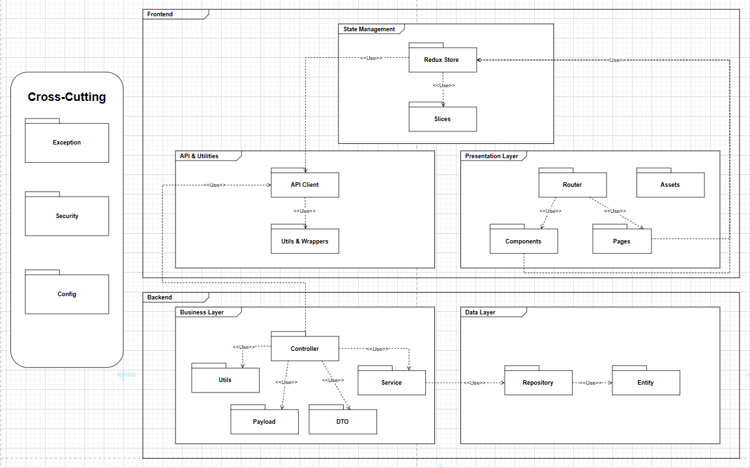
Package Descriptions
No | Package | Description
1 | Presentation Layer | Contains the User Interface components (Pages, Components, Router, Assets), handling the user's interaction with the system and displaying data to users.
2 | Business Layer | Contains the core business logic and processing modules (Controller, Service, Utils, DTO), managing data flow, business rules, and validations.
3 | Data Layer | Manages the data access logic (Repository, Entity), handling storage and retrieval from the database using JPA/Hibernate.
4 | Cross-Cutting - Config | Manages configuration settings and application environment variables across all layers.
5 | Controller | Acts as a bridge between the API Client (Frontend) and Service layer, processing REST API requests and returning responses.
6 | DTO | Contains Data Transfer Objects for transferring data between Business Layer and Data Layer, mapping between Entity and API responses to avoid exposing entity details.
7 | Entity | Represents the database table structures and domain models, mapped using JPA annotations for ORM.
8 | Cross-Cutting - Exception | Manages custom exception classes and global exception handlers for error scenarios across all layers.
9 | Repository | Manages data access repositories using Spring Data JPA, providing CRUD operations and custom queries for database tables.
10 | Cross-Cutting - Security | Handles authentication and authorization logic, including JWT token validation, security filters, and access control across Frontend and Backend.
11 | Service | Implements core business logic services, processing data, applying business rules, and coordinating between Controller and Repository.
12 | Utils (Backend) | Provides utility functions and common services used within the Business Layer, supporting Service and Controller operations.
13 | API Client | Manages HTTP communication between Frontend and Backend, handling REST API requests, responses, interceptors, and error handling.
14 | State Management | Contains Redux Store and Slices (Auth, User, App) managing global application state and dispatching actions to update state across Frontend components.
15 | Redux Store | Central state management container using Redux, managing global application state and coordinating data flow between components.
16 | Slices | Redux slices (Auth Slice, User Slice, App Slice) managing specific domains of application state with reducers and actions.
17 | Pages | Contains top-level page components representing different routes in the application (Dashboard, Login, UserManagement, Reports, etc.).
18 | Components | Contains reusable UI components used across multiple pages (Header, Sidebar, Table, Modal, Forms, Buttons, etc.).
19 | Router | Manages application routing and navigation, defining route configurations, protected routes, and handling navigation between pages and components.
20 | Assets | Contains static resources such as images, icons, fonts, stylesheets (CSS/Tailwind), and other media files used throughout the application.
21 | API & Utilities | Layer grouping API Client and utility functions (Utils & Wrappers) used for Frontend data operations and helper functions.
22 | Utils & Wrappers | Contains utility helper functions (helpers.js, authUtils.js, localStorage.js) and Higher-Order Components/wrappers (protectedRoute, withSearchParams, scrollToTop, documentTitle) for enhancing functionality.
23 | Payload | Contains request/response payload structures and validation schemas used for data transfer between Controller and Service layers in the Backend.
24 | Frontend | The client-side layer of the application containing all UI components, state management, routing, and client-side logic that runs in the user's browser.
25 | Backend | The server-side layer containing business logic, data processing, API endpoints, and database operations that handle requests from the Frontend.

II. Requirement Specifications

1. Authentication

1.1 UC-01_Register

a. Functionalities
UC ID and Name: | UC-01_Register
Created By: | KhoiNN | Date Created: | September 19, 2025
Primary Actor: | Guest | Secondary Actors: | None
Trigger: | Guest clicks on the button “Đăng nhập/đăng ký” pop-up form.
Description: | As a guest I want to register successfully so that I can use the system’s authenticated features.
Preconditions: | Gmail must be unique when they register for the first time.
Postconditions: | Guests can register successfully.
Normal Flow: | 1.0 Register system  - A guest user navigates to the platform and clicks on the "Đăng nhập/Đăng ký" button located in the header.  - The platform opens a pop-up registration form that asks for details such as email, account, password, phone number and role ( Employee, Customer).  - The guest fills in the required information in the form fields (valid email, password, role selection).  - The guest clicks the "Đăng ký" button to submit the form for validation.  - The system validates the register details .  - The system sends a verification code to the registered email address account.  - The system tracks guest’s success register to the Activity Log.  - System accesses the Home Page.
Alternative Flows: | None
Exceptions: | 1.0.E1 Guest entered the wrong format of the fields  - The Error Message screen is shown to the user.  - Guests did not fill in required fields.  - Guests fills in invalid information.  - Customers do not use special characters  - Passwords do not match  1.0.E2 Guest’s email was available in system  - The Error Message screen is shown to the user.  - Email already in use please enter another email
Priority: | High
Frequency of Use: | High
Business Rules: | BR-01, BR-02, BR-03, BR-04, BR-15
Other Information:
Assumptions:

b.Business Rule
ID | Business Rule | Business Rule Description
BR-01 | Wrong email rule | System will notify guest the message MSG01 if they don't fill invalid email address
BR-02 | Wrong password rule | System will notify User the MSG02 if they fill in invalid password ( < 8 regex)
BR-03 | Used email rule | System will notify guest the MSG03 if they had been used email address for register
BR-04 | Wrong Re-entered Password rule | System will notify User the MSG11 if they fill in wrong re-entered password
BR-15 | Wrong code rule | Notify user with () if wrong OTP code is entered by the system sent to registered email

1.2 UC-02_Login

a. Functionalities
UC ID and Name: | UC_02_Login
Created By: | HuyTQ | Date Created: | September 19, 2025
Primary Actor: | Customer | Secondary Actors: | Employee, Admin
Trigger: | Guest clicks on the button “Đăng nhập/đăng ký” pop-up form.  Click on the ”đăng nhập”
Description: | The user (customer/employee/admin) wants to perform a certain operation in this coffee shop system corresponding to his role, and the first thing the user has to do with the system is to use the LOGIN function.
Preconditions: | An existing account
Postconditions: | Users can login successfully.
Normal Flow: | 2.0 Login system  1. The user accesses the login page via the homepage of the website.  2. The user enters a valid account, inputs a valid username and password.  (Alternative 2a, 2b)  3. The user presses Enter to start the login process.  4. The system verifies the existing account in the database and redirects the user to the dashboard page corresponding to his/her role.  [Exception 4a]  5. The system records the login session into the log file/database.
Alternative Flows: | 2 Google Login  2.1 The user clicks “Login with Gmail”  2.2 The system will open the Gmail login window  2.3 The user enters a valid Gmail account to be verified by the Gmail system  2.4 Gmail returns the successful login status to our system
Exceptions: | 4a System can’t authenticate the user  4a.1 The system displays/throws an error message: “Invalid password, must not be empty"  4a.2 The system redirects the user back to the “empty” login page  4a.3 If the wrong account is entered more than 5 times the system suggests the [RESET PASS] function
Priority: | High
Frequency of Use:
Business Rules: | BR-05, BR-06, BR-07, BR-08, BR-09, BR-10
Other Information:
Assumptions:

b.Business Rule
ID | Business Rule | Business Rule Description
BR-05 | Notification about login information rule | -System will notify User the MSG04 and redirect to the guest homepage if they fill the wrong registered account and password.  -System will notify User the MSG05 and redirect to user homepage if they fill correct registered account and password
BR-06 | Login-email address Rule | In case email address has been successfully registered with password on the system registration form, when logging in using email address login method, it still accesses that account.
BR-07 | Role choosing Form Rule | -This form only appears for email address when logging into the system for the first time (no role yet). The recommended role is Employee/Customer.  -This form does not apply to Admin accounts.
BR-08 | Forgot Password Suggestion Rule | If you log in incorrectly more than 5 times in a row, the system will suggest forgetting your password.
BR-09 | Concurrent Login Rule | An account is not allowed to log in on multiple devices at the same time.
BR-10 | Credential Validation Rule | The system must check the validity of the username and password, it cannot be empty.

1.3 UC-03_Logout

a. Functionalities
UC ID and Name: | UC-03_Logout
Created By: | HuyTQ | Date Created: | September 19, 2025
Primary Actor: | Admin, Employee, Customer | Secondary Actors:
Trigger: | Admin, Employee, Customer click on “Đăng xuất”
Description: | As a user, I want to be able to log out of the system so that I can change other accounts.
Preconditions: | Users are logged in successfully as the actor above.
Postconditions: | - Users can log out successfully.  - End up the user's session.
Normal Flow: | 3.0 Logout  - Users clicks on the avatar on the header.  - Users click on the button “Đăng xuất” on the header.
Alternative Flows: | None.

Exceptions: | None.
Priority: | High
Frequency of Use:
Business Rules: | None.
Other Information:
Assumptions:

b.Business Rule
None

1.4 UC-04_View profile

a. Functionalities
UC ID and Name: | UC-04_View profile
Created By: | DucTV | Date Created: | September 19, 2025
Primary Actor: | Admin, Employee, Customer | Secondary Actors:
Trigger: | Users click on the ”Thông tin”
Description: | As a user, I want to be able to view profile so that I can know exactly my specification
Preconditions: | Users logged in successfully as the actor above.
Postconditions: | Users can view detail information of their own accounts
Normal Flow: | 4.0 View profile system  - Users click on the avatar in the header.  - Users click on the ”Thông tin”
Alternative Flows: | None.
Exceptions: | None.
Priority: | High
Frequency of Use:
Business Rules: | None
Other Information:
Assumptions:

b.Business Rule
None

1.5 UC-05_Edit profile

a. Functionalities
UC ID and Name: | UC-05.1_Edit profile
Created By: | DucTV | Date Created: | September 19, 2025
Primary Actor: | Admin, Employee, Customer | Secondary Actors:
Trigger: | Users has clicked on “Thông tin tài khoản” on the platform
Description: | As a user, I want to be able to change my account so that I can change my avatar.
Preconditions: | Users logged in successfully as actor above.
Postconditions: | Users can update information successfully.
Normal Flow: | 4.1.0 Edit profile system  - Users click on the avatar in the header.  - Users click on the ”Thông tin”  - Users click on the ”Chỉnh sửa thông tin”
Alternative Flows: | 4.1.1 Edit profile system  - Users click on the avatar in the header.  - Users click on the ”Sửa thông tin”
Exceptions:
Priority: | High
Frequency of Use:
Business Rules: | BR-16
Other Information:
Assumptions:

b.Business Rule
ID | Business Rule | Business Rule Description
BR-16 | Upload profile successfully rule | System will notify guest the MSG06 if they update new profile and database successfully

1.6 UC-06_Change password

a. Functionalities
UC ID and Name: | UC-06_Change password
Created By: | DuyVN | Date Created: | September 19, 2025
Primary Actor: | Admin, Employee, Customer | Secondary Actors:
Trigger: | Users click on “Đổi mật khẩu”
Description: | As a user, I want to be able to change my password so that I can update new password
Preconditions: | Users logged in successfully as the actor above.
Postconditions: | ● Users can change passwords successfully.  ● Users can use new password to login
Normal Flow: | 4.2.0 Change password system  - Users click on the avatar in the header.  - Users click on the ”Sửa thông tin”
Alternative Flows: | 4.2.1 Change password system  - Users click on the avatar in the header.  - Users click on the ”Sửa thông tin”
Exceptions:
Priority: | High
Frequency of Use:
Business Rules: | BR-02, BR-12, BR-11, BR-13, BR-04, BR14
Other Information:
Assumptions:

b.Business Rule
ID | Business Rule | Business Rule Description
BR-02 | Wrong password rule | System will notify User the MSG02 if they fill in invalid password ( < 8 regex)
BR-12 | Wrong old password rule | System will notify users the message MSG06 if they don’t fill correct old password of account
BR-11 | Upload password successfully rule | The system must send an email notification to the user if password update and database save is successful.
BR-13 | Wrong username | Notify user with (), need to enter correct account name to change password when not logged into the system
BR-04 | Wrong re-enter password | System will notify users of the message MSG11 if the re-entered password is incorrect.
BR-14 | Wrong new password | System will notify users the message MSG22 if the re-entered password is the same as the old password.

1.7 UC-07_Forgot password

a. Functionalities
UC ID and Name: | UC-07_Forgot password
Created By: | DuyVN | Date Created: | September 19, 2025
Primary Actor: | Admin, Employee, Customer | Secondary Actors:
Trigger: | User click on “Quên mật khẩu” on form login
Description: | As a user, I want to retrieve my password using email address so that I can update a new password when I forget it.
Preconditions: | User have already had account
Postconditions: | User is logged in successfully with new password
Normal Flow: | Change password system  - The user clicks on”Đăng nhập/Đăng ký”in the header  - The user click on the ”Quên mật khẩu”  - The user enters the created username and email used to create the account.  - The user presses Enter to start the password recovery process  - The system checks the existing account in the database and sends the account information to the user's email [Exception 5a]
Alternative Flows: | None
Exceptions: | 5a System can't authenticate the user  5a.1 The system displays/returns an error message: “Invalid username or email, cannot be blank”  5a.2 The system returns to the page asking for re-entering authentication information
Priority: | High
Frequency of Use:
Business Rules: | BR-17, BR-18
Other Information:
Assumptions:

b.Business Rule
ID | Business Rule | Business Rule Description
BR-17 | Forgotten Account’s Gmail rule | If email address has never registered before, the system will display message MSG07.
BR-18 | Security Notification Rule | The system sends a notification to the user that the password has been sent via email, and recommends that the password be changed immediately after logging in again.

1.8 UC-08_Login with Google

a. Functionalities
UC ID and Name: | UC-8_Login with Google
Created By: | DatPT | Date Created: | September 19, 2025
Primary Actor: | Admin, Employee, Customer | Secondary Actors: | Google OAuth Service
Trigger: | User clicks "Login with Google" on the login popup/page.
Description: | As a user, I want to log in to the system using my Google account, so I don’t have to remember a separate password.
Preconditions: | User has an existing Google account.  The Google API is connected and available.
Postconditions: | User is successfully logged into the system using Google OAuth.  User account is automatically linked or created in the local database.
Normal Flow: | Login with Google system:  - User opens the login page.  - User clicks “Login with Google”.  - System redirects to Google OAuth login page.  - User enters Google credentials and grants permissions.  - Google returns authentication token to the system.  - System verifies token and logs user in.  - System redirects user to the homepage.
Alternative Flows: | If user denies permissions, the system shows an error message and remains on the login page.
Exceptions: | Google OAuth API unavailable.  Internet connection error.
Priority: | High
Frequency of Use: | Frequent
Business Rules: | BR-01, BR-06, BR-07, BR-17
Other Information: | This use case integrates with Google OAuth 2.0 API for authentication.  The system should log all login attempts for security tracking.
Assumptions: | Internet connection is stable.  The Google API client ID and secret key are properly configured.

b.Business Rule
ID | Business Rule | Business Rule Description
BR-01 | Invalid Email Rule | Notify Guests with MSG01 if they don't provide a valid email address.
BR-06 | Gmail Account Link Rule | If a Gmail account is registered with a password, the same account is accessed when using Gmail login.
BR-07 | Role Selection Rule | Role selection form appears for first-time login (Employer/Customer), not applied for Admin accounts.
BR-17 | Forgotten Account’s Gmail rule | If email address has never registered before, the system will display message MSG07.

2. Process Order

2.1 UC-11_Add product to shopping cart

a. Functionalities
UC ID and Name: | UC-11_Add product to shopping cart
Created By: | DuyVN | Date Created: | September 19, 2025
Primary Actor: | Customer | Secondary Actors:
Trigger: | User clicks “Add to cart” on a product/listing page.
Description: | As a customer, I want to add selected products to my shopping cart so that I can purchase multiple items in a single order.
Preconditions: | The user is logged in as a Customer.  The product exists in the database and is available for sale (stock > 0).
Postconditions: | The selected product is successfully added to the user’s shopping cart.  The system updates the total number of items and the total price in the cart.
Normal Flow: | Add product system  - The customer views the product list or product detail page.  - The customer clicks the “Add to Cart” button for the desired product.  - The system checks the product’s availability and stock quantity.  - If available, the system adds the product to the customer’s shopping cart.  - The system displays a confirmation message and updates the cart icon to show the total items.  - The user may continue browsing or proceed to checkout.
Alternative Flows: | - If the selected product’s quantity is 0 or below,  - The system displays MSG23: “Product already exists” or a stock-related message such as “Product out of stock”.
Exceptions: | If the system cannot retrieve product information due to a connection issue,  - The system displays MSG17: “Database connection error when performing an action.”  - The product is not added to the cart.
Priority: | High
Frequency of Use: | Very often
Business Rules: | BR-22, BR-25, BR-28, BR-33
Other Information:
Assumptions:

b.Business Rule
ID | Business Rule | Business Rule Description
BR-22 | Database Connection Error Rule | Notify with MSG17 if there is a database connection error when displaying or updating user information.
BR-28 | Inventory Quantity Rule | Inventory quantity must be an integer ≥ 0.
BR-25 | Product Status Rule | Update product status to “Available” or “Out of Stock” depending on inventory.
BR-33 | Order Display Rule | For each order, system must show product name, quantity, price, and total value.

2.2 UC-15_Bartending/Serving

a. Functionalities
UC ID and Name: | UC-15_Bartending/Serving
Created By: | KhoiNN | Date Created: | September 19, 2025
Primary Actor: | Employee | Secondary Actors:
Trigger: | A new order is placed by a customer..
Description: | As an employee, I want to view and process incoming orders so that I can prepare and serve the drinks/food accurately and on time.
Preconditions: | There are pending orders in the system.  The employee is logged in with valid credentials.
Postconditions: | The order status is updated (“In Progress” → “Completed”).
Normal Flow: | 15. Bartending/Serving system:  - The employee logs in and opens the order management screen.  - The system displays all pending orders.  - The employee selects an order to process.  - The system updates the order status to “In Process”.  - Once preparation is complete, the employee updates status to “Completed”.  - The system records the completion time and updates the order log.
Alternative Flows: | 15a. Missing Ingredients  - If an item cannot be prepared due to missing stock,  - The employee marks the order as “Cannot Prepare”.  - The system notifies the manager or inventory staff.
Exceptions: | 15. Network or DB Failure  - The system displays MSG17: “Database connection error.”
Priority: | High
Frequency of Use: | Often
Business Rules: | BR-45, BR-46, BR-47, BR-48
Other Information:
Assumptions:

b.Business Rule
ID | Business Rule | Business Rule Description
BR-45 | Order Status Rule | Orders must go through all valid statuses (“Pending”, “In Process”, “Completed”).
BR-46 | Time Log Rule | System must log start and finish time for every order.
BR-47 | Inventory Update Rule | Deduct used ingredients from inventory after completion.
BR-48 | Notification Rule | Notify admin when a product cannot be made due to shortage.

2.3 UC-20_Add to favorites

a. Functionalities
UC ID and Name: | UC-20_Add to favorites
Created By: | DuyVN | Date Created: | September 19, 2025
Primary Actor: | Customer | Secondary Actors:
Trigger: | User clicks “Favorite” on a product.
Description: | As a customer, I want to save my favorite items so I can quickly find and order them later.
Preconditions: | The user is logged in.  The product exists in the system.
Postconditions: | The item is added to the customer’s favorite list.
Normal Flow: | 20. Add to favorites system:  - The user browses the product list.  - The user clicks “Add to Favorites”.  - The system saves the product to the user’s favorite list.  - The system displays confirmation (“Added to Favorites”).
Alternative Flows: | 20a – Already in Favorites  - If product is already saved, system shows message MSG24: “Item already exists in your favorites.”
Exceptions: | 20b – Database Connection Error  - System displays MSG17: “Database connection error.
Priority: | Medium
Frequency of Use: | Often
Business Rules: | BR-40, BR-41
Other Information:
Assumptions:

b.Business Rule
ID | Business Rule | Business Rule Description
BR-40 | Favorites Limit Rule | Maximum 50 favorite items per user.
BR-41 | Duplicate Favorite Rule | Cannot add the same product twice.

2.4 UC-21_Search for products

a. Functionalities
UC ID and Name: | UC-21_Search products
Created By: | KhoiNN | Date Created: | September 19, 2025
Primary Actor: | All Users | Secondary Actors:
Trigger: | User enters a keyword in the search bar.
Description: | As a user, I want to search for products by name or category so I can quickly find what I want.
Preconditions: | Products exist in the system.
Postconditions: | The system displays products that match the search criteria.
Normal Flow: | Search products system:  - The user types keywords in the search bar.  - The system retrieves matching results from the database.  - The system displays all matched products with name, price, and image.
Alternative Flows: | 21a – No Results Found  - If no matching products exist, system shows MSG25: “No products found.”
Exceptions: | 21b – Network Error  - System displays MSG17: “Database connection error.”
Priority: | High
Frequency of Use: | Very often
Business Rules: | BR-31, BR-32
Other Information:
Assumptions:

b.Business Rule
ID | Business Rule | Business Rule Description
BR-31 | Search Accuracy Rule | Search results must match keywords by name or category.
BR-32 | Display Order Rule | Results displayed alphabetically or by relevance.

2.5 UC-22_View invoice

a. Functionalities
UC ID and Name: | UC-22_View invoice
Created By: | HuyTQ | Date Created: | September 19, 2025
Primary Actor: | Customer, Admin/Manager | Secondary Actors:
Trigger: | User clicks on “View Invoice” after order completion.
Description: | As a user, I want to view my order invoice so that I can review order details, total cost, and payment status.
Preconditions: | An order has been completed.  Invoice is generated by the system.
Postconditions: | The user can view or download the invoice in PDF or Excel format.
Normal Flow: | 22. View invoice system:  - The user opens the “Order History” section.  - The system displays completed orders.  - The user selects one order and clicks “View Invoice”.  - The system retrieves invoice details and displays them.  - The user can choose to print or download the invoice file.
Alternative Flows: | No
Exceptions: | 22b – Database Connection Error  - System displays MSG17: “Database connection error.”
Priority: | High
Frequency of Use: | Very Often
Business Rules: | BR-35, BR-36, BR-37
Other Information:
Assumptions:

b.Business Rule
ID | Business Rule | Business Rule Description
BR-35 | Invoice Storage Rule | Each order must have a unique invoice saved in the system.
BR-36 | Export File Format Rule | Invoices can be exported in PDF or Excel format.
BR-37 | Invoice Access Rule | Only the customer and manager can access the invoice.

3. Manage Account

3.1 UC-27_Manage User

a. Functionalities
UC ID and Name: | UC-27_Manage User
Created By: | DucTV | Date Created: | September 19, 2025
Primary Actor: | Admin/Manager | Secondary Actors: | System Database
Trigger: | Admin or Manager clicks on the “User Management” section in the system dashboard.
Description: | As an Admin or Manager, I want to add, edit, view, and lock/unlock user accounts so that I can control system access and maintain user account integrity.
Preconditions: | The Admin/Manager is successfully logged into the system.  The system database connection is active.
Postconditions: | User accounts are successfully added, edited, locked, or unlocked as requested.  Any updates are saved to the database and visible immediately.
Normal Flow: | 27.1 Manage User Process:  - Admin/Manager accesses the “User Management” page from the dashboard.  - The system displays the list of all users in the database.  - Admin/Manager can perform the following actions:  - Add new user: fill in full name, email, phone number, and address.  - Edit user: update role, contact info, or account status.  - Lock/Unlock user: temporarily restrict or restore login access.  - When the Admin/Manager clicks “Save”, the system displays a confirmation pop-up (MSG21) before applying changes.  - Upon confirmation, the system updates the database and displays a success message.
Alternative Flows: | 27.1a Missing or Incomplete Information  - If the Admin/Manager tries to add or edit a user without providing all required fields (full name, email, phone, address),  - The system displays MSG13: “Information is incomplete.”  27.1b Locked Account Login Attempt:  - If a locked user tries to log in,  - The system prevents login and displays a notification according to BR-42.
Exceptions: | 27.1c Database Connection Error:  27a.If the system fails to retrieve or update user data:  - The system displays MSG17: “Database connection error when performing an action.”  27.1d Unauthorized Access Attempt:  27b.If a non-admin user tries to access the “Manage User” module:  - The system denies access and logs the event.
Priority: | High
Frequency of Use: | Moderate
Business Rules: | BR-13, BR-22, BR-41, BR-42, BR-43
Other Information: | All account changes are logged for audit purposes (time, actor, action).  The system may implement pagination and search filters for user lists.  “Manager” roles can only view or edit customers and employees, not admins.
Assumptions: | The Admin/Manager has a stable connection and full permissions.  All user data follows the organization’s data security policy.

b.Business Rule
ID | Business Rule | Business Rule Description
BR-13 | Correct Account Name Rule | Notify with MSG15 if the account name is invalid when attempting account updates.
BR-22 | Data Integrity Rule | Notify with MSG17 if a database connection error occurs when displaying or updating user information.
BR-41 | Role Change Authorization | Only Admins have the right to change the “Employee” role.
BR-42 | Locked Account Rule | Locked accounts cannot log in until the Admin unlocks them.
BR-43 | Admin Account Control Rule | Only Admins can add, edit, delete, view information, or lock employee accounts.

3.2 UC-28_Role Management

a. Functionalities
UC ID and Name: | UC-28_Role Management
Created By: | DucTV | Date Created: | September 19, 2025
Primary Actor: | Admin/Manager | Secondary Actors: | System Database
Trigger: | Admin/Manager selects the “Role Management” feature from the dashboard or user management page.
Description: | As an Admin or Manager, I want to assign or change roles for user accounts (Customer, Employee, Manager) so that users can have appropriate access rights and system permissions.
Preconditions: | Admin/Manager is logged in with proper privileges.  User data is available in the database.
Postconditions: | Selected users have their roles successfully updated in the system.  All role change actions are logged for audit tracking.
Normal Flow: | 28.1 Role Management Process  - Admin/Manager opens the Role Management page or the user details section.  - The system displays all user accounts with their current roles.  - Admin/Manager selects a specific user and clicks on “Change Role.”  - The system shows available roles: Customer, Employee, Manager.  - Admin/Manager chooses a new role for the user.  - The system displays a confirmation message (MSG21): “Do you want to change this user’s role?”  - Upon confirmation, the system updates the user’s role in the database.  - The system displays a success message and refreshes the list.
Alternative Flows: | 28.1a Unauthorized Role Change  - If a Manager attempts to change an Admin’s role,  - The system denies the action according to BR-41, and displays an access restriction message.  28.1b Incomplete Information  - If Admin/Manager does not select a user or role before saving,  - The system displays MSG13: “Information is incomplete.”  28.1c Cancel Confirmation  - If Admin/Manager clicks “Cancel” on the confirmation dialog,  - The role update is aborted and no changes are made.
Exceptions: | 28.1d Database Connection Error  - If the system cannot update the user’s role,  - The system displays MSG17: “Database connection error when performing an action.”  28.1e Invalid User Selection  - If the chosen user no longer exists in the system,  - The system displays a message notifying that the user record is not found.
Priority: | High
Frequency of Use: | Moderate
Business Rules: | BR-07, BR-40, BR-41, BR-43
Other Information: | Every role change triggers a system log entry containing user ID, old role, new role, and timestamp.  Role management directly impacts system access (e.g., Employee cannot access Admin Dashboard).
Assumptions: | Admin/Manager has full permission to access and update user roles.  System operates with a stable internet connection and synchronized database.

b.Business Rule
ID | Business Rule | Business Rule Description
BR-07 | Validation Rule | System validates data before saving to ensure no empty fields.
BR-40 | User Role Restriction Rule | Admin cannot assign an invalid or duplicate role to a user..
BR-41 | Role Change Authorization | Only Admins have the right to change “Employee” or “Manager” roles.
BR-43 | Admin Account Control Rule | Only Admins can manage employee accounts and their roles.

3.3 UC-38_Ban/Unban User

a. Functionalities
UC ID and Name: | UC-38_Ban/Unban User
Created By: | DatPT | Date Created: | September 19, 2025
Primary Actor: | Admin/Manager | Secondary Actors: | System Database
Trigger: | Admin/Manager selects the “Manage Account” feature and chooses a user to ban or unban.
Description: | As an Admin or Manager, I want to temporarily ban or unban a user so that I can control user access when inappropriate activity or policy violations occur.
Preconditions: | Admin/Manager is logged in with proper privileges (Admin role is typically required for banning/unbanning sensitive accounts). User data is available in the database.
Postconditions: | Selected user has their account status (banned/unbanned) successfully updated in the system. The ban/unban action is logged for audit tracking.
Normal Flow: | 38.1 Ban/Unban Process  - Admin/Manager opens the User Management page.  - The system displays all user accounts with their current status (Active/Banned).  - Admin/Manager selects a specific user and clicks on the “Ban” or “Unban” button.  - The system displays a confirmation message: MSG21 ("Bạn có muốn lưu thay đổi").  - Upon confirmation, the system updates the user’s status in the database (e.g., set is banned = true/false).  - The system displays a success message and refreshes the list.
Alternative Flows: | 38.1a Unauthorized Ban/Unban:  - If a Manager attempts to ban/unban an Admin account, the system denies the action based on privileges and displays an access restriction message.  38.1b Incomplete Selection:  - If Admin/Manager attempts to perform the action without selecting a user, the system displays MSG13 ("Hãy điền đầy đủ thông tin").  38.1c Cancel Confirmation:  - If Admin/Manager clicks “Cancel” on the confirmation dialog, the action is aborted and no changes are made.
Exceptions: | 38.1d Database Connection Error:  - If the system cannot update the user’s status, the system displays MSG17 ("Lỗi kết nối cơ sở dữ liệu").  38.1e Invalid User Selection:  - If the chosen user no longer exists in the system, the system displays a message notifying that the user record is not found.
Priority: | High
Frequency of Use: | Moderate
Business Rules: | BR-13, BR-17, BR-21, BR-42, BR-43
Other Information: | A banned account status prevents the user from logging in (BR-42). Only Admins can manage employee accounts and their roles/statuses (BR-43).
Assumptions: | Admin/Manager role is properly defined with ban/unban permissions. System maintains a stable database connection.

b.Business Rule
ID | Business Rule | Business Rule Description
BR-13 | Validation | Notify User with MSG13 ("Hãy điền đầy đủ thông tin"), the system must check the validity of the username and password, it cannot be empty.
BR-17 | Notification | Notify User with MSG17 ("Lỗi kết nối cơ sở dữ liệu"), Database connection error when performing an action.
BR-21 | Action-Enable | Display MSG21 ("Bạn có muốn lưu thay đổi") - confirmation pop-up for changes.
BR-42 | Action-Enable | Locked accounts (Banned) cannot be logged in until the Admin unlocks them.
BR-43 | Notification | Notify with MSG21 ("Bạn có muốn lưu thay đổi"), Only Admin is allowed to add, edit, delete, view information or lock employee accounts.

4. Manage Order

4.1 UC-12_Order dish

a. Functionalities
UC ID and Name: | UC-12_Order dish
Created By: | DuyVN | Date Created: | September 19, 2025
Primary Actor: | Customer | Secondary Actors: | System Database, Employee
Trigger: | Customer has items in the cart and proceeds to checkout/confirmation.
Description: | As a Customer, I want to choose dishes from the menu, add them to the cart, and confirm the order so that I can purchase food/drinks.
Preconditions: | Customer is logged in or continues as a guest. Menu items are available in the system.
Postconditions: | A new order record is created in the database with "Pending" status. The order is passed to the Employee for processing (MSG19 is sent to the employee).
Normal Flow: | 12.1 Order Creation Process:  - Customer views the menu (UC-08_View Menu).  - Customer selects a dish, specifies quantity, and adds it to the cart.  - Customer proceeds to the cart/checkout page.  - Customer reviews the order details (product list, total price) (BR-33).  - Customer provides necessary shipping/payment information (if not logged in, or if required).  - Customer clicks “Confirm Order.”  - The system validates the order information (e.g., no empty fields - BR-13 / MSG13).  - The system creates the order record, sets the status to "Processing" or similar (BR-25), and deducts stock.  - The system sends a notification to the relevant Employee about the new order (MSG19 / BR-47).10.The system displays a success message and redirects the customer to the order tracking page.
Alternative Flows: | 12.1a Incomplete Information:  - If Customer does not fill in mandatory fields (e.g., address, phone) during checkout, the system displays MSG13 ("Hãy điền đầy đủ thông tin") (BR-13).  12.1b Cancel Confirmation:  - If Customer cancels the order during the confirmation step, the process is aborted.
Exceptions: | 12.1c Database Connection Error:  - If the system cannot create the order, the system displays MSG17 ("Lỗi kết nối cơ sở dữ liệu") (BR-17).  12.1d Out of Stock:  - If an item in the cart is suddenly out of stock, the system displays an appropriate message and prompts the customer to adjust the cart.
Priority: | High
Frequency of Use: | High
Business Rules: | BR-13, BR-17, BR-25, BR-33, BR-47
Other Information: | Successful order creation triggers a status update (BR-25). Order detail display must adhere to BR-33.
Assumptions: | Inventory is tracked and accurate. Payment step is integrated or assumed completed..

b.Business Rule
ID | Business Rule | Business Rule Description
BR-13 | Validation | Notify User with MSG13 ("Hãy điền đầy đủ thông tin"), the system must check the validity of the username and password, it cannot be empty.
BR-17 | Notification | Notify User with MSG17 ("Lỗi kết nối cơ sở dữ liệu"), Database connection error when performing an action.
BR-25 | Status | Update job status to “Chờ thanh toán”/”Đang làm việc”/ "Đã giao hàng"/" Đã hoàn thành".
BR-33 | Validation | For each order, the system must display at least: Order ID, Order Date, Product List, Quantity and Price of Each Product, Total Order Value, Order Status (Processing, Delivering, Completed, Cancelled).
BR-47 | Notification | Notify with MSG19 ("Bạn có một đơn hàng mới cho công việc"), Notify staff when new orders are created.

4.2 UC-13_Track the order

a. Functionalities
UC ID and Name: | UC-13_Track the order
Created By: | DuyVN | Date Created: | September 19, 2025
Primary Actor: | Customer | Secondary Actors: | System Database
Trigger: | Customer selects the “Order History” or “Track Order” feature.
Description: | As a Customer, I want to check the current status of my order (pending, in process, completed) so that I can know when to expect it.
Preconditions: | Customer is logged in and has placed at least one order. The order status has been updated by the system or staff.
Postconditions: | Customer is successfully displayed their current and past order status and details.
Normal Flow: | 13.1 Order Tracking Process:  - Customer navigates to the “Order History” page.  - The system retrieves and displays the customer's orders, sorted by date descending (BR-34).  - For each order, the system displays key details including Status (BR-25, BR-33).  - Customer clicks on a specific order to view details.  - The system displays the full order details (line items, total value, status log) to the account owner only (BR-35).
Alternative Flows: | 13.1a No Orders Found:  - If the customer has no order history, the system displays an informational message (e.g., “You have no orders yet”).  13.1b Unauthorized Access:  - If a user tries to access another customer's order, the system denies access (BR-32).
Exceptions: | 13.1c Database Connection Error:  - If the system cannot retrieve order data, the system displays MSG17 ("Lỗi kết nối cơ sở dữ liệu") (BR-17).
Priority: | High
Frequency of Use: | Moderate
Business Rules: | BR-17, BR-25, BR-32, BR-33, BR-34, BR-35
Other Information: | Customers can only view their own orders (BR-32, BR-35).
Assumptions: | The system correctly links orders to the placing customer account.

b.Business Rule
ID | Business Rule | Business Rule Description
BR-17 | Notification | Notify User with MSG17 ("Lỗi kết nối cơ sở dữ liệu"), Database connection error when performing an action.
BR-25 | Status | Update job status to “Chờ thanh toán”/”Đang làm việc”/ "Đã giao hàng"/" Đã hoàn thành".
BR-32 | Action-Enable | Customers are only allowed to view their own order history, not other people's orders.
BR-33 | Validation | For each order, the system must display at least: Order ID, Order Date, Product List, Quantity and Price of Each Product, Total Order Value, Order Status (Processing, Delivering, Completed, Cancelled).
BR-34 | Action-Enabler | Order history should be sorted by order date descending (newest first).
BR-35 | Action-Enable | Order information is only displayed to the account owner. Email and phone number of others (if included in the order) are not disclosed.

5. Manage Product

5.1 UC-08_View Menu

a. Functionalities
UC ID and Name: | UC-08_View Menu
Created By: | KhoiNN | Date Created: | September 19, 2025
Primary Actor: | Customer, Guest, Employee, Admin/Manager | Secondary Actors: | System Database
Trigger: | Any user navigates to the "Menu" or "Product List" page.
Description: | As any User, I want to view all the drinks/food items with prices and descriptions so that I can know what products are available.
Preconditions: | Products are available and marked as "visible" in the system database.
Postconditions: | The menu items are successfully displayed to the user.
Normal Flow: | 8.1 Menu Display Process:  - User accesses the Menu page.  - The system queries the database for active/visible product items.  - The system displays the list of products, typically categorized, including: Name, Price, Description, and an Image.  - User can scroll, filter, or search through the menu items.  - If a search is performed, and no results are found, the system displays MSG12 ("404 - Không tìm thấy kết quả nào") (BR-19).
Alternative Flows: | 8.1a No Products Available:  - If the database returns no active products, the system displays an informational message (e.g., “Menu is currently unavailable”).  8.1b Search No Result:  - If a search query yields no results, the system displays MSG12 ("404 - Không tìm thấy kết quả nào") (BR-19).
Exceptions: | 8.1c Database Connection Error:  - If the system cannot connect to the database to fetch product information, the system displays MSG17 ("Lỗi kết nối cơ sở dữ liệu").
Priority: | High
Frequency of Use: | High
Business Rules: | BR-17, BR-19
Other Information: | This is the foundation for ordering (UC-12) and product management (UC-19, UC-23, UC-24).
Assumptions: | Product data (name, price, description, status) is correct and up-to-date.

b.Business Rule
ID | Business Rule | Business Rule Description
BR-17 | Notification | Notify User with MSG17 ("Lỗi kết nối cơ sở dữ liệu"), Database connection error when performing an action.
BR-19 | Action-Enable | Display MSG12 ("404 - Không tìm thấy kết quả nào") if no search results are found.

5.2 UC-17_Update inventory

a. Functionalities
UC ID and Name: | UC-17_Update inventory
Created By: | KhoiNN | Date Created: | September 19, 2025
Primary Actor: | Employee, Admin/Manager | Secondary Actors: | System Database
Trigger: | Employee receives or uses raw materials and needs to update the stock.
Description: | As an Employee, I want to update the inventory of raw materials and report when stock is about to run out so that product creation can proceed smoothly.
Preconditions: | Employee is logged in with the necessary permissions (BR-45). Raw material data is available in the system.
Postconditions: | The raw material inventory is successfully updated in the system. A stockout report/notification is generated if the stock falls below a threshold.
Normal Flow: | 17.1 Inventory Update Process:  - Employee accesses the “Inventory Management” page.  - The system displays the current list of raw materials.  - Employee selects a material and enters a new quantity (e.g., quantity received or used).  - The system checks if the quantity is an integer greater than or equal to 0 (BR-28).  - The system displays a confirmation message (MSG21 / BR-23).6.Upon confirmation, the system updates the inventory in the database.  - The system checks for stockout and generates a report/notification if true.  - The system displays a success message.
Alternative Flows: | 17.1a Invalid Quantity Input:  - If Employee enters a non-integer or negative quantity, the system denies the action based on BR-28.  17.1b Incomplete Information:  - If Employee fails to select a material or enter a quantity, the system displays MSG13 ("Hãy điền đầy đủ thông tin") (BR-13).
Exceptions: | 17.1c Database Connection Error:  - If the system cannot update the inventory, the system displays MSG17 ("Lỗi kết nối cơ sở dữ liệu") (BR-17).
Priority: | High
Frequency of Use: | Moderate
Business Rules: | BR-13, BR-17, BR-23, BR-28, BR-45
Other Information: | Only the Employee role can enter inventory data and report stockouts (BR-45).
Assumptions: | A pre-defined stockout threshold exists.

b.Business Rule
ID | Business Rule | Business Rule Description
BR-13 | Validation | Notify User with MSG13 ("Hãy điền đầy đủ thông tin"), the system must check the validity of the username and password, it cannot be empty.
BR-17 | Notification | Notify User with MSG17 ("Lỗi kết nối cơ sở dữ liệu"), Database connection error when performing an action.
BR-23 | Action-Enable | Display MSG21 ("Bạn có muốn lưu thay đổi") - confirmation pop-up for changes.
BR-28 | Action-Enable | Inventory quantity must be an integer ≥0.
BR-45 | Action-Enable | Only the employee role can enter inventory data and report stockouts. Employees can typically only view inventory data.

5.2 UC-19_Add product

a. Functionalities
UC ID and Name: | UC-19_Add product
Created By: | KhoiNN | Date Created: | September 19, 2025
Primary Actor: | Admin/Manager | Secondary Actors: | System Database
Trigger: | Admin/Manager selects the “Add New Product” feature on the Product Management page.
Description: | As an Admin or Manager, I want to add a new item to the menu along with the price and stock quantity so that it becomes available for customers to order.
Preconditions: | Admin/Manager is logged in. Product categories exist in the system.
Postconditions: | A new product record is successfully created in the database. A system log entry is created for the product creation (BR-31).
Normal Flow: | 19.1 Product Creation Process:  - Admin/Manager accesses the Product Management page and clicks “Add New Product.”  - Admin/Manager fills in product details: Name, Price, Stock Quantity, and selects at least one Category.  - Admin/Manager uploads at least one image (JPG/PNG, size <5MB) (BR-29).  - Admin/Manager clicks “Save.”  - The system validates the input: checks for incomplete info (MSG13 / BR-13), valid price (>0) (MSG24 / BR-27), unique product code (MSG23 / BR-26), valid stock (≥0) (BR-28), category selection (BR-30), and image requirements (BR-29).  - Upon successful validation, the system creates the new product record and logs the action (BR-31).  - The system displays a success message and returns to the product list.
Alternative Flows: | 19.1a Incomplete Information:  - If mandatory fields are empty, the system displays MSG13 ("Hãy điền đầy đủ thông tin") (BR-13).  19.1b Invalid Product Data:  - If the Price is invalid, the system displays MSG24 ("Giá sản phẩm không hợp lệ") (BR-27). If the product Code is a duplicate, the system displays MSG23 ("Sản phẩm vừa thêm đã tồn") (BR-26).  19.1c Invalid Category/Image:  - If no category is selected (BR-30) or image criteria aren't met (BR-29), the system prompts for correction.
Exceptions: | 19.1d Database Connection Error:  - If the system cannot save the new product, the system displays MSG17 ("Lỗi kết nối cơ sở dữ liệu") (BR-17).
Priority: | High
Frequency of Use: | Low
Business Rules: | BR-13, BR-17, BR-26, BR-27, BR-28, BR-29, BR-30, BR-31
Other Information: | All product creations are logged (BR-31).
Assumptions: | Product Code uniqueness is validated automatically.

b.Business Rule
ID | Business Rule | Business Rule Description
BR-13 | Validation | Notify User with MSG13 ("Hãy điền đầy đủ thông tin"), the system must check the validity of the username and password, it cannot be empty.
BR-17 | Notification | Notify User with MSG17 ("Lỗi kết nối cơ sở dữ liệu"), Database connection error when performing an action.
BR-26 | Notification | Notify with MSG23 ("Sản phẩm vừa thêm đã tồn"), Product Code Uniqueness Rule.
BR-27 | Notification | Notify with MSG24 ("Giá sản phẩm không hợp lệ"), Product price must be valid and greater than 0.
BR-28 | Action-Enable | Inventory quantity must be an integer ≥0.
BR-29 | Notification | Admin must upload at least 1 product image. Valid image format: JPG, PNG; size <5MB.
BR-30 | Action-Enable | The product must belong to at least 1 category that already exists in the system.
BR-31 | Action-Enable | Every product creation action must be logged (creation time).

5.3 UC-23_Edit product

a. Functionalities
UC ID and Name: | UC-23_Edit product
Created By: | HuyTQ | Date Created: | September 19, 2025
Primary Actor: | Admin/Manager | Secondary Actors: | System Database
Trigger: | Admin/Manager selects a product on the Product Management page and clicks “Edit.”
Description: | As an Admin or Manager, I want to update existing product information (name, price, description, stock) so that the menu is accurate and current.
Preconditions: | Admin/Manager is logged in. The product to be edited exists.
Postconditions: | The product record is successfully updated in the database.
Normal Flow: | 23.1 Product Editing Process:  - Admin/Manager accesses the Product Management page and selects a product.  - Admin/Manager clicks “Edit” and the product's current details are displayed.  - Admin/Manager modifies the required fields (Name, Price, Description, Stock, etc.).  - Admin/Manager clicks “Save.”  - The system displays a confirmation pop-up (MSG21 / BR-23).  - Upon confirmation, the system validates the updated input (e.g., valid price (MSG24 / BR-27), valid stock (≥0) (BR-28)).  - The system updates the product record in the database.8.The system displays a success message.
Alternative Flows: | 23.1a Invalid Product Data:  - If the updated Price is invalid, the system displays MSG24 ("Giá sản phẩm không hợp lệ") (BR-27).  23.1b Cancel Confirmation:  - If Admin/Manager clicks “Cancel” on the confirmation dialog (MSG21), the update is aborted.
Exceptions: | 23.1c Database Connection Error:  - If the system cannot update the product, the system displays MSG17 ("Lỗi kết nối cơ sở dữ liệu") (BR-17).
Priority: | High
Frequency of Use: | Moderate
Business Rules: | BR-17, BR-23, BR-27, BR-28
Other Information: | Editing may also trigger a logging action (not explicitly listed but assumed good practice).
Assumptions: | The editing form retains all existing validation logic from creation.

b.Business Rule
ID | Business Rule | Business Rule Description
BR-17 | Notification | Notify User with MSG17 ("Lỗi kết nối cơ sở dữ liệu"), Database connection error when performing an action.
BR-23 | Action-Enable | Display MSG21 ("Bạn có muốn lưu thay đổi") - confirmation pop-up for changes.
BR-27 | Notification | Notify with MSG24 ("Giá sản phẩm không hợp lệ"), Product price must be valid and greater than 0.
BR-28 | Action-Enable | Inventory quantity must be an integer ≥0.

5.4 UC-24_Delete product

a. Functionalities
UC ID and Name: | UC-24_Delete product
Created By: | HuyTQ | Date Created: | September 19, 2025
Primary Actor: | Admin/Manager | Secondary Actors: | System Database
Trigger: | Admin/Manager selects a product on the Product Management page and clicks “Delete.”
Description: | As an Admin or Manager, I want to remove (hide) an item from the menu (soft delete) so that it is no longer available for order but its history is preserved.
Preconditions: | Admin/Manager is logged in. The product to be deleted exists.
Postconditions: | The product's status is updated to "Soft Deleted" or "Inactive" in the database. The product is no longer displayed on the menu (UC-08).
Normal Flow: | 24.1 Product Deletion (Soft) Process:  - Admin/Manager accesses the Product Management page and selects a product.  - Admin/Manager clicks the “Delete” button.  - The system displays a delete confirmation pop-up (BR-21).  - Upon confirmation, the system updates the product's status field (e.g., is_active = false) in the database (Soft Delete).  - The system displays a success message and refreshes the list.
Alternative Flows: | 24.1a Cancel Confirmation:  - If Admin/Manager clicks “Cancel” on the delete confirmation dialog (BR-21), the action is aborted.
Exceptions: | 24.1b Database Connection Error:  - If the system cannot update the product status, the system displays MSG17 ("Lỗi kết nối cơ sở dữ liệu") (BR-17).
Priority: | High
Frequency of Use: | Moderate
Business Rules: | BR-17, BR-21
Other Information: | A Soft Delete approach is used to preserve data integrity and historical orders.
Assumptions: | The menu display (UC-08) is filtered to only show active products.

b.Business Rule
ID | Business Rule | Business Rule Description
BR-17 | Notification | Notify User with MSG17 ("Lỗi kết nối cơ sở dữ liệu"), Database connection error when performing an action.
BR-21 | Action-Enable | Display delete confirmation pop-up for product deletion.

6. Manage Sales

6.1 UC-32_Export Excel, PDF of daily revenue

a. Functionalities
UC ID and Name: | UC-32_Export Excel, PDF of daily revenue
Created By: | HuyTQ | Date Created: | September 19, 2025
Primary Actor: | Admin/Manager | Secondary Actors: | System Database
Trigger: | Admin/Manager selects a revenue report and clicks the “Export” button.
Description: | As an Admin or Manager, I want to export sales revenue data into Excel or PDF files so that I can analyze and share the daily financial performance.
Preconditions: | Admin/Manager is logged in. Sales data is available in the database.
Postconditions: | An Excel or PDF file containing the selected daily revenue data is successfully generated and downloaded to the user's device.
Normal Flow: | 32.1 Revenue Export Process:  - Admin/Manager accesses the “Reports” page.  - Admin/Manager selects the desired date/period and views the revenue data (one of the report types in BR-39).  - Admin/Manager selects the export format (Excel or PDF) and clicks “Export.”  - The system retrieves the sales data from the official database (BR-40).  - The system generates the file in the chosen format.  - The file download begins automatically.  - The system displays a success message upon file generation.
Alternative Flows: | 32.1a No Data for Period:  - If there is no sales data for the selected period, the system displays an informational message and the export is cancelled.
Exceptions: | 32.1b Database Connection Error:  - If the system cannot retrieve data, the system displays MSG17 ("Lỗi kết nối cơ sở dữ liệu") (BR-17).  32.1c File Generation Error:  - If the system fails to create the file, an appropriate error message is displayed.
Priority: | High
Frequency of Use: | Moderate
Business Rules: | BR-17, BR-39, BR-40
Other Information: | Reports must adhere to the types defined in BR-39. Data must not be manually edited (BR-40).
Assumptions: | The system has necessary tools for file generation (Excel, PDF).

b.Business Rule
ID | Business Rule | Business Rule Description
BR-17 | Notification | Notify User with MSG17 ("Lỗi kết nối cơ sở dữ liệu"), Database connection error when performing an action.
BR-39 | Action-Enable | The system must support the following minimum types of reports: Revenue report (by day/week/month/year). Product report (best seller, inventory). Customer report (new, returning, VIP). Promotion report (number of uses, effectiveness). Sales channel report (Web/App/Offline).
BR-40 | Action-Enable | Reports must be taken from the system's official database. Manual data editing is not allowed.

6.2 UC-33_Revenue chart: day, month, year, quarter

a. Functionalities
UC ID and Name: | UC-33_Revenue chart: day, month, year, quarter
Created By: | DuyVN | Date Created: | September 19, 2025
Primary Actor: | Admin/Manager | Secondary Actors: | System Database
Trigger: | Admin/Manager navigates to the “Sales Management” or “Revenue Chart” page.
Description: | As an Admin or Manager, I want to view the revenue chart of the store by day, month, year, or quarter so that I can easily visualize and analyze business performance trends.
Preconditions: | Admin/Manager is logged in. Sales data is available in the database.
Postconditions: | The revenue data is successfully visualized in chart format (line, bar, etc.) for the selected period.
Normal Flow: | 33.1 Revenue Chart Display Process:  - Admin/Manager accesses the "Revenue Chart" page.  - The system defaults to displaying a chart for a common period (e.g., current month).  - Admin/Manager selects a filter option: Day, Month, Year, or Quarter.  - The system retrieves the necessary sales data from the official database (BR-40) and aggregates it according to the selected filter.  - The system dynamically generates and displays the revenue chart.  - Admin/Manager can interact with the chart to see specific data points.
Alternative Flows: | 33.1a No Data for Period:  - If the database returns no sales data for the chosen period, the system displays an empty chart with an informational message.
Exceptions: | 33.1b Database Connection Error:  - If the system cannot retrieve sales data, the system displays MSG17 ("Lỗi kết nối cơ sở dữ liệu") (BR-17).
Priority: | High
Frequency of Use: | Moderate
Business Rules: | BR-17, BR-39, BR-40
Other Information: | Reports must adhere to the types defined in BR-39. Data must not be manually edited (BR-40).
Assumptions: | The system has necessary tools for file generation (Excel, PDF).

b.Business Rule
ID | Business Rule | Business Rule Description
BR-17 | Notification | Notify User with MSG17 ("Lỗi kết nối cơ sở dữ liệu"), Database connection error when performing an action.
BR-39 | Action-Enable | The system must support the following minimum types of reports: Revenue report (by day/week/month/year). Product report (best seller, inventory). Customer report (new, returning, VIP). Promotion report (number of uses, effectiveness). Sales channel report (Web/App/Offline).
BR-40 | Action-Enable | Reports must be taken from the system's official database. Manual data editing is not allowed.

6.3 UC-37_Product evaluation

a. Functionalities
UC ID and Name: | UC-37_Product evaluation
Created By: | DucTV | Date Created: | September 19, 2025
Primary Actor: | Customer | Secondary Actors: | System Database
Trigger: | Customer views a product they have purchased or navigates to their completed order history.
Description: | As a Customer, I want to rate products from 1 to 5 stars so that I can share my feedback with the store and other users.
Preconditions: | Customer is logged in. Customer has completed an order containing the product to be rated.
Postconditions: | A new rating/review is created or an existing one is updated in the database, linked to the customer and the product.
Normal Flow: | 37.1 Product Rating Process:  - Customer views their completed order history (UC-13_Track the order).  - Customer selects a completed order and finds a product to rate.  - Customer clicks on the "Rate Product" option.  - The system displays a rating form (1-5 stars).  - Customer selects a star rating (1-5) and enters optional text.  - Customer clicks “Submit.”  - The system validates the input (e.g., star rating must be 1-5, no empty star field - BR-13).  - The system saves the rating to the database.9.The system displays a success message.
Alternative Flows: | 37.1a Incomplete Rating:  - If Customer tries to submit without selecting a star rating, the system displays MSG13 ("Hãy điền đầy đủ thông tin") (BR-13).
Exceptions: | 37.1b Database Connection Error:  - If the system cannot save the rating, the system displays MSG17 ("Lỗi kết nối cơ sở dữ liệu") (BR-17).
Priority: | High
Frequency of Use: | Low
Business Rules: | BR-13, BR-17
Other Information: | Ratings typically influence the product's average score displayed to all users.
Assumptions: | Customers can only rate products they have purchased and the order is completed.

b.Business Rule
ID | Business Rule | Business Rule Description
BR-13 | Validation | Notify User with MSG13 ("Hãy điền đầy đủ thông tin"), the system must check the validity of the username and password, it cannot be empty.
BR-17 | Notification | Notify User with MSG17 ("Lỗi kết nối cơ sở dữ liệu"), Database connection error when performing an action.

7. Manage System

7.1 UC-34_Add notification

a. Functionalities
UC ID and Name: | UC-34_Add notification
Created By: | DucTV | Date Created: | September 19, 2025
Primary Actor: | Admin | Secondary Actors:
Trigger: | Admin clicks “Add Notification” on the dashboard.
Description: | As an Admin, I want to create new notifications so that I can send important information or announcements to users.
Preconditions: | Admin or Manager is logged in.
Postconditions: | Notification is created and stored in the system.  Notification is displayed to target users.
Normal Flow: | 34. Add notification system:  - Admin navigates to the Notification Management page.  - Admin clicks “Add Notification”.  - Admin fills in title, content, and target user group.  - Admin clicks “Save”.  - The system stores the notification and displays confirmation message.
Alternative Flows: | 34a – Preview before posting  Admin previews the notification before confirming save.
Exceptions: | 34b – Missing required fields  System displays MSG13: “Information is incomplete.”
Priority: | Medium
Frequency of Use: | Occasional
Business Rules: | BR-38, BR-43
Other Information:
Assumptions:

b.Business Rule
ID | Business Rule | Business Rule Description
BR-38 | Notification Creation Rule | Only Admin/Manager can add, edit, delete notifications.
BR-43 | Required Fields Rule | Title and content are mandatory when adding notifications.

7.2 UC-35_Edit notification

a. Functionalities
UC ID and Name: | UC-35_Edit notification
Created By: | DucTV | Date Created: | September 19, 2025
Primary Actor: | Admin | Secondary Actors:
Trigger: | Admin clicks “Edit” on an existing notification.
Description: | As an Admin, I want to edit notifications so that I can correct or update previously posted information.
Preconditions: | Admin or Manager is logged in.  Notification exists in the system.
Postconditions: | Notification is updated successfully in the system.
Normal Flow: | 35. Edit notification system:  - Admin views the notification list.  - Admin selects a notification and clicks “Edit”.  - Admin modifies the content or title.  - Admin clicks “Save Changes”.  - The system updates the record and displays a success message.
Alternative Flows: | 35a – Cancel edit  Admin clicks “Cancel”; system discards changes and returns to list view.
Exceptions: | 35b – Invalid input  System displays MSG13: “Information is incomplete.”
Priority: | Medium
Frequency of Use: | Occasional
Business Rules: | BR-38, BR-43
Other Information:
Assumptions:

b.Business Rule
ID | Business Rule | Business Rule Description
BR-38 | Notification Edit Rule | Only Admin/Manager can edit existing notifications.
BR-43 | Audit Rule | All edits must be logged with editor info and time.

7.3 UC-36_Show and hide notification

a. Functionalities
UC ID and Name: | UC-36_Show and hide notification
Created By: | DucTV | Date Created: | September 19, 2025
Primary Actor: | Admin | Secondary Actors:
Trigger: | Admin clicks the “Show/Hide” toggle on a notification.
Description: | As an Admin, I want to show or hide notifications so that I can control which messages are visible to users.
Preconditions: | Notification exists in the system.  Admin or Manager is logged in.
Postconditions: | Notification visibility status is updated (shown or hidden).
Normal Flow: | 36. Show and hide notification system:  - Admin views the notification list.  - Admin clicks the “Show/Hide” switch beside a notification.  - The system updates the visibility flag in the database.  - The system displays a success message: “Notification updated successfully.”
Alternative Flows: | 36a – Bulk hide/show  Admin selects multiple notifications and applies “Hide All” or “Show All.”
Exceptions: | 36b – Database connection error  System displays MSG17: “Database connection error.”
Priority: | Medium
Frequency of Use: | Often
Business Rules: | BR-38, BR-43
Other Information:
Assumptions:

b.Business Rule
ID | Business Rule | Business Rule Description
BR-38 | Visibility Control Rule | Only Admin/Manager can change notification visibility.
BR-43 | UI Update Rule | Notification visibility updates should reflect instantly on user dashboards.

8. Manage Employee

8.1 UC-18_Check the work schedule

a. Functionalities
UC ID and Name: | UC-18_Check the work schedule
Created By: | KhoiNN | Date Created: | September 19, 2025
Primary Actor: | Employee | Secondary Actors:
Trigger: | User selects “Work Schedule” from the menu.
Description: | As an employee, I want to check my work schedule so that I can know my assigned working hours and shifts.
Preconditions: | Employee is logged in.  Schedule data exists in the system.
Postconditions: | Employee’s schedule is displayed on the screen.
Normal Flow: | 18. Check the work schedule system:  - Employee logs into the system.  - Employee navigates to “Work Schedule.”  - System retrieves the schedule from the database.  - System displays assigned shifts, dates, and times.
Alternative Flows: | 18a – Filter by week or month  Employee can filter schedule by week or month; system updates displayed data.
Exceptions: | 18b – No schedule found  System displays MSG19: “No work schedule available.”
Priority: | High
Frequency of Use: | Daily/Weekly
Business Rules: | BR-40, BR-45
Other Information:
Assumptions:

b.Business Rule
ID | Business Rule | Business Rule Description
BR-40 | Data Source Rule | Reports and schedules must be fetched from the system's official database.
BR-45 | Employee Access Rule | Employees can only view their own schedules and inventory data.

8.2 UC-26_Work shift assignment

a. Functionalities
UC ID and Name: | UC-26_Work shift assignment
Created By: | KhoiNN | Date Created: | September 19, 2025
Primary Actor: | Admin | Secondary Actors:
Trigger: | Manager clicks “Assign Shift” in the management menu.
Description: | As a manager, I want to assign work shifts to employees so that all positions are properly staffed.
Preconditions: | Manager is logged in.  Employee records exist.
Postconditions: | Work shifts are assigned and saved to the system.
Normal Flow: | 26. Work shift assignment system:  - Manager opens the “Shift Management” page.  - Manager selects an employee.  - Manager assigns shift date, time, and position.  - Manager clicks “Save.”  - System updates the database and confirms success.
Alternative Flows: | 26a – Assign multiple employees to a shift  Manager selects multiple employees and assigns the same shift to all.
Exceptions: | 26b – Duplicate assignment  System displays MSG20: “Employee already assigned to another shift.”
Priority: | High
Frequency of Use: | Daily/Weekly
Business Rules: | BR-40, BR-47
Other Information:
Assumptions:

b.Business Rule
ID | Business Rule | Business Rule Description
BR-40 | Data Source Rule | Reports and schedules must be fetched from the system's official database.
BR-47 | Notification Rule | Notify staff when new work assignments or orders are created.

9. Payment

9.1 UC-14_Payment

a. Functionalities
UC ID and Name: | UC-14_Payment
Created By: | DatPT | Date Created: | September 19, 2025
Primary Actor: | Customer | Secondary Actors:
Trigger: | Customer proceeds to payment after placing an order.
Description: | As a customer, I want to make a payment for my order so that I can complete the purchase process.
Preconditions: | Customer has items in the shopping cart.  Payment methods are available (credit card, e-wallet, etc.).
Postconditions: | Payment is processed and order status is updated to “Paid.”
Normal Flow: | 14. Payment system:  - Customer reviews the order and clicks “Proceed to Payment.”  - System displays available payment methods.  - Customer selects a method and confirms payment.  - Payment gateway processes the transaction.  - System updates order status to “Paid” and displays confirmation.
Alternative Flows: | 14a – Apply discount or voucher  Customer enters a valid voucher code; system updates total amount.
Exceptions: | 14b – Payment failed  System displays MSG30: “Payment failed. Please try again.”  14c – Invalid payment method  System displays MSG29: “Invalid or unsupported payment method.”
Priority: | High
Frequency of Use: | Often
Business Rules: | BR-25, BR-40, BR-48
Other Information:
Assumptions:

b.Business Rule
ID | Business Rule | Business Rule Description
BR-25 | Status Update Rule | Update order/job status accurately: “Chờ thanh toán” / “Đang làm việc” / “Đã giao hàng” / “Đã hoàn thành”.
BR-40 | Data Source Rule | Reports and schedules must be fetched from the system's official database.
BR-48 | Customer Notification Rule | Notify customers when orders are complete or payment is confirmed.

9.2 UC-16_Confirm payment

a. Functionalities
UC ID and Name: | UC-16_Confirm payment
Created By: | DatPT | Date Created: | September 19, 2025
Primary Actor: | Employee | Secondary Actors:
Trigger: | Employee selects an order and clicks “Confirm Payment.”
Description: | As an employee, I want to confirm payments so that I can validate customer transactions and update their order status.
Preconditions: | Payment record exists.  Employee is logged in.
Postconditions: | Order status is updated to “Confirmed.”
Normal Flow: | 16. Confirm payment system:  - Employee opens the “Orders” page.  - Employee selects a paid order.  - Employee clicks “Confirm Payment.”  - System updates the payment status to “Confirmed.”  - System displays message: “Payment confirmed successfully.”
Alternative Flows: | 16a – Confirm multiple payments  Employee selects multiple orders and confirms them at once.
Exceptions: | 16b – Payment not found  System displays MSG25: “Payment record not found.”
Priority: | High
Frequency of Use: | Daily/Weekly
Business Rules: | BR-25, BR-40, BR-48
Other Information:
Assumptions:

b.Business Rule
ID | Business Rule | Business Rule Description
BR-25 | Status Update Rule | Update order/job status accurately: “Chờ thanh toán” / “Đang làm việc” / “Đã giao hàng” / “Đã hoàn thành”.
BR-40 | Data Source Rule | Reports and schedules must be fetched from the system's official database.
BR-48 | Customer Notification Rule | Notify customers when orders are complete or payment is confirmed.

10. Report

10.1 UC-25_View the revenue report

a. Functionalities
UC ID and Name: | UC-25_View the revenue report
Created By: | KhoiNN | Date Created: | September 19, 2025
Primary Actor: | Admin | Secondary Actors:
Trigger: | Admin opens Reports → Revenue.
Description: | As an Admin, I want to view revenue by day/week/month/quarter so I can track performance and make decisions.
Preconditions: | User has reporting permission.  Orders and payments are recorded; time zone and currency configured.
Postconditions: | Revenue metrics and charts displayed for the selected period and granularity.  User can export (CSV/PDF) or schedule recurring delivery.
Normal Flow: | 25. View revenue report system:  - Admin selects report type (day/week/month/year).  - System fetches data from the official database.  - System displays charts and summary statistics.
Alternative Flows: | 25a – No sales data available  System shows MSG17: “Database connection error”
Exceptions: | 25b – Database connection fails  System shows MSG17
Priority: | High
Frequency of Use: | Often
Business Rules: | BR-39, BR-40
Other Information:
Assumptions:

b.Business Rule
ID | Business Rule | Business Rule Description
BR-39 | Report Types Rule | System must support revenue report.
BR-40 | Data Source Rule | Reports and schedules must be fetched from the system's official database.

III. Design Specifications

1.Authentication

1.1. Register
Register new account to access features of the Platform

UI Design

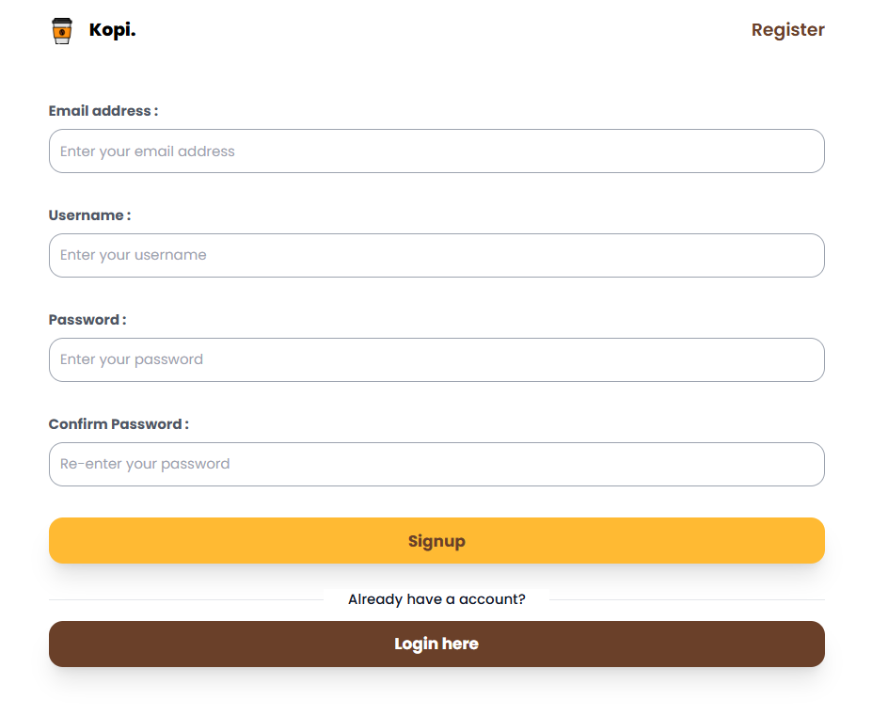

Field Name | Field Type | Description
Title | Heading | Display tittle “Register”
Username | Input field | Field to input username (required, unique)
Email | Input field | Field to input a valid email address (required, unique, must follow email format)
Password | Input field | Field to input password (required, min length)
Confirm password | Input field | Field to confirm password (must match Password)
Register Button | Button | Submit registration form and insert user data into database
Log in here | Link | Navigate to Login screen
Coffee Image | Image/Icon | Decorative image for UI

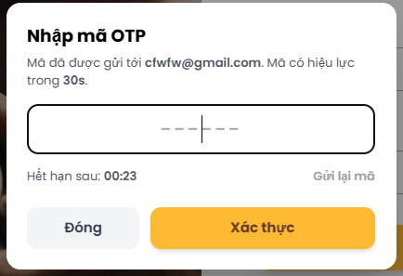

Field Name | Field Type | Description
Title | Heading | Display tittle “OTP”
OPT | Input field | Field to input username (required, unique)
Resend code | Button | Resend random 6-digit OTP code
Cancel | Button | Cancel action
Confirm | Button | Confirm registration saved to database with email_verify field is true

Database Access

Table | CRUD | Description
Users | C | Insert new user information (username, email, password) into database when registering
Users | R | Check if email/username already exists before creating new account

SELECT * FROM users WHERE username=? OR email=?;
INSERT INTO users (username, email, password_hash, role_id, status, created_at)
VALUES (?, ?, ?, 3, 'active', SYSUTCDATETIME());

1.2. Forgot Password
Description
This screen allows registered Kopi Coffee users to recover their account password by requesting an OTP sent to their email, then using that OTP to set a new password.
Related Use Cases
- UC-07: Forgot Password

UI Design
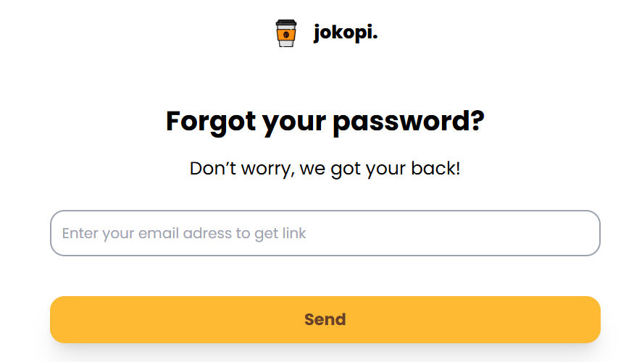
Field Specifications
Forgot Password – Request OTP
Field Name | Field Type | Description
Registered Email | Text | Enter registered email; system validates existence & status
Send Verification Code | Button | Triggers OTP creation and sends email if the email is valid
Back to Login | Link | Navigates user back to the login screen
Forgot Password – Reset Password
Field Name | Field Type | Description
Email | Text | Email being reset (may be pre-filled from previous step)
OTP Code | Text | One-time code sent to email
New Password | Password Input | New password to set
Confirm Password | Password Input | Re-enter new password to confirm
Confirm Reset | Button | Submits form to verify OTP and update users.password_hash

Database Access
Table | CRUD | Description
users | R | Check that the email exists and user status is valid (e.g. ACTIVE)
user_otps | C | Create new OTP record with hash and expiry
user_otps | R | Validate OTP for a given user (by user_id + otp_hash + not expired)
user_otps | D | Optionally delete OTP after successful use
users | U | Update password hash after successful OTP verification

1. Validate email & create OTP
SELECT
user_id,
email,
status
FROM dbo.users
WHERE email = @Email
AND status = 'ACTIVE';

INSERT INTO dbo.user_otps (user_id, otp_hash, expires_at)
VALUES (
@UserId,
@OtpHash, -- hashed OTP
DATEADD(MINUTE, 10, SYSUTCDATETIME())
);

2. Validate OTP
SELECT TOP 1
id,
user_id,
otp_hash,
expires_at
FROM dbo.user_otps
WHERE user_id = @UserId
AND otp_hash = @OtpHash
AND expires_at > SYSUTCDATETIME();

3. Update password & clean up OTP
UPDATE dbo.users
SET
password_hash = @NewPasswordHash,
updated_at = SYSUTCDATETIME()
WHERE user_id = @UserId;

DELETE FROM dbo.user_otps
WHERE user_id = @UserId;

1.3. Login
Login with username and password to access the Platform

UI Design
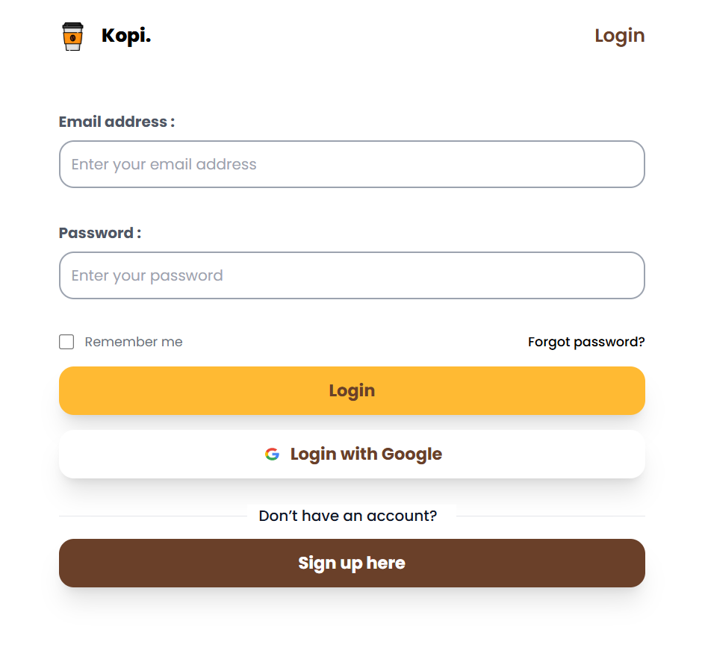

Field Name | Field Type | Description
Title | Heading | Display tittle “Login”
Username | Input field | Field to input username (required)
Password | Input field | Field to input password (required)
Login Button | Button | Submit login form and verify credentials
Login with google | Button | Log in and authenticate with your email account
Forgot password | Link | Navigate to password recovery
Register | Link | Navigate to registration form

Database Access
Table | CRUD | Description
Users | R | Retrieve user data (username, password) to verify login
Users | U | Update last login timestamp

SELECT * FROM users WHERE username=? AND password_hash=? AND status='active';
UPDATE users SET last_login_at=SYSUTCDATETIME() WHERE user_id=?;

1.4. Login via Google
Description
This feature allows users to log into the Kopi Coffee system using their Google account via OAuth 2.0. If the email already exists, the system logs them in; otherwise, a new customer account is created.
Related Use Cases
- UC-09: Login with Google

UI Design
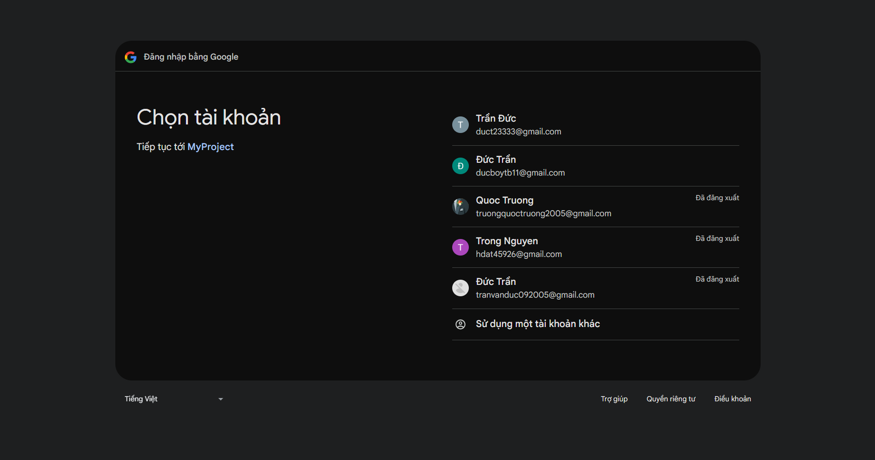
Field Specifications
Field Name | Field Type | Description
Login with Google | Button | Triggers Google OAuth login flow (redirect to Google)

Database Access
Table | CRUD | Description
users | R | Checks if a user already exists with the Google email
users | C | Inserts new user if no record is found
roles | R | Retrieves CUSTOMER role_id for new Google-based accounts

IF EXISTS (SELECT 1 FROM dbo.users WHERE email = @Email)
BEGIN
SELECT
u.user_id,
u.username,
u.email,
u.full_name,
u.status,
u.email_verified,
r.name AS role_name
FROM dbo.users u
JOIN dbo.roles r ON u.role_id = r.role_id
WHERE u.email = @Email;
END
ELSE
BEGIN
INSERT INTO dbo.users (
username,
email,
phone,
password_hash,
full_name,
role_id,
status,
email_verified,
avatar_url,
created_at,
updated_at,
position_id
)
VALUES (
@GeneratedUsername, -- e.g. from Google name + random suffix
@Email,
NULL,
@RandomPasswordHash, -- random or fixed internal value, not used by user
@FullName,
(SELECT role_id FROM dbo.roles WHERE name = 'CUSTOMER'),
'ACTIVE',
1, -- Google email is considered verified
@AvatarUrl,
SYSUTCDATETIME(),
SYSUTCDATETIME(),
NULL
);

SELECT
u.user_id,
u.username,
u.email,
u.full_name,
u.status,
u.email_verified,
r.name AS role_name
FROM dbo.users u
JOIN dbo.roles r ON u.role_id = r.role_id
WHERE u.email = @Email;
END

1.5. Logout
Description
This function allows users to securely end their session in the Kopi Coffee system.
Related Use Cases
- UC-03: Logout

UI Design
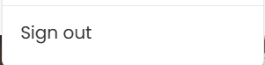
Field Specifications
Field Name | Field Type | Description
Logout | Button | Located in header/sidebar; when clicked, clears session/JWT and redirects to /auth/login

Database Access
Table | CRUD | Description
— | — | No direct DB access is required

1.6. User Profile
View and update user profile details and photo

UI Design

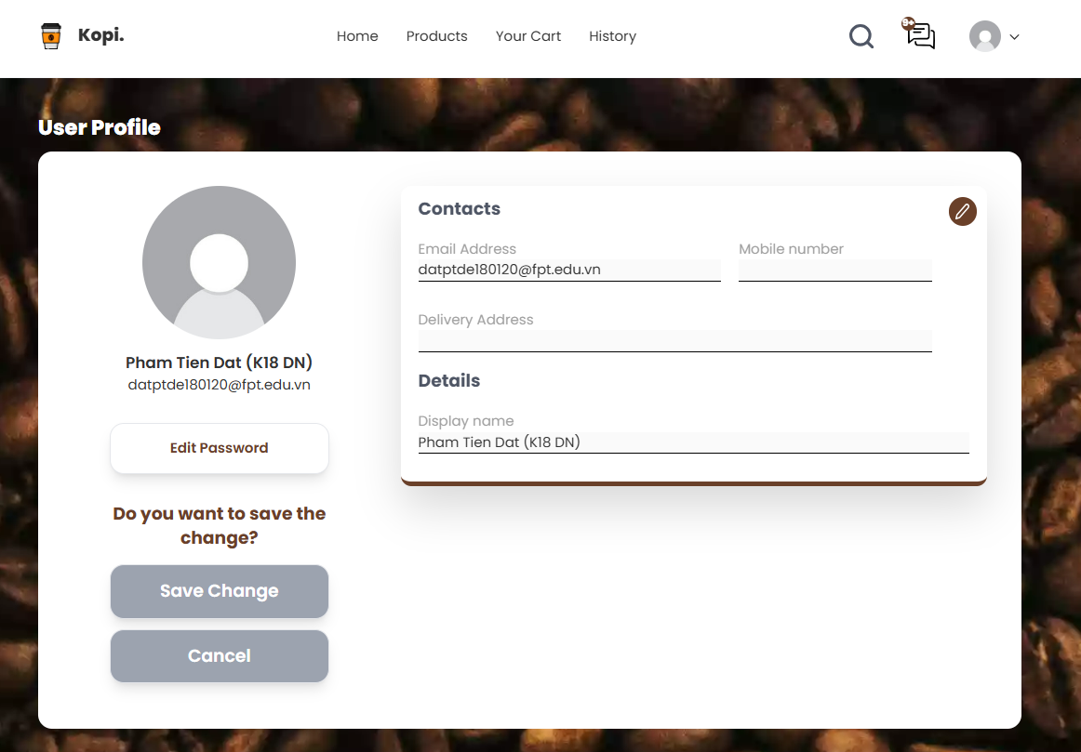
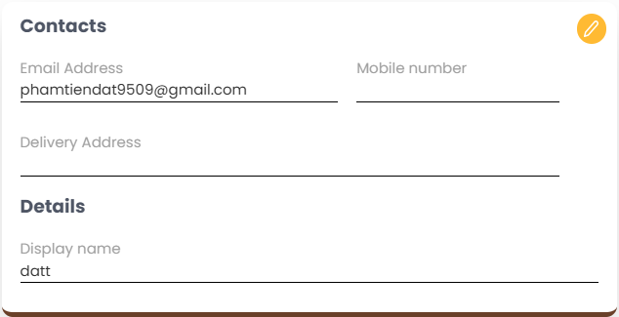
Field Name | Field Type | Description
Profile image | Image/ icon | Display user photo
Change photo | Button | Upload new profile photo
Full name | Input field | Input full name
Email | Input field | Input valid email address
Username | Input field | Input username
Phone number | Input field | Input phone number
Address | Input field | Input residential address
Save change | Button | Save updated profile info
Cancel | Button | Cancel editing profile

Database Access
Table | CRUD | Description
Users | R | Retrieve user profile by ID
Users | U | Update user profile info (name, email, phone, dob, address)

SELECT * FROM users WHERE user_id=?;
UPDATE users SET full_name=?, email=?, phone=?, updated_at=SYSUTCDATETIME() WHERE user_id=?;

2. Menu & Product Browsing

2.1 View Menu
Related Use Cases
- UC-08: View Menu

UI Design
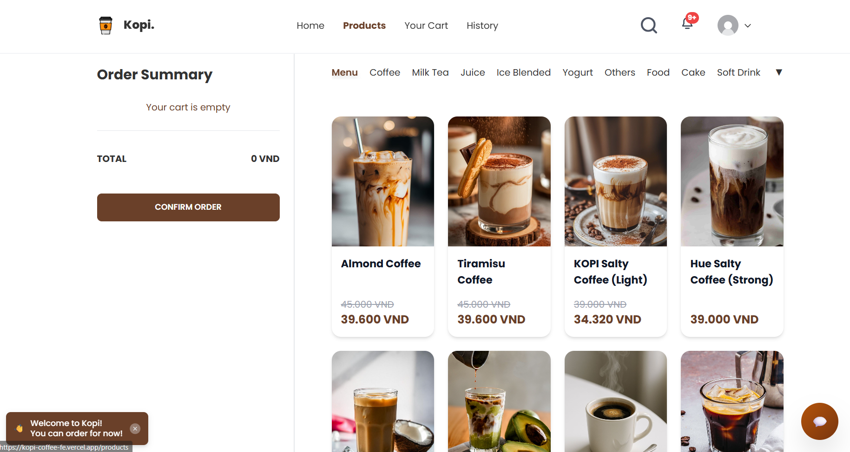
Field Specifications
Field Name | Field Type | Description
Search Bar | Text Input | Optional search box at top to quickly search products by name or keyword
Category Filter | Dropdown | Filter menu by category (e.g., All, Coffee, Tea, Bakery, Seasonal, Promotion)
Sort Option | Dropdown | Sort by price (low-high, high-low), popularity, newest
Product Card | Container | Card displaying basic product info (name, image, price, short description, status)
Product Name | Text | Name of drink/food (e.g., “Kopi Latte”)
Product Image | Image | Thumbnail of the product
Price | Text | Display unit price (e.g., “45.000 VND”)
Short Description | Text | Short description (e.g., “Vietnamese coffee with condensed milk”)
Availability Tag | Badge | Show status such as “Available”, “Out of stock”, or “Temporarily unavailable”
View Detail | Button/Link | Navigates to product detail page /products/{id}
Add to Cart | Button | Adds selected product to the shopping cart (default quantity = 1 or chosen quantity)
Add to Favorites | Icon Button | Adds/removes product from user’s favorite list (if logged in)

Database Access
Table | CRUD | Description
products | R | Retrieve active products with price, description, image, category, stock
categories | R | Retrieve product categories to show in filter dropdown
favorites | R | (Optional, only if logged in) Retrieve which products user has favorited

Get menu list with category & active status
SELECT
p.product_id,
p.name,
p.description,
p.price,
p.image_url,
p.stock,
p.status,
c.category_name
FROM dbo.products p
LEFT JOIN dbo.categories c ON p.category_id = c.category_id
WHERE p.status = 'ACTIVE'
ORDER BY p.name;

Get categories for filter
SELECT
category_id,
category_name
FROM dbo.categories
WHERE is_active = 1
ORDER BY display_order, category_name;

2.2 Search Products
Related Use Cases
- UC-21 / UC-19: Search for products using the toolbar

UI Design
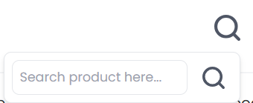
Field Specifications
Field Name | Field Type | Description
Search Box | Text | Input field for product name or keyword (e.g., “latte”, “matcha”, “cold brew”)
Search Button | Button | Executes search when clicked (hoặc auto search khi user gõ Enter)
Search Results | Grid/List | Displays filtered products based on search term
No Result Label | Text | Message displayed when no products match the search query

Database Access
Table | CRUD | Description
products | R | Search active products by name/description/tags using LIKE conditions

SELECT
p.product_id,
p.name,
p.description,
p.price,
p.image_url,
p.stock,
p.status
FROM dbo.products p
WHERE p.status = 'ACTIVE'
AND (
p.name LIKE '%' + @Keyword + '%' OR
p.description LIKE '%' + @Keyword + '%' OR
p.tags LIKE '%' + @Keyword + '%'
)
ORDER BY p.name;

2.3 Add Product to Shopping Cart
Related Use Cases
- UC-11: Add product to shopping cart

UI Design
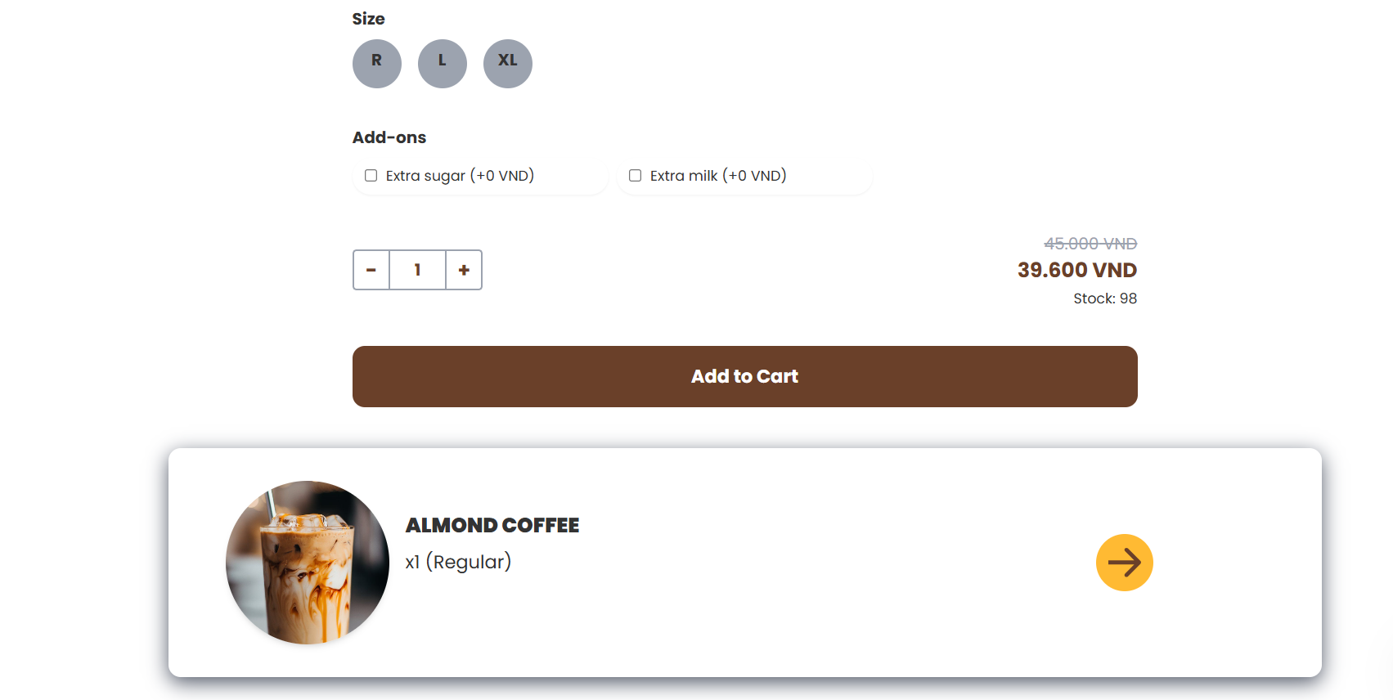
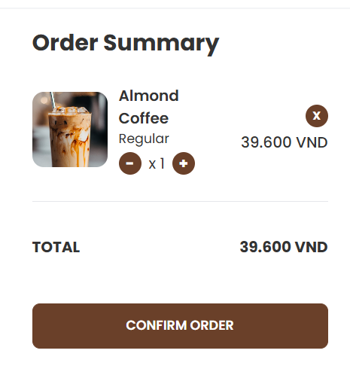
Field Specifications
Field Name | Field Type | Description
Product ID | Hidden | Unique identifier of product to be added
Product Name | Text | Display name in cart (for confirmation)
Size / Variant | Dropdown | Size (S/M/L) or hot/iced, if applicable
Sugar/Ice Option | Dropdown | Optional customizations (e.g., 0% sugar, less ice)
Quantity | Number Input | Number of units user wants to add
Unit Price | Text | Price per unit for selected size/variant
Subtotal | Text | Calculated = Unit Price * Quantity
Add to Cart | Button | Confirms adding the selected configuration to cart
Cart Icon (Header) | Icon + Badge | Shows number of items in cart, click to open mini-cart
Cart Item List | List | List of items currently in cart with name, size, quantity, subtotal
Update Quantity Button | Button (+/-) | Allows increasing/decreasing quantity in cart
Remove Item Button | Button (Remove) | Removes an item from the cart
Cart Total | Text | Displays total amount of cart
Checkout Button | Button (Primary) | Navigates to checkout page or opens checkout step

Database Access
Table | CRUD | Description
orders | C/R/U | Create or update a pending order (cart) for the current user or table
order_items | C/R/U/D | Add, update, or delete items in the cart (each row represents one product line)
products | R | Check price, stock, and status for product being added

INSERT INTO dbo.orders (
customer_id,
table_id,
order_type, -- 'IN_STORE', 'DELIVERY', 'TAKEAWAY'
status, -- 'CART'
total_amount,
created_at,
updated_at
)
VALUES (
@CustomerId,
@TableId,
@OrderType,
'CART',
0,
SYSUTCDATETIME(),
SYSUTCDATETIME()
);

3. Order & Payment

3.1 Order Dish (Create Order)
Related Use Cases
- UC-12: Order dish
- UC-11: Add product to shopping cart (tiền đề)

UI Design
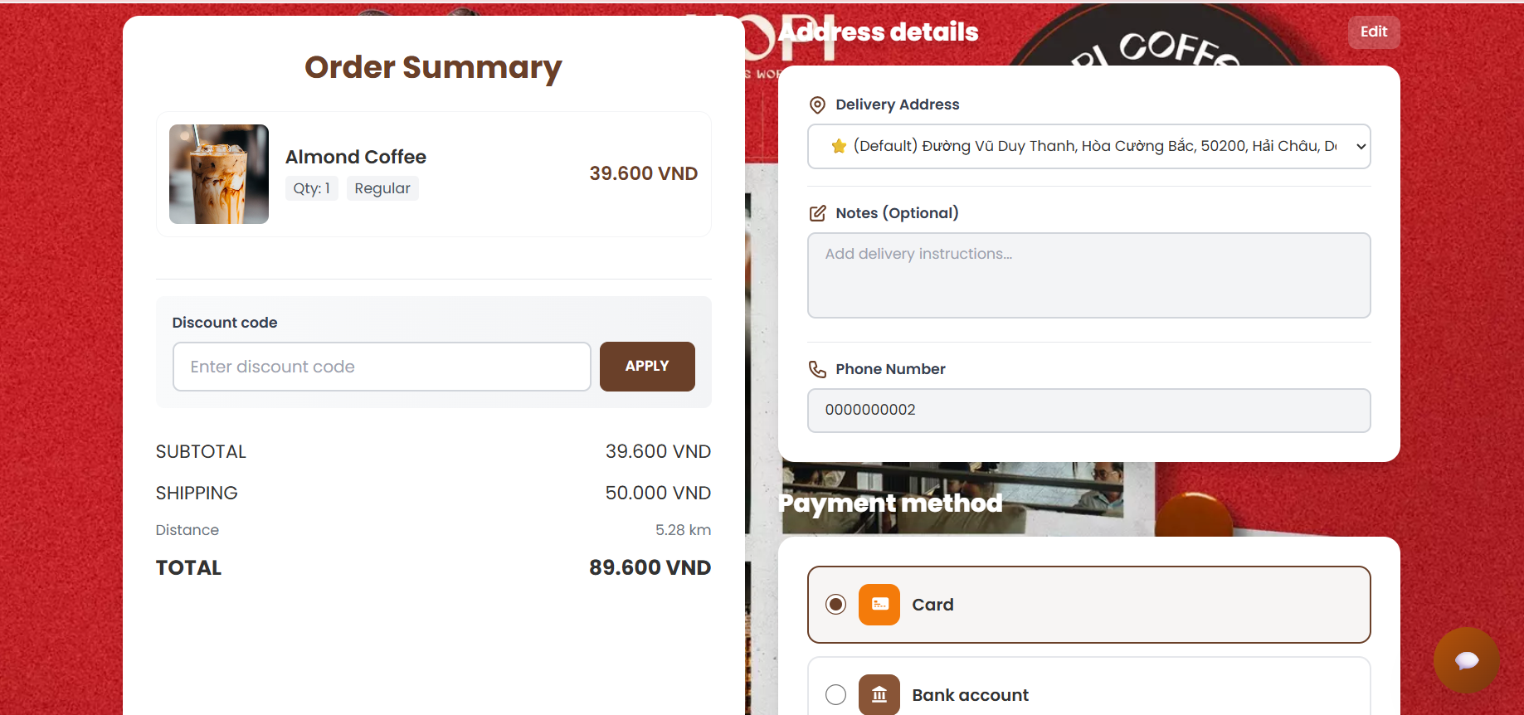
Field Specifications
Field Name | Field Type | Description
Cart Items List | List / Table | Displays all items in the cart: product name, size, quantity, unit price, subtotal
Quantity (+ / –) | Number Input | Allows user to adjust quantity per item
Remove Item | Button | Removes an item from the cart
Order Type | Radio Buttons | Select: IN_STORE, TAKEAWAY, DELIVERY
Customer Name | Text Input | Full name of the customer (default từ profile nếu đã login)
Phone Number | Text Input | Contact phone number
Delivery Address | Text Area/Input | Full delivery address (if ORDER_TYPE = DELIVERY)
Use Current Location | Button | Calls location API to autofill/address suggestion (UC-44)
Use Map to Choose Address | Button/Link | Opens map picker for selecting address (UC-45)
Order Notes | Text Area | Optional notes for barista/shipper
Subtotal | Text | Sum of all item subtotals (before shipping / discount)
Shipping Fee | Text | Calculated delivery fee (0 for in-store/takeaway)
Discount / Promotion | Text | Total discount from promotions/vouchers
Total Amount | Text | Final amount customer needs to pay
Payment Method | Radio Buttons | CASH, CARD, E_WALLET, PAYOS_QR
Place Order Button | Button (Primary) | Creates new order in the system with status PENDING_PAYMENT or PENDING

Database Access
Table | CRUD | Description
orders | C | Create a new order record with order_type, status, and total_amount
orders | U | Update order status after payment or cancellation
order_items | C | Insert line items for the order
order_items | R | Load items when displaying order detail
products | R | Get price, name, and stock when building order items
users | R | Get customer info (name, phone, default address)

1. Create new order
INSERT INTO dbo.orders (
customer_id,
order_type,
order_channel,
status,
subtotal_amount,
shipping_fee,
discount_amount,
total_amount,
payment_method,
payment_status,
delivery_address,
notes,
created_at,
updated_at
) VALUES (
@CustomerId,
@OrderType, -- 'IN_STORE' / 'DELIVERY' / 'TAKEAWAY'
'WEB_APP', -- or 'QR_TABLE', 'MOBILE'
'PENDING_PAYMENT', -- initial status
@Subtotal,
@ShippingFee,
@DiscountAmount,
@TotalAmount,
@PaymentMethod, -- 'CASH', 'PAYOS_QR', ...
'UNPAID',
@DeliveryAddress,
@Notes,
SYSUTCDATETIME(),
SYSUTCDATETIME()
);
2. Insert order items
INSERT INTO dbo.order_items (
order_id,
product_id,
product_name,
size,
ice_level,
sugar_level,
quantity,
unit_price,
subtotal
)
VALUES (
@OrderId,
@ProductId,
@ProductName,
@Size,
@IceLevel,
@SugarLevel,
@Quantity,
@UnitPrice,
@UnitPrice * @Quantity
);

3.2 Payment (Cash, E-wallet, PayOS QR)
Related Use Cases
- UC-14: Payment
- UC-16: Confirmation of payment QR transfer

UI Design
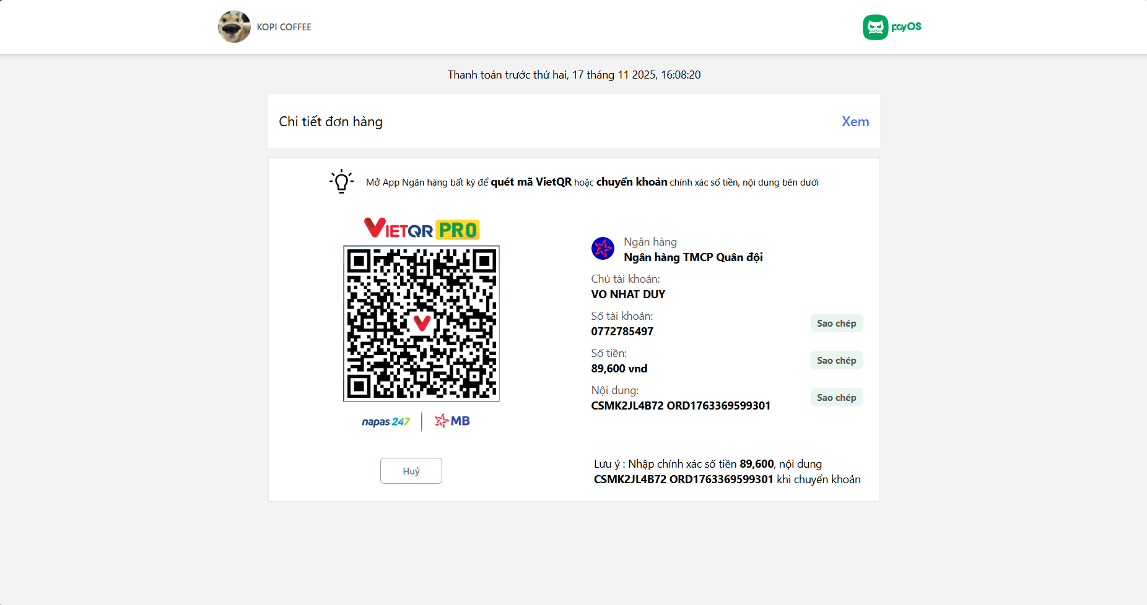
Field Specifications
Field Name | Field Type | Description
Order Code | Text | Unique code generated to identify the order & payment
Amount | Number | Total amount in VND to be paid
Payment Method | Radio Buttons | CASH, CARD, E_WALLET, PAYOS_QR
Payment Status | Text / Badge | PENDING, PAID, FAILED, REFUNDED
PayOS Checkout URL | Text / Link | URL to PayOS hosted payment page / QR
QR Image | Image | PayOS QR code for scanning (if using QR)
Confirm Payment Btn | Button (Cash) | Staff confirms cash payment and updates order as paid
Return from PayOS | Callback Handler | Backend endpoint to receive payment status from PayOS webhook

Database Access
Table | CRUD | Description
payments | C | Create a payment record for an order
payments | R | Read payment info when verifying or displaying receipts
payments | U | Update payment status after PayOS returns result
orders | U | Update order payment_status and status after payment confirmation

1. Create payment record
INSERT INTO dbo.payments (
order_id,
order_code,
amount,
description,
method,
status,
checkout_url,
created_at,
updated_at
) VALUES (
@OrderId,
@OrderCode,
@Amount,
@Description,
@Method, -- 'CASH', 'PAYOS_QR', ...
'PENDING',
@CheckoutUrl,
SYSUTCDATETIME(),
SYSUTCDATETIME()
);

2. Update payment after PayOS callback
UPDATE dbo.payments
SET
status = @NewStatus, -- 'PAID' / 'FAILED'
updated_at = SYSUTCDATETIME()
WHERE order_code = @OrderCode;

3. Mark order as paid
UPDATE dbo.orders
SET
payment_status = 'PAID',
status = 'CONFIRMED',
updated_at = SYSUTCDATETIME()
WHERE order_id = (
SELECT order_id FROM dbo.payments WHERE order_code = @OrderCode
);

3.3 Order Tracking & Delivery
Related Use Cases
- UC-13: Track the order
- UC-35: Track delivery location
- UC-46: View order progress

UI Design
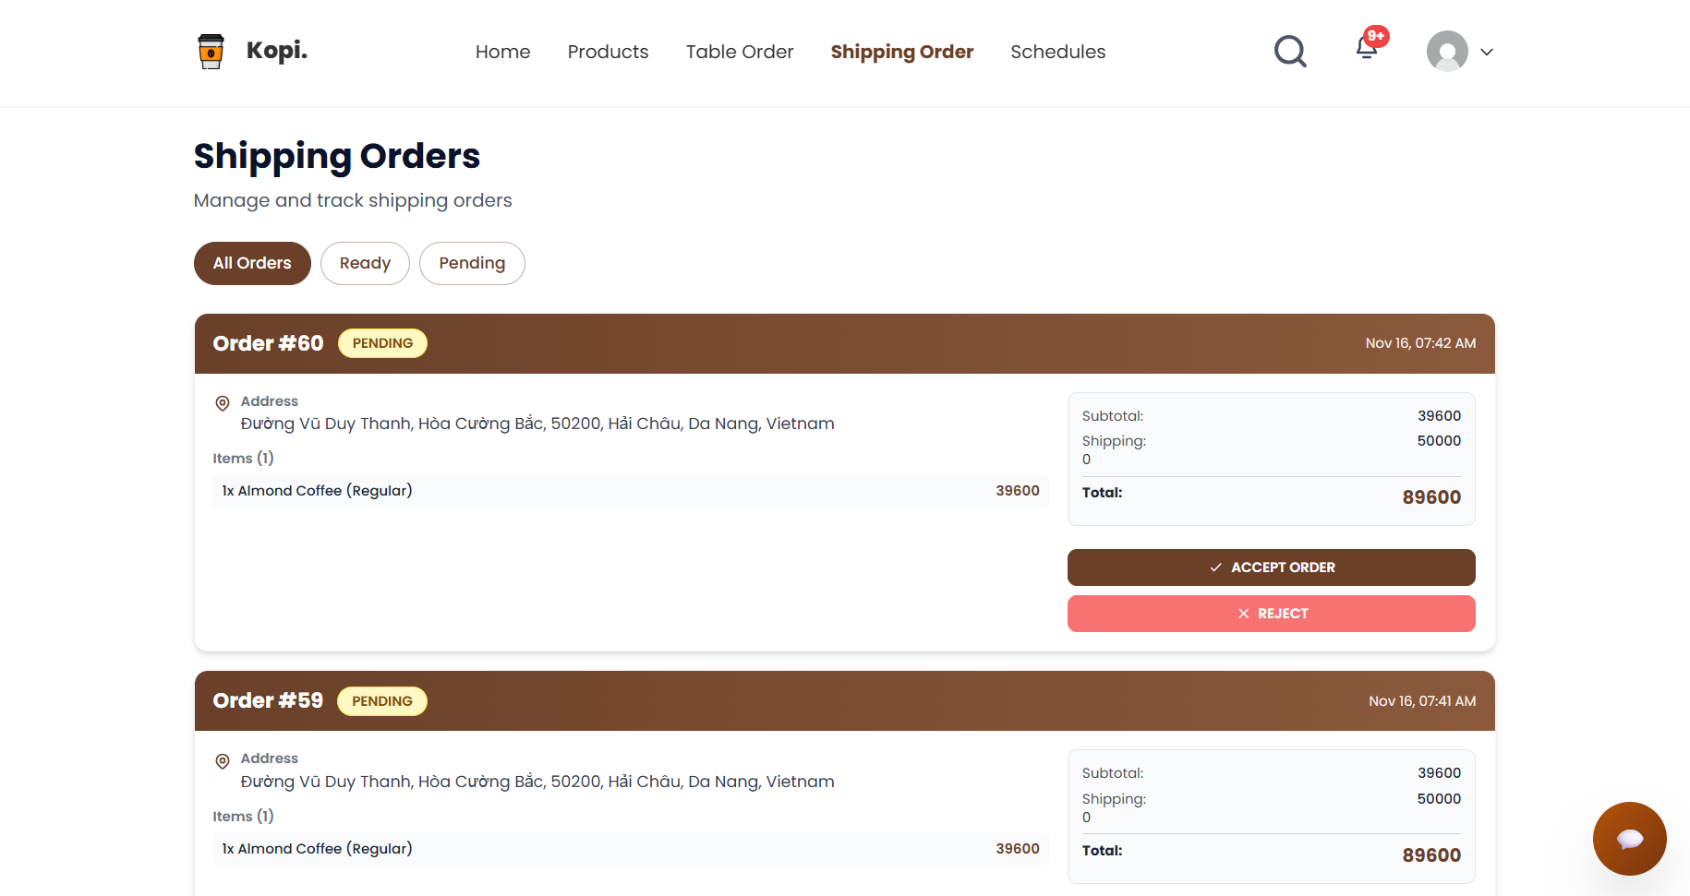
Field Specifications
Field Name | Field Type | Description
Order Code | Text | Identifier to load current order
Order Status | Status Timeline | Visual progression of statuses (PENDING, CONFIRMED, PREPARING, SHIPPING, COMPLETED, CANCELED)
Current Location | Map Marker | Real-time shipper location on map
Delivery Address | Text | Customer’s delivery address
Refresh Button | Button | Manual refresh of tracking data (optional; usually auto-refresh)

Database Access
Table | CRUD | Description
orders | R | Retrieve order status, delivery address, timestamps
delivery_assignments | R | Retrieve shipper assigned to the order
delivery_tracking | R | Retrieve last known location of shipper/order

1. Get order status & basic tracking info
SELECT
o.order_id,
o.order_code,
o.status,
o.payment_status,
o.total_amount,
o.delivery_address,
o.created_at,
o.updated_at,
d.shipper_id,
s.full_name AS shipper_name,
s.phone AS shipper_phone
FROM dbo.orders o
LEFT JOIN dbo.delivery_assignments d ON o.order_id = d.order_id
LEFT JOIN dbo.staff s ON d.shipper_id = s.staff_id
WHERE o.order_code = @OrderCode;
2. Get last known shipper location
SELECT TOP 1
latitude,
longitude,
recorded_at
FROM dbo.delivery_tracking
WHERE shipper_id = @ShipperId
ORDER BY recorded_at DESC;

3.4. Locate User’s Current Location & Map Input
Related Use Cases
- UC-44: Locate the user's current location
- UC-45: Map positioning based on user input

UI Design
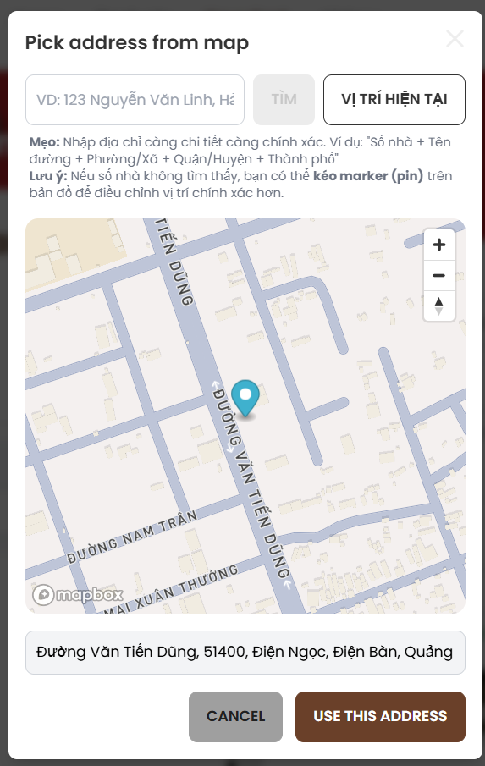
Field Specifications
Field Name | Field Type | Description
Current Location | Button | Triggers browser geolocation to get lat/long
Map Search Box | Text Input | User types address or place name
Map View | Map Component | Shows map with draggable pin
Use This Address | Button | Saves selected location as delivery address or profile

Database Access
Table | CRUD | Description
orders | U | Save final address & coordinates for delivery order
user_addresses | C | Save address to reusable address book (optional)
user_addresses | U | Update saved address/location

UPDATE dbo.orders
SET
delivery_address = @FormattedAddress,
delivery_lat = @Latitude,
delivery_lng = @Longitude,
updated_at = SYSUTCDATETIME()
WHERE order_id = @OrderId;

3.5 Order History

UI Design
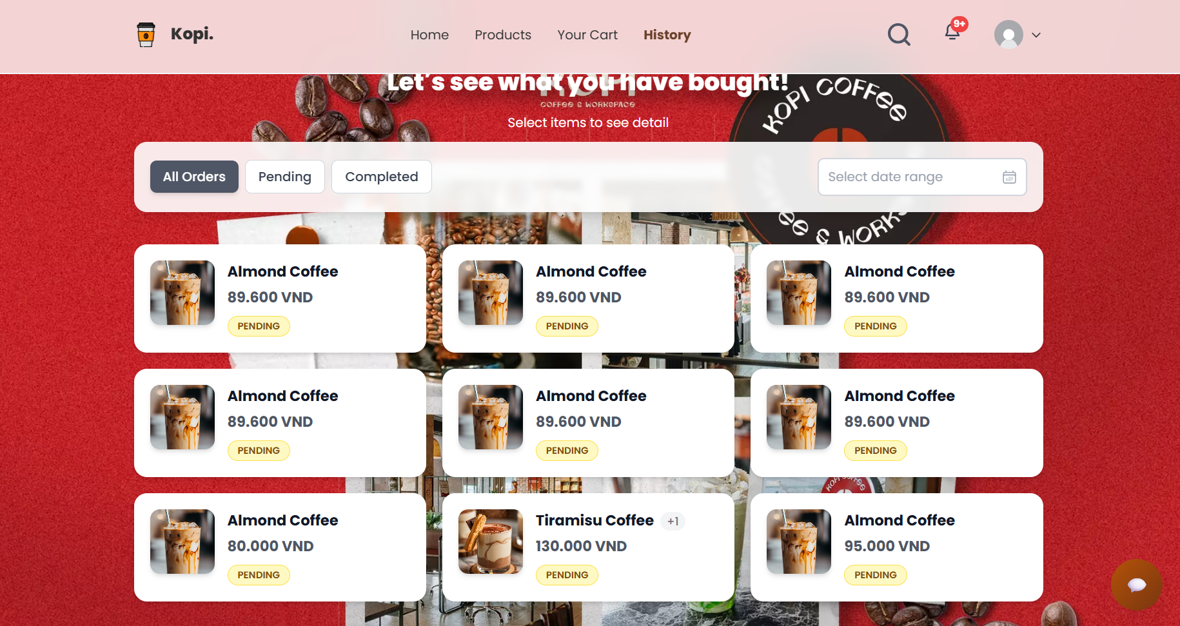
Related Use Cases
- UC-39: View order history
Field Specifications
Field Name | Field Type | Description
Order Status | Badge | Status (COMPLETED, CANCELED, REFUNDED, etc.)
Total Amount | Text | Final amount paid
View Detail | Button | Opens order detail view

Database Access
Table | CRUD | Description
orders | R | Retrieve list of orders by customer
order_items | R | Retrieve items per order for detail view
SELECT
order_id,
order_code,
total_amount,
status,
created_at
FROM dbo.orders
WHERE customer_id = @CustomerId
ORDER BY created_at DESC;

3.6. View Incoming Orders List (Staff)
Related Use Cases
- UC-41: View incoming orders list
- liên quan UC-15: Bartending/Serving, UC-37: Shipping order

UI Design
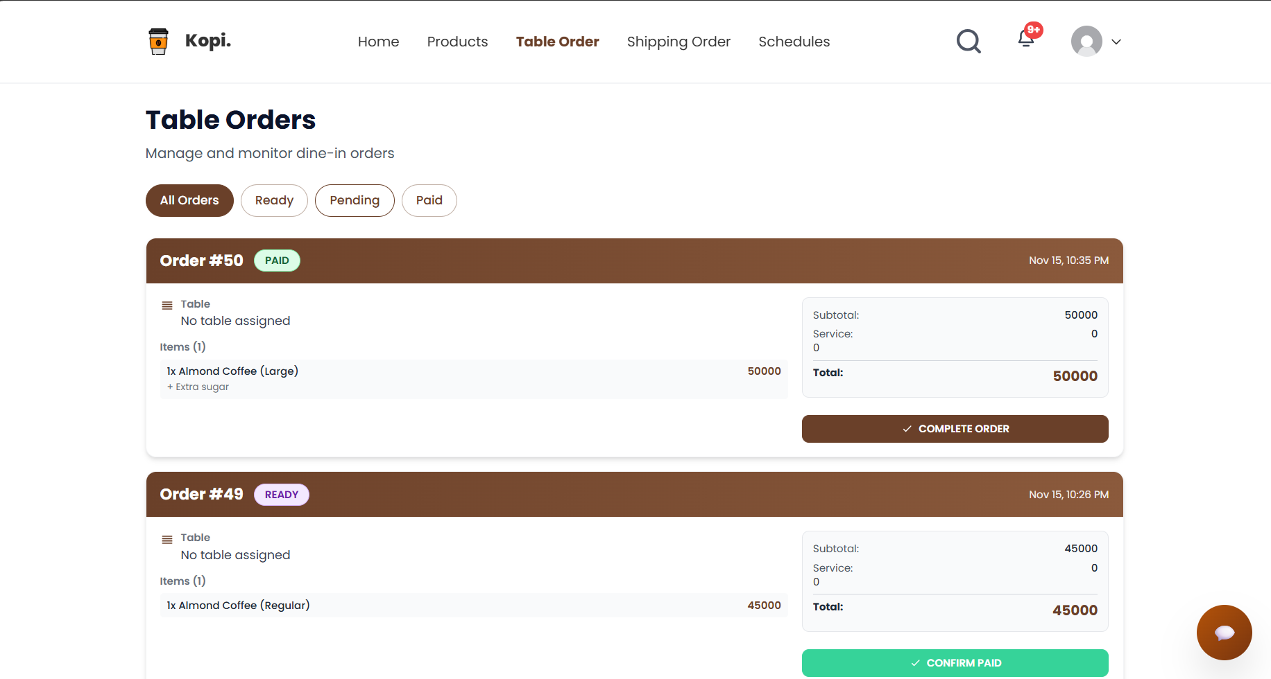
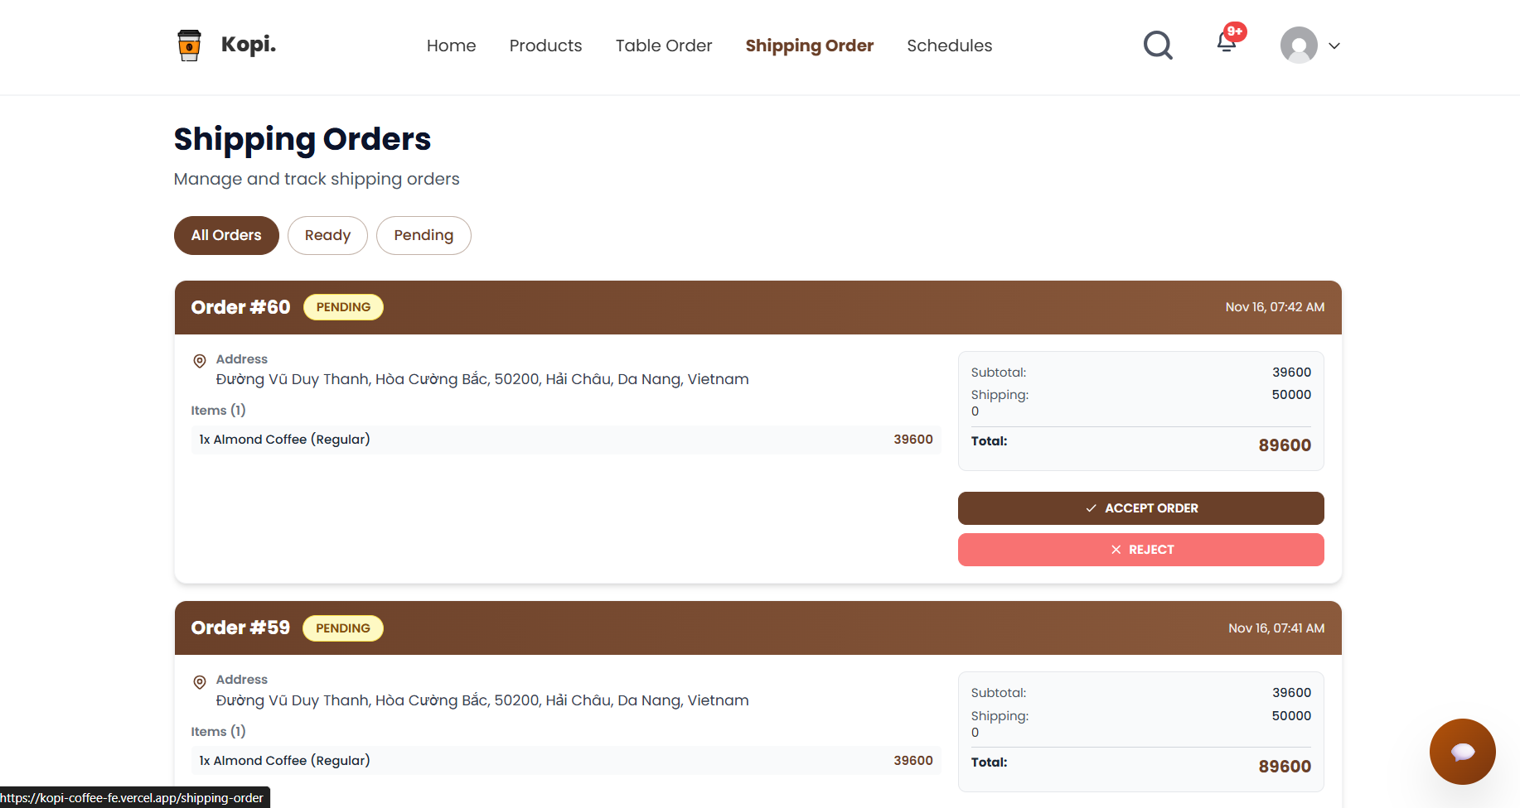
Field Specifications
Field Name | Field Type | Description
Filter by Status | Dropdown | Filter orders by PENDING, CONFIRMED, PREPARING, READY
Incoming Orders | Table | List of orders to handle (code, type, table, customer, status)
Order Code | Text Link | Open order detail for preparation
Order Type | Text | IN_STORE, DELIVERY, TAKEAWAY
Table Code | Text | Table name/number (for in-store)
Created Time | Text | When the order was created
Status | Badge | Current status
Assign Shipper | Button | For delivery orders – assign shipper (UC-37)
Mark as Preparing | Button | Update status to PREPARING
Mark as Ready | Button | Update status to READY

Database Access
Table | CRUD | Description
orders | R | Retrieve orders filtered by status/type
orders | U | Update status when staff progresses the order
cafe_tables | R | Get table info for display
users | R | Get basic customer info
SELECT
o.order_id,
o.order_code,
o.order_type,
o.status,
o.total_amount,
o.created_at,
t.table_code,
u.full_name AS customer_name
FROM dbo.orders o
LEFT JOIN dbo.cafe_tables t ON o.table_id = t.table_id
LEFT JOIN dbo.users u ON o.customer_id = u.user_id
WHERE o.status IN ('PENDING', 'CONFIRMED', 'PREPARING', 'READY')
ORDER BY o.created_at ASC;

3.7. Notification
(UC: View notification center / Show & hide notification ở phía user)

UI Design
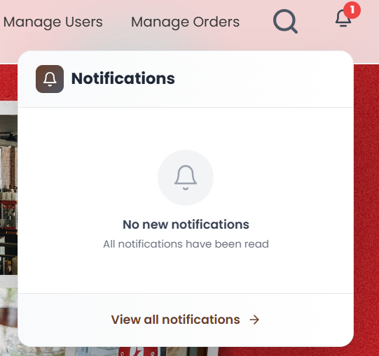
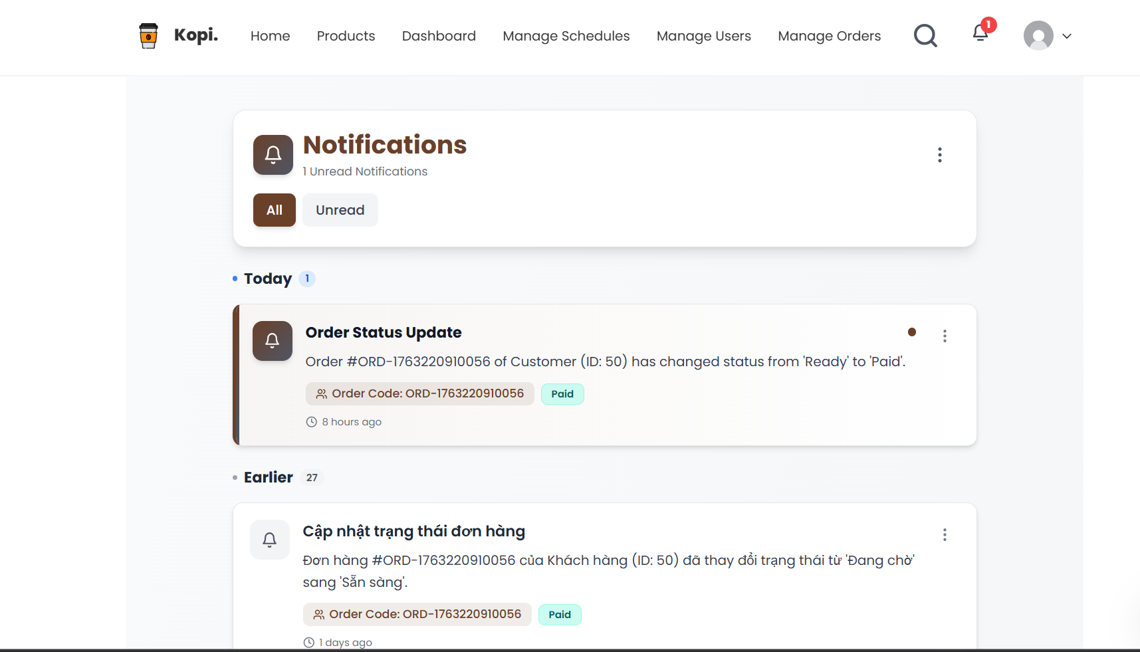

Field Specifications
Field Name | Field Type | Description
Page Title | Label / Text | Shows the screen title “Notification Center”.
Filter Status | Dropdown | Lets the user filter notifications by status (All or Unread only).
Notification List | Scrollable List / Table | Displays all notifications for the current user in a list or table view.
Column: Title | Text | Shows the main title text of each notification.
Column: Message Preview | Text | Shows a short preview of the notification content (1–2 lines).
Column: Type | Badge / Label | Indicates the category of notification (e.g., order, system, promotion).
Column: Created At | Text (DateTime) | Shows when the notification was created, formatted as dd/MM/yyyy HH:mm.
Column: Status | Badge | Indicates whether the notification is unread or already read.
Row Highlight | Styling | Visually emphasizes unread notifications (e.g., bold text or background).
Mark All as Read | Button | Marks all currently unread notifications as read for this user.
View Details / Go To Page | Link / Button | Opens the related detail page (for example, an order detail screen).

Database Access
Table | CRUD | Description
notifications | R | Load the list of notifications for the current user based on filters.
notifications | U | Update read status when marking notifications as read.
orders | R | Optionally fetch related order details for linked notifications.

Get the list of notifications (with status & type filter):
SELECT
n.notification_id,
n.user_id,
n.order_id,
n.title,
n.message,
n.type,
n.is_read,
n.created_at
FROM dbo.notifications n
WHERE n.user_id = @CurrentUserId
AND (@Type IS NULL OR @Type = N'All' OR n.type = @Type)
AND (@Status IS NULL OR @Status = N'All'
OR (@Status = N'Unread' AND n.is_read = 0)
OR (@Status = N'Read' AND n.is_read = 1))
AND n.created_at >= @FromDate
AND n.created_at < DATEADD(DAY, 1, @ToDate)
ORDER BY n.created_at DESC;
Mark a notification as read:
UPDATE dbo.notifications
SET is_read = 1
WHERE notification_id = @NotificationId
AND user_id = @CurrentUserId;
Mark all unread notifications as read:
UPDATE dbo.notifications
SET is_read = 1
WHERE user_id = @CurrentUserId
AND is_read = 0;

4. Manage Product & Inventory

4.1 Add Product
Related Use Case: UC-18 Add product (Admin/Manager)

UI Design
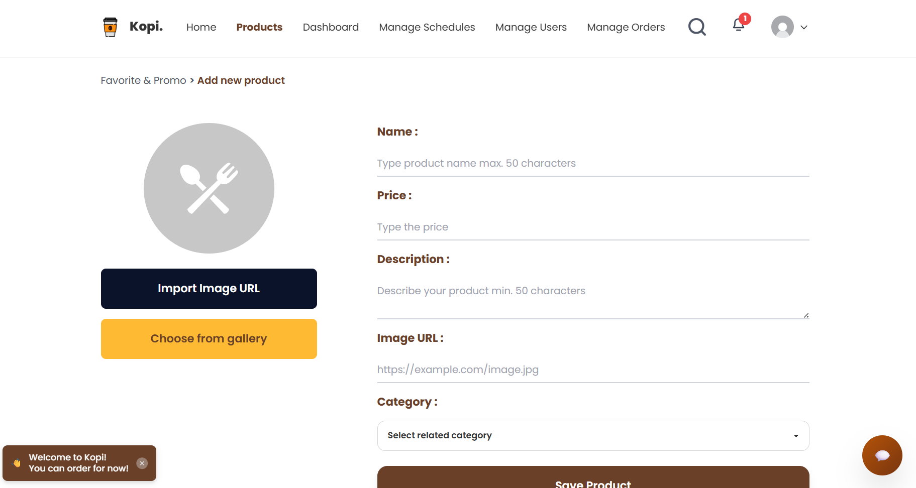
Field Specifications
Field Name | Field Type | Description
Category | Dropdown | Select the category of the product from the available category list.
Product Name | Text | Enter the display name of the product.
Image URL | Text / File | Enter or upload the image used to display the product thumbnail.
Description | Textarea | Provide a detailed description of the product.
Price (VND) | Number (decimal) | Enter the selling price of the product in VND.
Stock Quantity | Number (int) | Set the initial available stock for this product.
Save Button | Button | Submits the form to create the new product.
Cancel Button | Button | Cancels the action and returns to the product list.

Database Access
Table | CRUD | Description
categories | R | Load the list of active categories for the dropdown.
products | C | Insert a new product into the menu.
Load categories:
SELECT category_id, name
FROM dbo.categories
WHERE is_active = 1
ORDER BY display_order;

Insert new product:
(Assuming is_available defaults to “available” when created and sku is optional.)
INSERT INTO dbo.products (
category_id,
name,
img_url,
description,
price,
is_available,
stock_qty,
created_at,
updated_at
)
VALUES (
@CategoryId,
@Name,
@ImgUrl,
@Description,
@Price,
1, -- new product is available by default
@StockQty,
SYSDATETIME(),
SYSDATETIME()
);

4.2 Edit Product
Related Use Case: UC-21 Edit product

UI Design
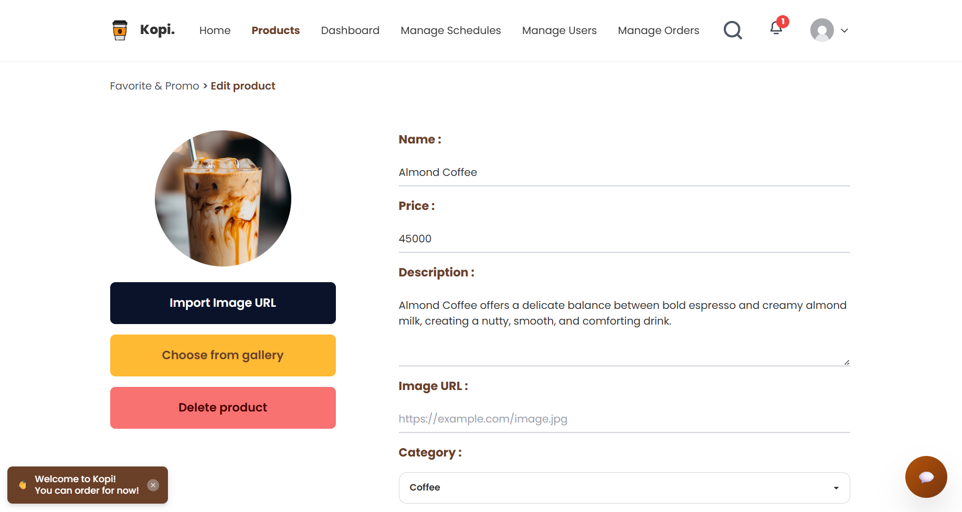
Field Specifications
Field Name | Field Type | Description
Product ID | Hidden | Stores the unique identifier of the product being edited.
Category | Dropdown | Allows selecting the category to assign to the product.
Product Name | Text | Enter the new display name of the product.
Image URL | Text / File | Update the product image link or upload a new one.
Description | Textarea | Update the detailed description of the product.
Price (VND) | Number (decimal) | Update the selling price in VND.
Stock Quantity | Number (int) | Update the available stock quantity shown to users.
Update Button | Button | Saves all changes to the product.
Cancel Button | Button | Cancels editing and returns to the product list.

Database Access
Table | CRUD | Description
products | R | Load detailed information of the selected product.
products | U | Update the product’s information.
categories | R | Load category list for the dropdown.
Load product by ID:
SELECT
p.product_id,
p.category_id,
p.name,
p.img_url,
p.description,
p.price,
p.is_available,
p.stock_qty
FROM dbo.products p
WHERE p.product_id = @ProductId;
Update product:
UPDATE dbo.products
SET
category_id = @CategoryId,
name = @Name,
img_url = @ImgUrl,
description = @Description,
price = @Price,
is_available = @IsAvailable,
stock_qty = @StockQty,
updated_at = SYSDATETIME()
WHERE product_id = @ProductId;

5. Manage Employee & Work Shifts

5.1 View Work Schedule (Employee)
Related Use Case: UC-17 View the work schedule

UI Design (My Schedule – Employee)
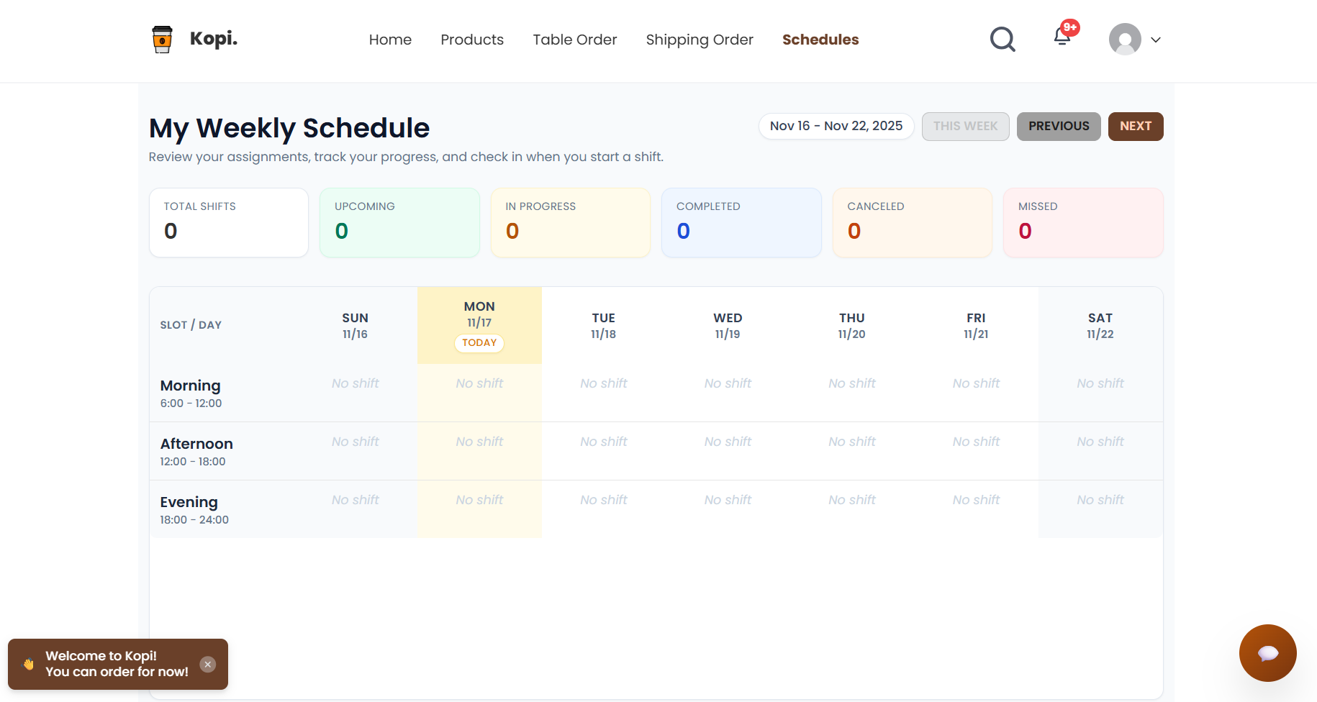
Field Specifications
Field Name | Field Type | Description
Date Filter | Date Range | Allows the employee to filter their work schedule by a specific date range.
View Mode | Toggle/Select | Switches the schedule view between weekly and monthly display modes.
Shift Date | Text | Shows the calendar date of the working shift.
Shift Name | Text | Displays the name or label of the shift (e.g., Morning, Afternoon, Night).
Time Range | Text | Shows the working time range for the shift (start time – end time).
Position | Text | Displays the job position for this shift (e.g., Barista, Cashier).
Status | Text | Shows the current status of the shift (scheduled, completed, on leave, etc.).
Notes | Text | Optional notes from the manager regarding this shift.

Database Access
Table | CRUD | Description
employee_shifts | R | Retrieve the list of shifts assigned to the current employee.
shift | R | Load shift templates, including shift name and default time range.
work_schedules | R | (Optional) Check which work schedule or planning batch a shift belongs to.
positions | R | Resolve and display the position name linked to the employee’s role.
users | R | Load basic employee information when needed in the schedule view.
Query: Get work schedule for one employee in a date range
SELECT
es.employee_shift_id,
es.shift_date,
s.shift_name,
s.start_time,
s.end_time,
es.status,
es.notes,
p.position_name
FROM dbo.employee_shifts es
JOIN dbo.shift s
ON es.shift_id = s.shift_id
LEFT JOIN dbo.users u
ON es.employee_id = u.user_id
LEFT JOIN dbo.positions p
ON u.position_id = p.position_id
WHERE es.employee_id = @EmployeeId
AND es.shift_date BETWEEN @FromDate AND @ToDate
ORDER BY es.shift_date, s.start_time;

5.2 Work Shift Assignment (Admin/Manager)
Related Use Case: UC-24 Work shift assignment

UI Design (Shift Assignment Screen)
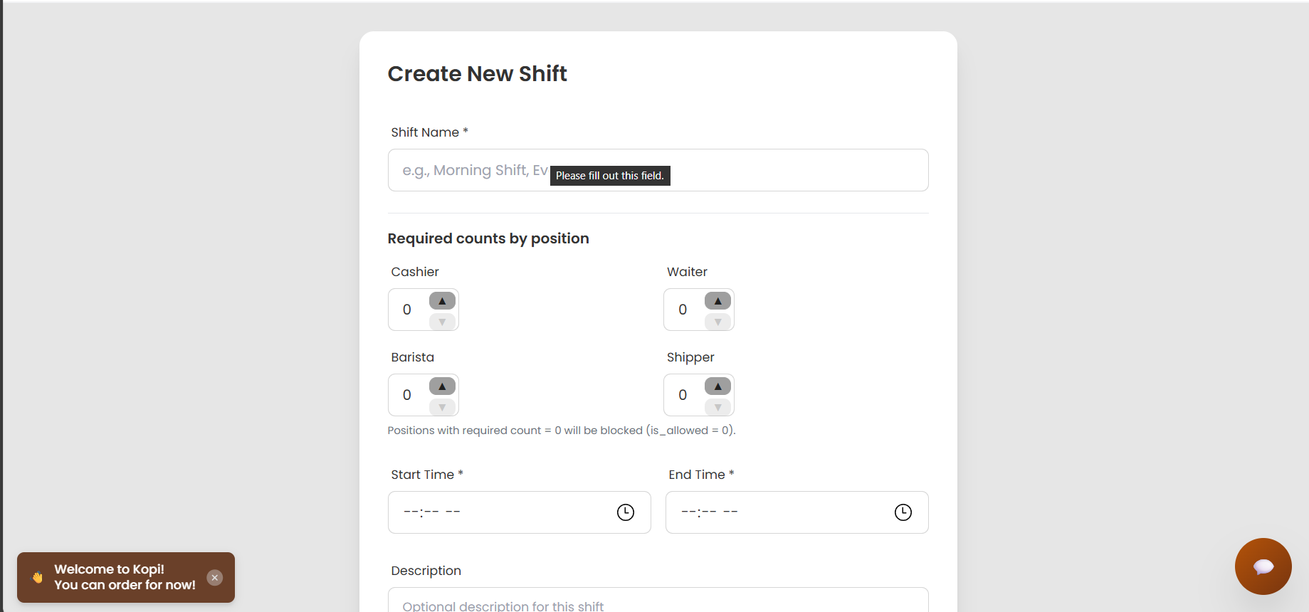
Field Specifications
Field Name | Field Type | Description
Employee | List/Select | Select one or more employees to assign to a shift.
Position | Dropdown | Filter employees by position (e.g., Barista, Cashier, Manager).
Shift | Dropdown | Select the shift template to assign (e.g., Morning, Afternoon, Night).
Shift Date | Date | Choose the calendar date for the working shift.
Status | Select | Set the initial status of the assignment (for example: scheduled).
Notes | Textarea | Optional notes such as replacement info or special instructions.
Save Assignment | Button | Saves the shift assignment(s) as new records in the system.

Database Access
Table | CRUD | Description
users | R | Load the list of employees.
positions | R | Filter employees by position when assigning shifts.
shift | R | Load available shift definitions (name, default time range).
employee_shifts | C | Create new shift assignments for employees.
employee_shifts | U | Update status or notes when editing existing assignments.
work_schedules | C/R | (Optional) Group assignments under a specific work schedule/batch.
Insert a single shift assignment:
INSERT INTO dbo.employee_shifts (
work_schedule_id,
employee_id,
shift_id,
shift_date,
status,
notes,
override_start_time,
override_end_time,
created_by_user_id,
created_at
)
VALUES (
@WorkScheduleId, -- can be NULL if this is a standalone assignment
@EmployeeId,
@ShiftId,
@ShiftDate,
N'scheduled', -- must follow valid status values defined in CHECK constraint
@Notes,
NULL, -- optional custom start time override
NULL, -- optional custom end time override
@AdminUserId,
SYSDATETIME()
);

5.3 Auto-generate Work Schedules
Related Use Case: UC-36 Auto-generate work schedules

UI Design (Auto Schedule Screen)
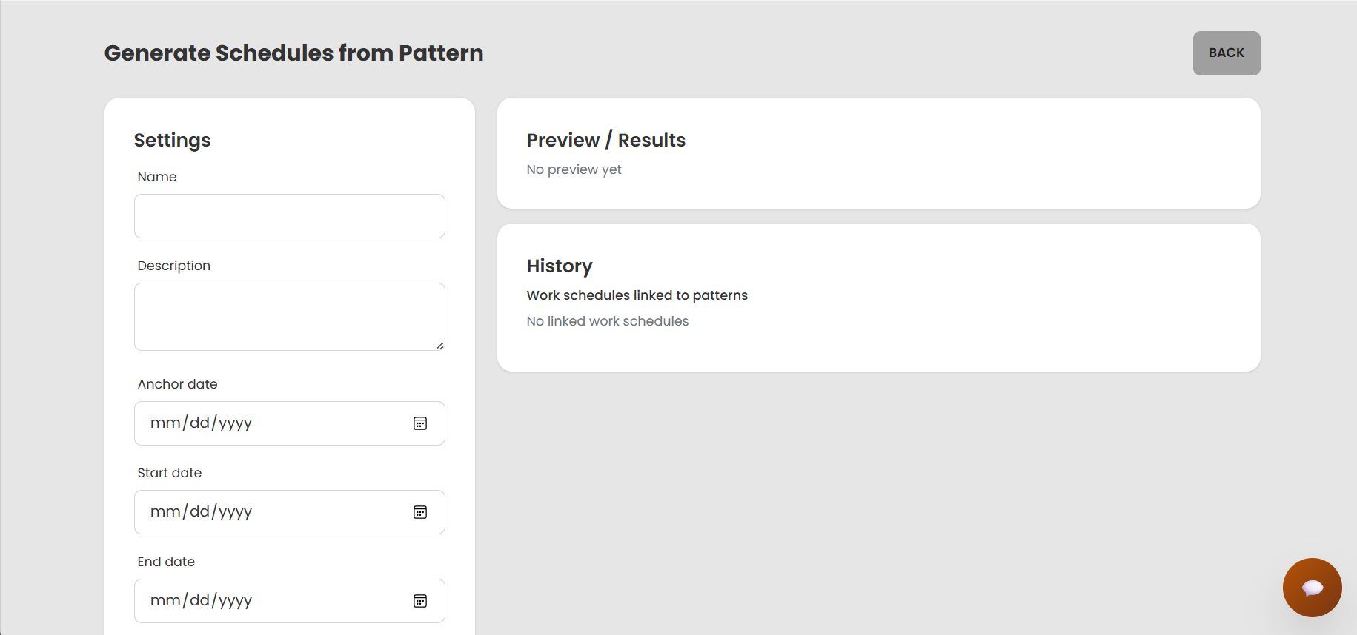
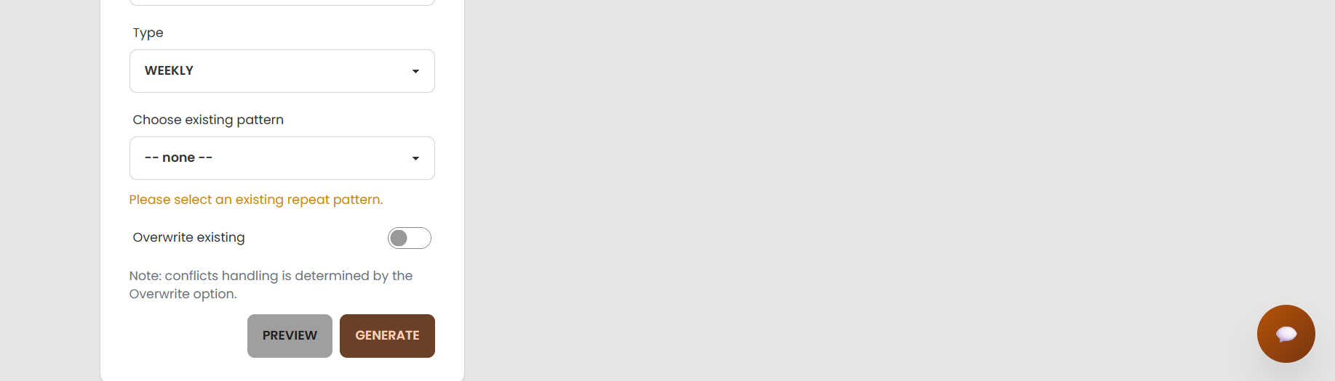
Field Specifications
Field Name | Field Type | Description
Schedule Name | Text | Name of the work schedule batch (for example: “Week 3 – Barista Shifts”).
Description | Textarea | Short description of the schedule (purpose, notes, special rules, etc.).
Start Date | Date | The first day covered by this schedule.
End Date | Date | The last day covered by this schedule.
Recurrence Type | Dropdown | Defines how the pattern repeats: none, daily, weekly, or monthly.
Day of Week | Dropdown | If weekly, choose which day(s) of the week the pattern applies (Mon–Sun).
Interval Days | Number (int) | Interval between occurrences (e.g., every 2 days, every 3 weeks).
Position | Dropdown | Select the position for which shifts will be generated (e.g., Barista).
Shift | Dropdown | Select the shift template to apply (e.g., Morning, Afternoon, Night).
Required Count | Number (int) | Number of employees needed for this position on each generated shift.
Generate Button | Button | Runs the generation logic to create the proposed employee shifts.
Preview Area | Table/Calendar | Shows a preview of all generated shifts before they are saved permanently.

Database Access
Table | CRUD | Description
recurrence_patterns | C/R | Store and read recurrence configurations used by the schedule.
work_schedules | C/R | Store overall information (name, date range, recurrence) for one schedule.
positions | R | Load the list of positions for which shifts can be scheduled.
shift | R | Load available shift definitions (name, start time, end time).
position_shift_rules | C/R | Define which positions can work which shifts, and how many are required.
users | R | Load employees by position when auto-assigning or validating shifts.
employee_shifts | C | Create individual shift rows for employees after generating the schedule.
1. Create a recurrence pattern
INSERT INTO dbo.recurrence_patterns (
recurrence_type,
day_of_week,
interval_days
)
VALUES (
@RecurrenceType, -- 'none' / 'daily' / 'weekly' / 'monthly'
@DayOfWeek, -- NULL if not weekly
@IntervalDays -- NULL if 'none'
);

DECLARE @RecurrenceId INT = SCOPE_IDENTITY();
2. Create a work schedule
INSERT INTO dbo.work_schedules (
name,
description,
start_date,
end_date,
recurrence_id,
created_by_user_id,
created_at
)
VALUES (
@Name,
@Description,
@StartDate,
@EndDate,
@RecurrenceId,
@AdminUserId,
SYSDATETIME()
);
DECLARE @WorkScheduleId INT = SCOPE_IDENTITY();
3. Save position–shift rule
INSERT INTO dbo.position_shift_rules (
position_id,
shift_id,
is_allowed,
required_count
)
VALUES (
@PositionId,
@ShiftId,
1, -- is_allowed
@RequiredCount
);

5.4 View All Shifts (Admin)
Related Use Case: UC-38 View all shifts (admin)

UI Design (Admin – All Shifts View)
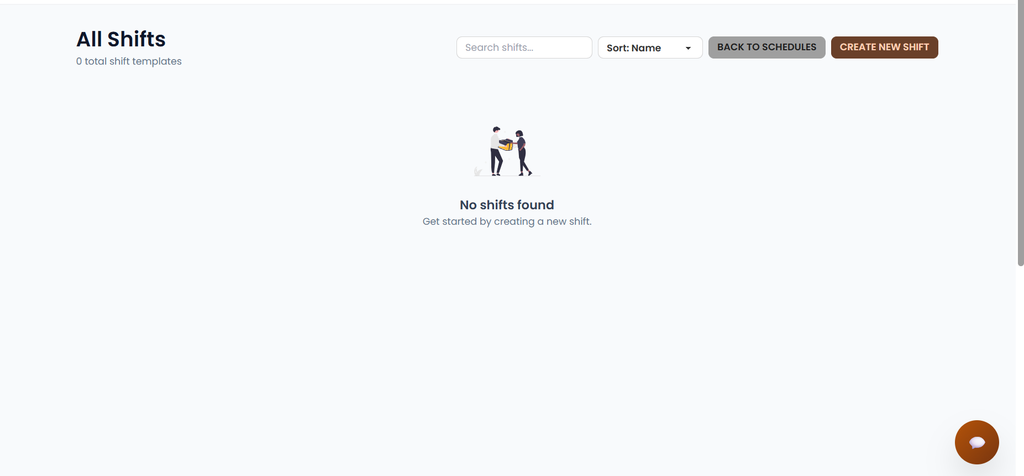
Field Specifications
Field Name | Field Type | Description
Date Filter | Date/Range | Allows the admin to filter shifts by a single day or a date range.
Position | Dropdown | Filters the list by employee position (e.g., Barista, Cashier, Manager).
Shift | Dropdown | Filters by shift name (e.g., Morning, Afternoon, Night).
Status | Dropdown | Filters by shift status (e.g., scheduled, completed, on_leave).
Employee Name | Text | Shows the full name of the employee assigned to the shift.
Shift Date | Text | Displays the calendar date of the shift.
Shift Name | Text | Displays the name/label of the shift.
Time Range | Text | Displays the working time range for the shift (start time – end time).
Position Name | Text | Shows the position of the employee on that shift.
Notes | Text | Shows additional notes for the shift from the manager or scheduler.

Database Access
Table | CRUD | Description
employee_shifts | R | Retrieve all shifts within the selected time period.
shift | R | Load shift definitions (name and time range).
users | R | Load basic employee information.
positions | R | Load position information linked to employees.
work_schedules | R | (Optional) Check which work schedule a shift belongs to.
Query: Get shift list by date range for admin view
SELECT
es.employee_shift_id,
es.shift_date,
s.shift_name,
s.start_time,
s.end_time,
es.status,
es.notes,
u.user_id,
u.full_name,
p.position_name
FROM dbo.employee_shifts es
JOIN dbo.shift s
ON es.shift_id = s.shift_id
LEFT JOIN dbo.users u
ON es.employee_id = u.user_id
LEFT JOIN dbo.positions p
ON u.position_id = p.position_id
WHERE es.shift_date BETWEEN @FromDate AND @ToDate
AND (@PositionId IS NULL OR p.position_id = @PositionId)
AND (@ShiftId IS NULL OR s.shift_id = @ShiftId)
AND (@Status IS NULL OR es.status = @Status)
ORDER BY es.shift_date, s.start_time, u.full_name;

6. Dashboard & Revenue Reports.
Related use cases:
- UC-23 View the revenue report
- UC-29 Export Excel, PDF of daily revenue
- UC-30 Revenue chart: day, month, year, quarter
- UC-39 AI Revenue Analytics

UI Design
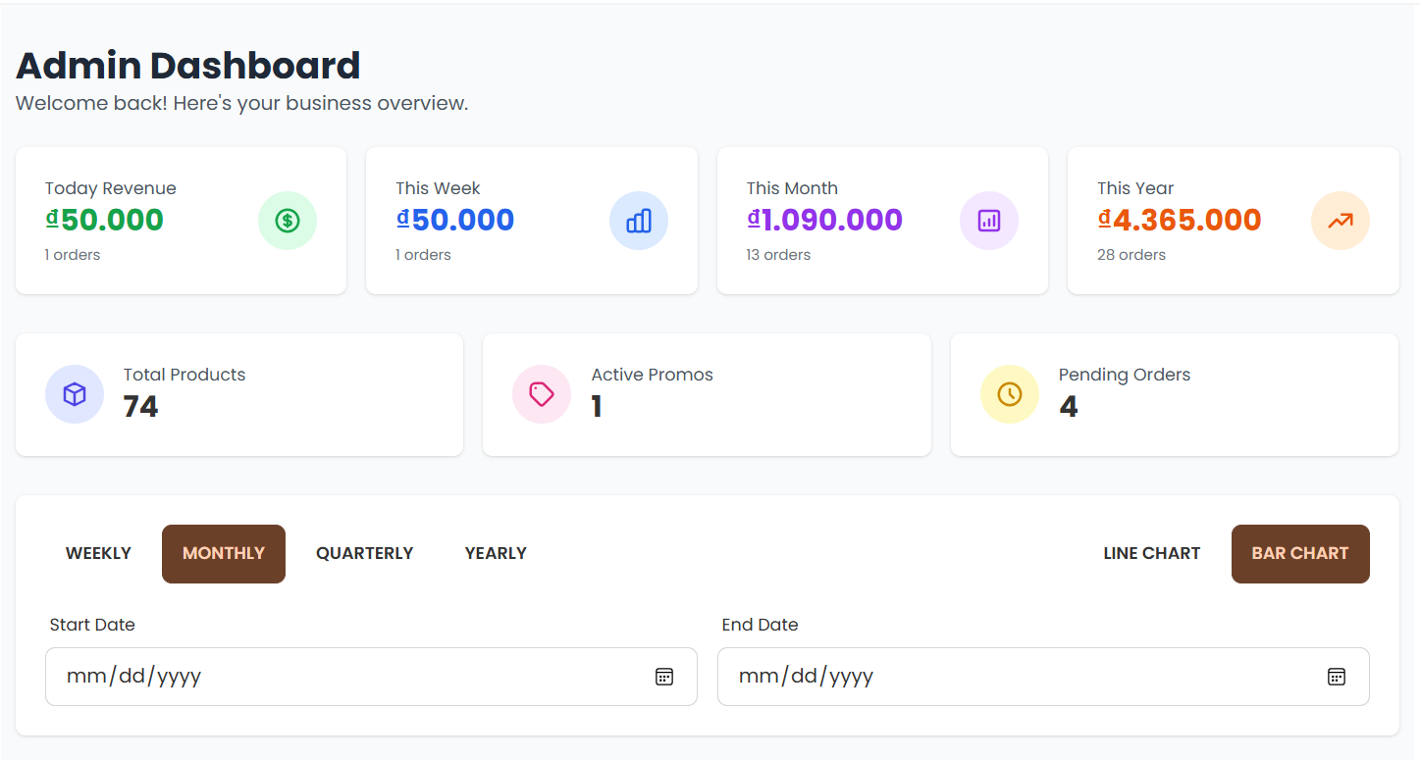
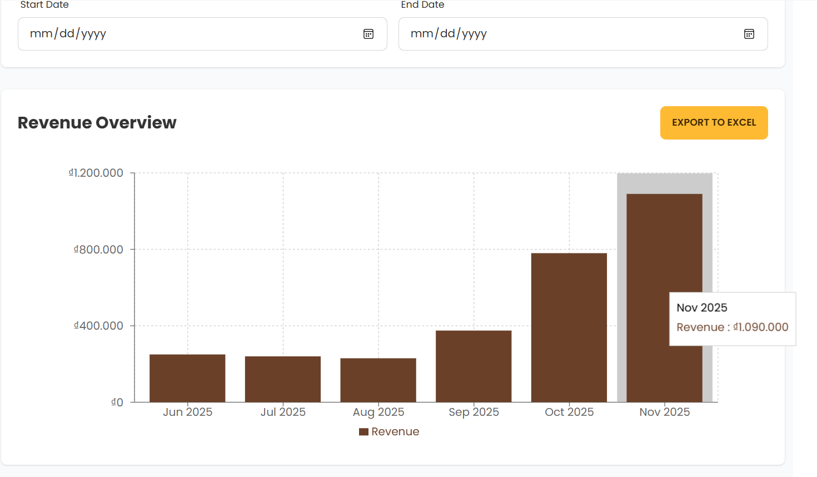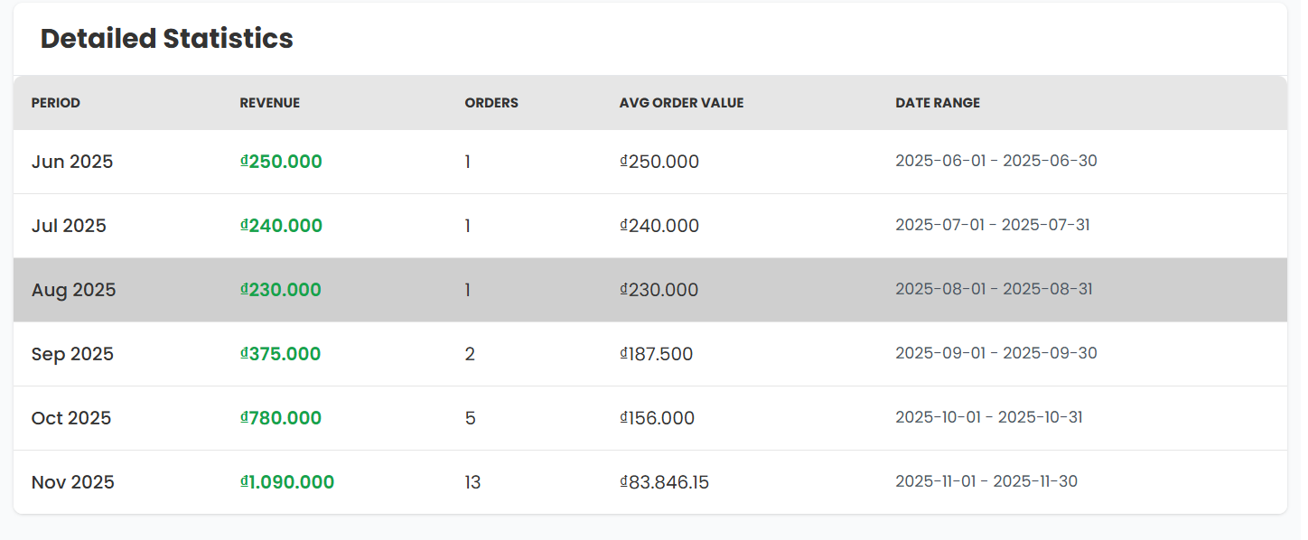

Field Specifications
Field Name | Field Type | Description
Page Title | Label / Text | Displays the main admin page title, for example “Kopi Admin Dashboard”.
Time Filter | Dropdown + Date Range | Lets the admin choose the reporting period (Today, This Week, This Month, or a custom date range).
Total Revenue Card | Info Card | Shows the total net revenue of paid orders within the selected time period.
Total Orders Card | Info Card | Shows the total number of paid orders within the selected time period.
Average Order Value Card | Info Card | Shows the average revenue per order for the selected period.
Active Promotions Card | Info Card | Shows how many promotions or discount codes are currently active in the selected period.
Revenue Trend Chart | Line Chart | Displays the revenue trend over time (by day/week/month) within the selected period.
Export Button Group | Buttons | Provides actions to export daily revenue, e.g. “Export Daily Revenue (Excel)” and “Export Daily Revenue (PDF)”.

Database Access
Table | CRUD | Description
orders | R | Read paid orders to calculate total revenue, order count, and time-based aggregates.
order_details | R | Read line items to compute product-level statistics such as top-selling products.
products | R | Read product information and stock data for dashboards like top products and low stock.
discount_events | R | Count and list currently running promotion events.
discount_codes | R | Count and list currently active discount codes.
payments | R | Optionally analyze revenue by payment method if needed.

Sample Revenue Aggregation Query
SELECT
CAST(o.created_at AS DATE) AS order_date,
COUNT(DISTINCT o.order_id) AS total_orders,
SUM(o.total_amount) AS total_revenue,
CASE WHEN COUNT(DISTINCT o.order_id) = 0
THEN 0
ELSE SUM(o.total_amount) * 1.0 / COUNT(DISTINCT o.order_id)
END AS avg_order_value
FROM dbo.orders o
WHERE o.status = N'paid'
AND o.created_at >= @FromDate
AND o.created_at < DATEADD(DAY, 1, @ToDate)
GROUP BY CAST(o.created_at AS DATE)
ORDER BY order_date;

7. AI Functions (Kopi)
Two main AI functions in the current use case list:
- AI Product Suggestion (Agent AI)
- Chatbox AI Assistant (Agent AI)

7.1 AI Product Suggestion
Related use cases:
- AI Product Suggestion (Agent AI)
- Indirectly support Manage Product (Add product / Edit product)

UI Design
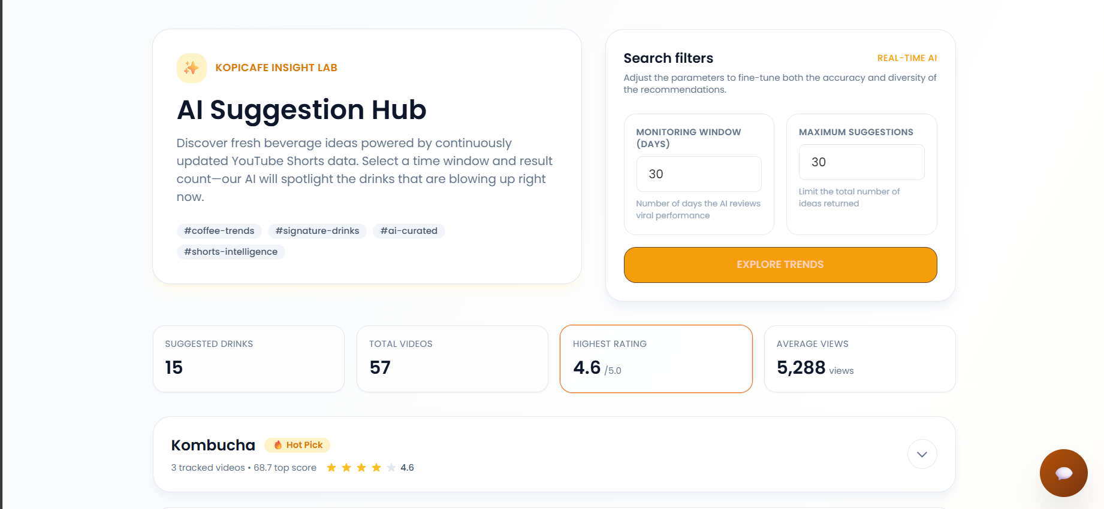
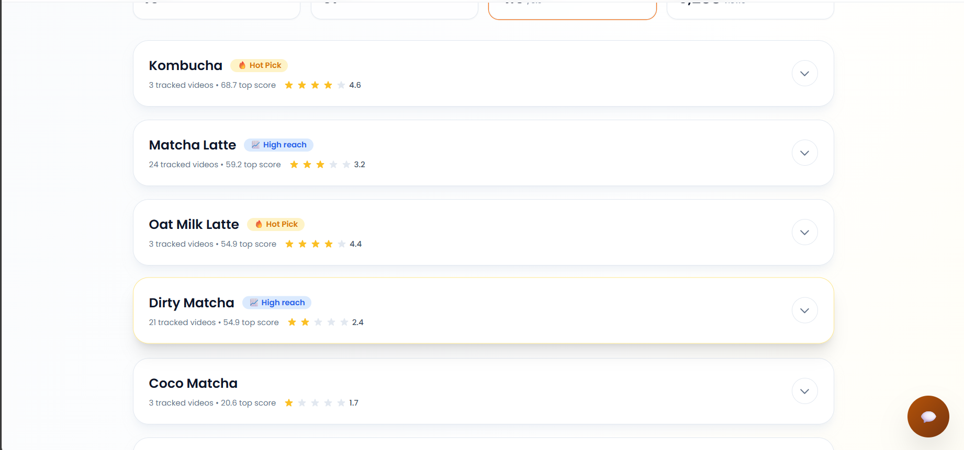Field Specifications
Field Name | Field Type | Description
Page Title | Label / Text | Displays the feature title, for example: “AI Product Suggestion – Kopi Lab”.
Time Range Filter | Dropdown | Lets the admin choose an internal trend window (Last 7 days, 30 days, 90 days) for analysis.
Suggestion Count Selector | Number Input | Sets how many new drink ideas to request from AI (for example, 3–10 suggestions).
Run AI Suggestion Button | Button (Primary) | Sends a request to the AI service to generate new drink suggestions based on trends and videos.
Suggestion List | Card List | Displays each AI-generated drink suggestion as a separate card.
Field: Suggested Drink Name | Text | Shows the name of the drink suggested by AI.
Field: Base Recipe Summary | Text / Bullets | Shows a short summary of the base recipe (main ingredients and rough proportions).
Field: Reference Video Links | Hyperlink List | Lists YouTube or other reference links the AI used as inspiration.

Database Access
Table | CRUD | Description
orders | R | Provide internal sales history used to detect hot and trending products.
order_details | R | Provide item-level quantity and revenue to rank top-selling products.
products | R | List current menu items so AI can avoid duplicates or suggest variations.
categories | R | Group drinks (coffee, tea, frappe, etc.) to help AI categorize suggestions.
discount_events | R | (Optional) Indicate which drinks are currently being promoted.
discount_codes | R | (Optional) Show products often linked to campaigns or bundles.

Example: Internal Trend Dataset for AI
Top 10 best-selling products in the last 30 days:
SELECT TOP 10
p.product_id,
p.name,
c.name AS category_name,
SUM(od.quantity) AS total_qty_sold,
SUM(od.line_total) AS total_revenue
FROM dbo.orders o
JOIN dbo.order_details od ON o.order_id = od.order_id
JOIN dbo.products p ON od.product_id = p.product_id
JOIN dbo.categories c ON p.category_id = c.category_id
WHERE o.status = N'paid'
AND o.created_at >= DATEADD(DAY, -30, GETDATE())
GROUP BY p.product_id, p.name, c.name
ORDER BY total_qty_sold DESC;

7.2 Chatbox AI Assistant
Related use cases:
- Chatbox AI Assistant (Agent AI)
- Process Order (Search products, Add to cart)
- Manage Sales (View revenue simply via chat)

UI Design

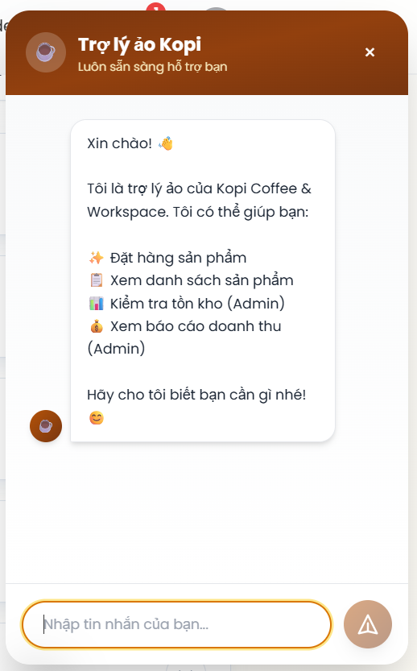

Field Specifications
Field Name | Field Type | Description
Chat Launcher Button | Floating Button | Floating button at the bottom-right corner to open/close the AI chatbox on the Kopi frontend.
Chat Window Header | Label / Text | Shows the assistant title (e.g., “Kopi AI Assistant”) and user role (Guest / Customer / Admin).
Bot Message Bubble | Text Bubble | Displays messages from the AI assistant with timestamp, supports basic formatting/Markdown.
User Message Bubble | Text Bubble | Displays user messages, right-aligned with distinct color/style.
Quick Suggestion Buttons | Button Group | Provides common quick actions such as “Today’s drink suggestions”, “View signature menu”, “Check order status”.
Message Input | Text Input | Input box where the user types questions about menu, orders, or promotions.
Send Button | Button / Icon | Sends the message to the AI backend; also supports pressing Enter to send.
Error Toast | Snackbar | Shows an error notification if the AI backend fails or loses connection.
Suggested Action Links | Buttons / Links | Shows follow-up actions such as “Open cart page”, “Go to order #123”, “View promotion details”.

Database Access
Table | CRUD | Description
products | R | Retrieve menu items, prices, and availability when users ask about drinks or food.
categories | R | Group products by category (coffee, tea, food) for category-based answers.
orders | R | Check order status or basic revenue info when users or admins ask about orders.
order_details | R | Show detailed items in an order when explaining what was ordered.
payments | R | Check payment status when troubleshooting payment-related questions.
discount_events | R | Retrieve ongoing promotions when users ask “what promotions are available?”.
discount_codes | R | Retrieve currently valid discount codes.
inventory_items | R | (Optional) Provide basic stock information if exposed to the assistant for admin questions.
inventory_log | R | (Optional) Provide stock movement history for admin-level queries.
users | R | Retrieve user info for admin questions about accounts (with proper access control).

Sample Queries Used by AI Backend
Answering menu & price questions:
SELECT
p.product_id,
p.name,
p.price,
p.is_available,
c.name AS category_name
FROM dbo.products p
JOIN dbo.categories c ON p.category_id = c.category_id
WHERE p.is_available = 1
ORDER BY c.name, p.name;
Checking order status for a customer:
SELECT
o.order_id,
o.order_code,
o.status,
o.total_amount,
o.created_at,
o.closed_at
FROM dbo.orders o
WHERE o.order_code = @OrderCode
AND o.customer_id = @CustomerId;
Listing active promotions:
SELECT
de.discount_event_id,
de.name,
de.description,
de.discount_type,
de.discount_value,
de.starts_at,
de.ends_at
FROM dbo.discount_events de
WHERE de.is_active = 1
AND de.starts_at <= SYSDATETIME()
AND de.ends_at >= SYSDATETIME();

IV. Appendix

1. Assumptions & Dependencies

Assumptions:
- AS-1: Users (customers, staff, and managers) will have stable internet access to use the Kopi Café platform.
- AS-2: Users possess basic technological knowledge to interact with the system (placing orders, making online payments, managing shifts, viewing reports, etc.).
- AS-3: Staff and managers will cooperate and follow the defined processes for ordering, serving, updating inventory, and managing work schedules.
- AS-4: Information regarding products, pricing, sales data, and user input will be accurate and valid.
- AS-5: The administrative team will promptly approve and handle requests (e.g., adding new products, updating notifications, backing up data) to maintain system performance.

Dependencies:
- DE-1: The system relies on modern web technologies (HTML, CSS, JavaScript, Java/JSP, or a suitable framework) to build the user interface.
- DE-2: The platform will utilize a database management system (e.g., MySQL) to store information about products, orders, users, and revenue.
- DE-3: Integration with online payment services (e.g., Momo, ZaloPay, banking cards) is required to support customer transactions.
- DE-4: The system depends on third-party delivery services (e.g., GrabFood, ShopeeFood, or similar partners) to transport products to customers.
- DE-5: The project depends on the software development team and technical partners to ensure that business requirements are implemented accurately and on schedule.

2. Limitations & Exclusions
LI-1: Mobile Application
- The initial release will not include a dedicated mobile application.
- Access will be limited to web browsers on desktop and mobile devices.
LI-2: Multi-Branch Support
- The system will initially support only a single coffee shop branch.
- Multi-branch management (centralized dashboard across branches) will not be available in the initial release.
LI-3: Advanced Analytics and Reporting
Detailed analytics such as sales forecasting, customer trend analysis, and staff performance reports will not be included in the first version.
LI-4: Integration with Third-Party Systems
The product will not integrate with external accounting systems, delivery platforms, or third-party payment gateways in the initial rollout.
LI-5: Inventory Automation with IoT Devices
- Automatic stock updates using IoT devices (e.g., smart sensors) will not be supported in the initial release.
- Inventory will be updated manually through the system.
LI-6: Customer Mobile Loyalty & Membership App
- The initial system will not include a mobile loyalty app or membership card integration.
- Loyalty and reward programs will only be managed internally by the shop staff.
LI-7: Social Media & Marketing Automation
Features such as automatic posting of promotions to social media or integration with email marketing tools will not be included in the initial release.
LI-8: Performance Metrics & Benchmarking
The system will not provide built-in benchmarking tools to compare shop performance against industry standards in the first version.

3. Business Rules
ID | Category | Rule Definition
BR-01 | Validation | Notify Guests with MSG01 if they don't provide a valid email address.
BR-02 | Validation | Notify Users with MSG02 if they provide an invalid password (less than 8 characters).
BR-03 | Integrity | Notify Guest with MSG03 if the provided email or username has already been used to register.
BR-04 | Validation | Notify User with MSG11 if the re-entered password is incorrect.
BR-05 | Authorization | Notify User with MSG04 if incorrect login credentials are provided, redirect to guest homepage; notify with MSG05 if correct credentials are provided, redirect to user homepage.
BR-06 | Integrity | If a Gmail account is registered with a password, the same account is accessed when using Gmail login.
BR-07 | Authorization | Role selection form appears for first-time login (Employer/Customer) does not apply to Admin accounts
BR-08 | Action-Enabler | If you log in incorrectly more than 5 times in a row, the system will suggest forgetting your password.
BR-09 | Notification | Notify User with MSG14 , an account is not allowed to log in on multiple devices at the same time.
BR-10 | Notification | Notify User with MSG13 ,the system must check the validity of the username and password, it cannot be empty.
BR-11 | Notification | The system must send an email notification to the user if password update and database save is successful.
BR-12 | Validation | Notify Users with MSG06 if they provide an invalid old password.
BR-13 | Validation | Notify user with MSG15, need to enter correct account name to change password when not logged into the system
BR-14 | Validation | Notify the user with MSG22 if the re-entered password is the same as the old password.
BR-15 | Validation | Notify user with MSG10 if wrong OTP code, code is entered by the system sent to registered email
BR-16 | Notification | System will notify guest the MSG06 if they update new profile and database successfully
BR-17 | Notification | If email address has never registered before, the system will display message MSG07.
BR-18 | Notification | The system sends a notification to the user that the password has been sent via email, and recommends that the password be changed immediately after logging in again.
BR-19 | Action-Enabler | Display MSG17 if no search results are found.
BR-20 | Action-Enabler | Display transaction history (including details like amount, date, etc.), filter by date, max 5 lines, with "Lọc" (Filter) and "Xem thêm" (View More) options.
BR-21 | Action-Enabler | Display delete confirmation pop-up for product deletion.
BR-22 | Integrity | Notify with MSG10 if there is a database connection error when displaying users information.
BR-23 | Action-Enabler | Display a confirmation pop-up for changes.
BR-24 | Action-Enabler | Display confirmation pop-up for accepting a period.
BR-25 | Status | Update job status to “Chờ thanh toán”/”Đang làm việc”/ "Đã giao hàng"/" Đã hoàn thành".
BR-26 | Notification | Notify with MSG23, Product Code Uniqueness Rule
BR-27 | Notification | Notify with MSG24, Product price must be valid and greater than 0.
BR-28 | Action-Enabler | Inventory quantity must be an integer >= 0.
BR-29 | Notification | Admin must upload at least 1 product image.  Valid image format: JPG, PNG; size < 5MB.
BR-30 | Action-Enabler | The product must belong to at least 1 category that already exists in the system.
BR-31 | Action-Enabler | Every product creation action must be logged (creation time).
BR-32 | Action-Enabler | Customers are only allowed to view their own order history, not other people's orders.
BR-33 | Validation | For each order, the system must display at least:  - Order ID  - Order Date  - Product List  - Quantity and Price of Each Product  - Total Order Value  - Order Status (Processing, Delivering, Completed, Cancelled)
BR-34 | Action-Enabler | Order history should be sorted by order date descending (newest first).
BR-35 | Action-Enabler | Order information is only displayed to the account owner. Email and phone number of others (if included in the order) are not disclosed.
BR-36 | Action-Enabler | Only accounts with Admin/Manager roles can access the history of all customers.
BR-37 | Action-Enabler | Admin can open Order Detail: list of line items (name, price, discount, ...), shipping, payment/refund, status log.
BR-38 | Action-Enabler | Only Admin/manage is allowed to create, edit, delete notifications.
BR-39 | Action-Enabler | The system must support the following minimum types of reports:  - Revenue report (by day/week/month/year).  - Product report (best seller, inventory).  - Customer report (new, returning, VIP).  - Promotion report (number of uses, effectiveness).  - Sales channel report (Web/App/Offline).
BR-40 | Action-Enabler | Reports must be taken from the system's official database. Manual data editing is not allowed.
BR-41 | Notification | Notify with MSG21, Only Admin has the right to change the “employee” role.
BR-42 | Action-Enabler | Locked accounts cannot be logged in until the Admin unlocks them.
BR-43 | Notification | Notify with MSG21, Only Admin is allowed to add, edit, delete, view information or lock employee accounts.
BR-44 | Notification | Notify with MSG13, When creating a new employee profile, it is required to have: Full name, Company email, Phone number, address.
BR-45 | Action-Enabler | Only the employee role can enter inventory data and report stockouts.  Employees can typically only view inventory data.
BR-46 | Action-Enabler | Only staff role has permission to update product order status "đang làm việc"/"đã giao hàng"/"đã hoàn thành"
BR-47 | Notification | Notify with MSG19, Notify staff when new orders are created
BR-48 | Notification | Notify with MSG20, notify customers when orders are complete

4. Application Messages List
# | Message Code | Message Type | Context | Content
1 | MSG01 | In line | Invalid email format when user fills out the email field | Sai định dạng email
2 | MSG02 | In line | Password does not meet the minimum length of 8 characters | Mật khẩu phải 8 kí tự trở lên
3 | MSG03 | Toast message | Email is already used when attempting to register | Email này đã được dùng để đăng kí
4 | MSG04 | Toast message | Login failed due to incorrect credentials | Đăng nhập thất bại
5 | MSG05 | Toast message | Login succeeded with correct credentials | Đăng nhập thành công
6 | MSG06 | Toast message | Password change failed | Đổi mật khẩu thất bại
7 | MSG07 | Toast message | Gmail has not been registered when attempting to retrieve account | Gmail chưa được đăng kí tài khoản
8 | MSG08 | Toast message | OTP sent successfully for account verification | Đã gửi mã OTP thành công
9 | MSG09 | Toast message | OTP verified successfully during account recovery | Xác thực OTP thành công
10 | MSG10 | Toast message | OTP verification failed during account recovery | Xác thực OTP thất bại
11 | MSG11 | In line | Re-entered password does not match the original password | Mật khẩu nhập lại không đúng
12 | MSG12 | Toast message | No search results found | 404 - Không tìm thấy kết quả nào
13 | MSG13 | In line | Information is incomplete | Hãy điền đầy đủ thông tin
14 | MSG14 | Toast message | Account is logged in elsewhere | Tài khoản đã được đăng nhập
15 | MSG15 | Toast message | Account not created | Tài khoản không tồn tại
16 | MSG16 | Toast message | Profile update successful | Cập nhật hồ sơ thành công
17 | MSG17 | Toast message | Database connection error when performing an action | Lỗi kết nối cơ sở dữ liệu
18 | MSG18 | Toast message | Payment completed successfully | Đã thanh toán thành công
19 | MSG19 | Pop up message | Send new order notifications to employees | Bạn có một đơn hàng mới cho công việc
20 | MSG20 | Pop up message | Send completed product notification to customer | Sản phẩm của bạn đã hoàn thành và đang được giao hàng
21 | MSG21 | Pop up message | Send a confirmation message to save changes | Bạn có muốn lưu thay đổi
22 | MSG22 | In line | The re-entered password is the same as the old password. | Mật khẩu mới trùng với mật khẩu cũ.
23 | MSG23 | In line | Duplicate product ID notification | Sản phẩm vừa thêm đã tồn
24 | MSG24 | In line | Notification when entering wrong price | Giá sản phẩm không hợp lệ

